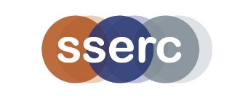
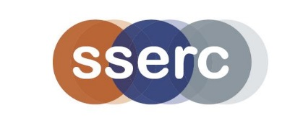
Privacy Policy
Context and overview
Key details

- Policy prepared by: Alastair MacGregor
- Approved by board / management on: 10/04/2018
- Policy became operational on: 01/05/2018
- Next review date: 01/05/2020

Introduction
People may share personal information with us to enable access to our Advisory Services, or to attend SSERC courses. We recognise the importance of protecting all personal data.
Why this policy exists
We want everyone to feel confident and comfortable with how personal information will be looked after or used. This Privacy Policy sets out how we collect, use and store personal information (this means any information that identifies or could identify a person).
Policy scope
This policy applies to all activities which uses personally identifiable information. These include:
- the running of professional learning events
- distribution of health and safety related information
- improving the experience of visitors to our website
- marketing and promotional purposes, if you have opted to receive such forms of communication.

Responsibilities
All SSERC staff are responsible for ensuring the safe keeping of personal data. It is the responsibility of the SSERC Senior Management Team to ensure that all staff are aware of, and follow this, privacy policy.

How We Use Your Information

General Use
We will not sell, share, or rent personally identifying information in ways other than those disclosed in this statement.

We use personal data to derive statistical information that we may provide to funders, potential funders, and other partner organisations. The data we pass to these organisations will not contain any personal information relating to individuals and cannot be used to identify individuals.

Sharing of Data with Third Parties
If you have agreed to receive marketing emails from us, your information may be uploaded to our email client system. We use the Benchmark email system for this purpose. You may opt out of these emails at any time.
We also provide data to a third-party evaluation team. This data is used to evaluate the success of various SSERC activities, primarily in the professional development area. We then use this feedback to help maintain and improve upon the quality of our professional development and other activities.

If you are participating in a professional learning activity delivered by a third party, we may share your personal data with them. We will only share data necessary in relation to your professional learning activity. If there is a sponsor for the professional learning activity, SSERC may pass your data onto them.

SSERC cannot be held responsible for how your data is treated by third party organisations but you should recognise that they may hold and process your information and you may be contacted by them regarding their relevant products or services.

Transfer of Data Outside the UK and European Union
Information you provide may be transferred outside of the UK and European Union. These countries may not have similar data protection laws to the UK. By submitting your personal data, you are agreeing to this transfer, storage, and processing. When your data is transferred outside of the EU in this way, we take steps to ensure that your data privacy rights continue to be protected.
Managing and deleting your information
We endeavour to ensure that all information which we retain is up to date but for us to do that please inform us of any relevant changes - for example, a change of address or place of employment. We may also update information if we identify that it is incorrect - for example, a school closes and reopens with a different name.

If you wish to have any personal data that we hold about you deleted, you can request this by emailing us at enquires@sserc.scot. If you are planning to attend a professional learning event we may be unable to delete your information and still allow you to attend the event. We may also be unable to delete your data if it conflicts with legal obligations we may have to retain such information.

Accessing your personal information
Individuals can find out if we hold any information about them by emailing us at enquires@sserc.scot. If we do hold information about you, we will give you a copy of this data, as well as telling you why we are holding it and who it may be disclosed to. We aim to be as open as possible in terms of allowing people access to their personal data.

Use of cookies
We use cookies on our website to improve the overall experience and allow our site to function correctly. You may block or delete all cookies used by our site, but some website areas may stop working correctly.
The main uses of cookies on our site are as follows:
- Storing information about a user’s session - such as whether they are logged in.
- Gathering anonymous data about the use of our site via Google Analytics.
- Cookies are not used for any kind of personal profiling.
If you have further concerns regarding your personally identifiable information, please contact us at enquires@sserc.scot.

