Environmental
Science
Soil science
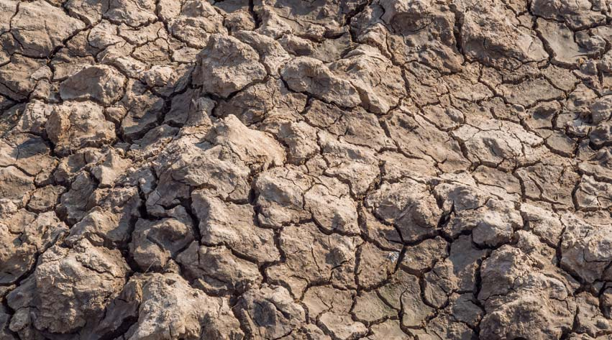
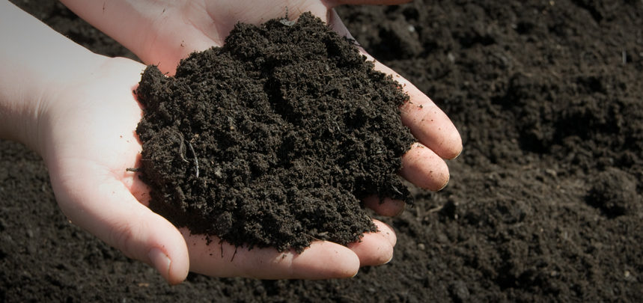

Introduction
While it is often overlooked and thought of as mere ‘dirt’, soil is in fact a complex mixture of organic matter, minerals, gases, liquids, and organisms that together provide an environment that can support life. It has several critical functions:
- a medium for plant growth
- a means of water storage, supply and purification
- a modifier of Earth's atmosphere
- a habitat for organisms
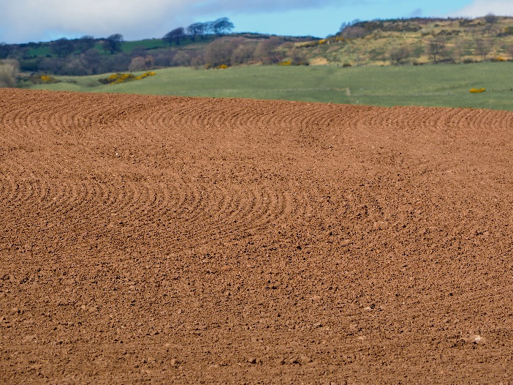
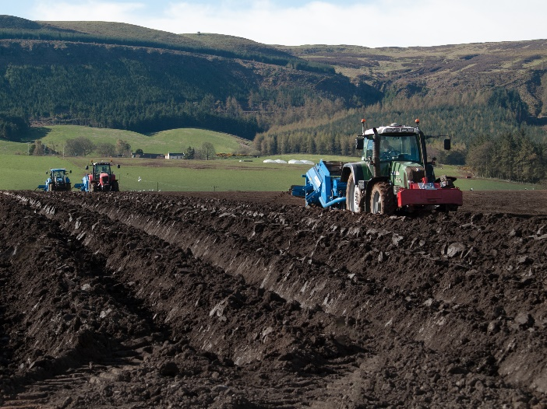
Soils vary enormously from place to place depending on a variety of factors. (These two fields are only a few miles apart)

Typically soil is about 50% solid and 50% voids (or pores) of which half is occupied by water and half by gas. Compaction (compression) a common problem with soils where they are walked on or driven on by vehicles, reduces this space, preventing air and water from reaching plant roots and soil organisms.
The solid matter is on average around 45% mineral and 5% organic matter – though there can be a considerable variation.
From the point of view of environmental science, the study of soil is extremely important, being a key factor in the ecosystem.

In this booklet,, we look at a few of the many aspects of soil that can be examined easily in schools.
- Temperature – This will naturally vary. Soil in sunny spots will be warmer than that in shaded ones for instance. It will also vary through the year. The soil temperature can determine what types of plants can grow and also how early in the year they will grow. This in turn can have knock-on effects on the rest of the ecosystem.
- pH – the pH of soils can also have a great effect. Although there are exceptions, soils generally have pH values between about 5 and 8. Plants such as heathers grow best on acidic soils while cabbages grow well on alkaline soils.
pH can be determined wither by use of a pH probe/meter or by extracting the minerals in water and using an indicator to test the pH of the solution.
- Moisture content – this will also vary. It is obviously dependent on rainfall but also on other factors. For instance, a high concentration of organic matter retains more moisture while a sandy soil is more free draining and will dry out rapidly.
To find the moisture content you weigh a sample of soil before and after drying in an oven and work out the difference.
- Density – Less of a factor for the environment but the density of a soil can tell you much about its composition.
To determine the density, just as with a liquid, you find the mass of a known volume of soil.
- Permeability – this is the rate at which water will soak into the soil. This is affected by the structure of the soil and compaction, which reduces the air/water spaces in the bulk soil will reduce the permeability.
There are a few ways to measure this but the simplest is simply to apply a set amount of water to the soil surface and see how long it takes to soak in.
- Porosity – related to permeability, the porosity of a material is a measurement of how much of its volume is open space (also called pore space). It is also affected by compaction.
- Organic/inorganic matter. Dry soil can be roughly divided into 2 components: inorganic matter (sand, silt etc originally from rocks) and organic matter (humus from decayed/decaying plant and animal matter.
It is possibly to determine how much of a soil sample is organic matter by heating it strongly to burn off all the organic matter and then weighing to see how much inorganic matter remains.
- Particle size – The inorganic matter in soils can be divided into three main categories depending on size: sand, silt and clay. The exact composition will have various effects on the soil, such as its rate of drainage. It is possible to determine the composition of soils by using the different rates at which these particles settle to the bottom when shaken with water.

Activity 1

In situ measurement of pH, moisture and temperature (and sampling)

You will need
Access to a soil augur (or trowel) | Metre ruler
pH meter | Moisture meter
Thermometer | (containers for samples)

These properties vary with depth and this can be interesting to investigate.

To do
- If needed, clear the surface of the soil of grass or other vegetation so you can access the bare soil.
- Use the meters to record pH, moisture content and temperature.
- If needed take a sample of the soil
- Use a trowel or an augur to dig down into the soil a certain depth about 20 cm.
- Clear the debris and repeat the measurements of pH, moisture and temperature.
- If required take another sample of soil
- Dig down another 20 cm and repeat again

Results
Depth (cm) | pH | moisture | temperature
0
20
40

Activity 2

In situ measurement of permeability
You will need
Access to a trowel, possibly | timer
Plastic measuring jug | Sample of water
Tin can open at both ends

The permeability of water will vary with its compaction. If you are investigating the effect of this, chose two sites (at least) one on a path or other compacted area and one off it.

To do
- If needed, clear the surface of the soil of grass or other vegetation so you can access the bare soil.
- Take your can and press (or hammer) into the soil. Not too far but a cm or two - enough so that your water sample can’t escape under the rim.
- Use the jug to measure out 250 cm³ of water.
- Pour the water into the tin (on top of the soil) and start your timer.
- As soon as the water has soaked into the soil, stop the timer and record your result.
- Move to a different site and repeat with the same volume of water.

Results
Sample number | Description | Time taken for water to soak in (s)
1
2
3

Activity 3

pH of water samples in the lab

You will need
Water/soil sample | Pasteur pipette
2 test tubes / bijoux | Filter and funnel
Indicator strips | Universal indicator

To do
- Add some water to your sample of soil and shake well to mix.
- Place the filter paper in a funnel sitting in a test tube (or other container) and pour some of the mixture in.
- Allow a few cm³ of filtrate to drip through.
- Add 2 or 3 cm³ to each of 2 bijoux/test tubes.
- Into one, add a few drops of universal indicator.
In fact, as the range of soil pH is quite small, more accurate results can be obtained with narrow-range indicator.
- In the other one, add 2 drops of aquarium indicator.
If you can get hold of a good soil pH indicator or a suitable narrow-range pH paper that will probably be better but this works reasonably well.

Results
Sample number | pH (universal) | pH (Aquarium)

Activity 4

Particle size

You will need
2 x water/soil samples | 2 x measuring cylinders
timer | ruler
10 cm³ of 0.4% Iron(III)chloride | Boiling Tube Rack

To do
- Take your 2 soil samples and add to the measuring cylinders – roughly half full.
- Fill one to 2-3 cm from the top with water. To the other, add your 10 cm³ of iron III chloride and then add water to make it the same level as the other.
In both cases, you will need to shake a few times to make sure all the soil is suspended.
- Shake the 2 tubes of soil/water mix until all the soil is suspended.
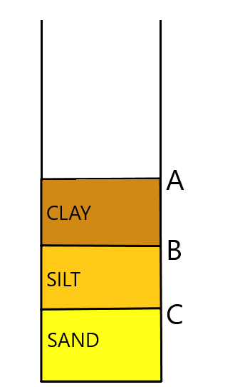
- Put down in the rack and start the timer.
- After 2 minutes, measure the height.
This is height C
As the experiment takes a good while to finish (24 hours) we are not going to proceed any further. In class, measurements are taken after 2 minutes for sand (height C) 30 minutes – 2 h for silt (height B) and 24h for clay (height A).

Results
 | Measurements in these columns |  |  | Calculate these values
Soil sample | A | B | C Sand | D - Sand % | E - Silt | F - Silt % | G - Clay | H – Clay %
 |  |  |  | (C / A) x 100 | B - C | (E / A) x 100 | A - B | (G / A) x 100
1
2

Use the diagram on the following page to find out what type of soil you have.
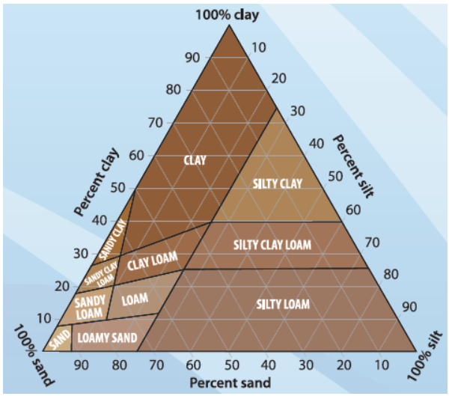

Activity 5

Porosity
The porosity of a soil tells you how much of it is taken up with pores – air spaces. We measure this by adding water – this fills up the spaces so the volume of water needed to saturate the soil will equal the volume of the pore spaces.
You will need
1 soil sample | 250 cm³ beaker
100 cm³ measuring cylinder | Water

To do
- Take a 250 cm³ beaker
- Fill with your soil sample up to the 100 cm³ line
- Place 100 cm³ of water in a measuring cylinder
- Slowly and carefully pour water into the beaker until the water reaches the top of your sample.
- Write the volume of water remaining in the graduated cylinder on your data sheet.
- Subtract the volume remaining from the total volume.
- This is the amount of water you added to your sample. Write the volume of water added to the sample on your data sheet – this is the pore space.
- To determine the porosity of the sample, divide the pore space volume by the total volume and multiply the result by 100.

Results
Sample number | Volume of water remaining (W) | Volume of water added (A) | Porosity  (A / 100) * 100

Activity 6

Moisture content
Again, to save time, we have done part of this for you.
You will need
1 x pre-dried soil sample | balance

To do
Despite the table, you are only doing one soil sample
- Copy the values for columns B, C and D from the label of your soil sample.
- Weigh the sample
- Record the value
- Find the original mass of the soil sample before drying.
- Work out the difference in mass.
- Work this out as a percentage of the initial volume

Results
A | B | C | D | E | F | G
Sample number | Mass of jar | Mass of jar + wet soil | Mass of wet soil | Mass of jar + dried soil | Dry soil mass  (E – B) | Mass of water.  (D – F) | % water  (G / D) x 100
1
2
3

Activity 7

Density
You will need
pre-dried soil sample – from previous activity | balance
Beaker

To do
- Weigh your beaker and record the value
- Fill the beaker to the 50 cm³ line with the dry soil.
- Weigh again and record the value
- Work out the difference in mass.
- Divide the mass by the volume to get the density.

Results
Sample number | Mass of beaker (B) | Mass of beaker + soil (S) | Mass of soil (D) | Volume of soil cm³ | Density  (Mass (D) / volume)
 |  |  |  | 50

Activity 8

Organic matter
You will need
pre-dried soil sample – from previous activity | balance
Bunsen burner | crucible
tripod | Pipe-clay triangle
tongs

To do
- Put the crucible on the balance and record its mass
- Add a few grammes of soil and record the new mass
- Put the crucible and soil over the Bunsen burner and heat strongly over the hottest flame
- When the soil stops smoking, keep heating for a couple more minutes and then switch off the Bunsen burner
- Allow it to cool for a little while before re weighing.
- Record the new mass and work out the difference and then the percentage that has been lost.

Results
Sample number | Mass of crucible (C) | Mass of crucible + soil (S) | Mass of soil (D) | Mass of soil after heating (H) | Loss of mass (I)  (D – H) | % loss  (I / D) x 100

