Investigating the inhibition of yeast catalase by ethanol
SSERC (2024).
Aim: To investigate the effect of ethanol concentration on catalase activity in S. cerevisiae.

Method 1: Substrate pre-incubated with inhibitor
In this experiment, hydrogen peroxide and varying concentrations of ethanol were mixed before adding a filter paper disc soaked in yeast to the surface. The time taken for the filter paper disc to sink and then rise fully to the surface was recorded. This happens because the yeast contains catalase, which degrades the hydrogen peroxide to form oxygen. This oxygen makes the filter paper disc more buoyant, allowing it to rise to the surface.
Materials
5x universal bottles | Weigh boat
Ethanol | Spatula
10 vol hydrogen peroxide | Magnetic stirrer and flea
20 cm³ measuring cylinder | Water
1 cm³ automatic pipette and tips | 100 cm³ measuring cylinder
balance | Filter paper
Petri dish to store filter paper discs | Hole punch
Stopwatch | Baker’s yeast
Beaker | Forceps
Paper towels | Beaker of water to rinse forceps

Preparation of materials
- A 1% Baker’s yeast suspension was made by combining 1 g of Baker’s yeast with water up to a volume of 100 cm3. A magnetic stirrer and flea were used to mix the suspension thoroughly. The suspension was kept at room temperature.
- Filter paper discs were prepared of equal diameter using a hole punch.
- Figure 1 shows the volumes of 10 vol hydrogen peroxide and 100% ethanol used to prepare the substrate/inhibitor solutions. These were decanted into universal bottles and left at room temperature for 5 minutes prior to the start of the experiment.
Overview of materials required
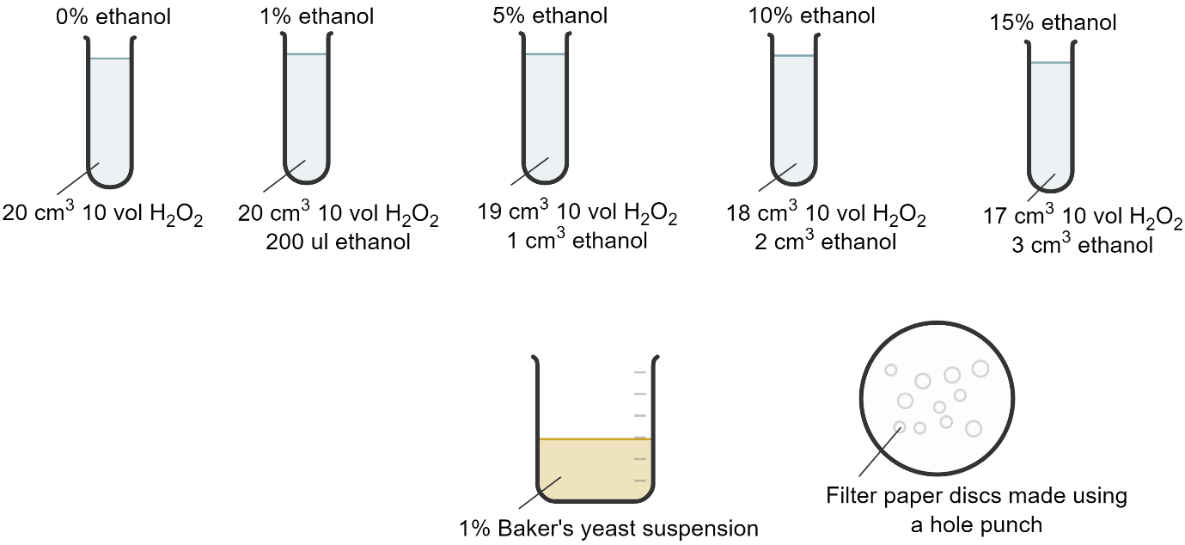
Figure 1: Materials required for the experiment.

Method
- Using a clean pair of forceps, a filter paper disc was immersed in the yeast suspension.
- The filter paper disc was dropped onto the surface of the hydrogen peroxide solution (containing no inhibitor).
- The stopwatch was started immediately and used to time how long it took for the filter paper disc to sink and then rise fully to the top of the solution.
- The forceps were used to remove the filter paper disc and the forceps were then rinsed using water and dried.
- Steps 1-4 were repeated two further times with this substrate solution.
- The experiment was then repeated with each of the inhibitor concentrations.

Results
Ethanol concentration (%) | Time for filter paper disc to sink and then float (s)
 | 1 | 2 | 3 | Mean
0 | 13.02 | 11.20 | 12.12 | 12.11
1 | 9.11 | 10.29 | 10.79 | 10.06
5 | 13.69 | 14.86 | 15.48 | 14.68
10 | 15.88 | 13.94 | 15.3 | 15.04
15 | 15.20 | 17.69 | 16.75 | 16.55

Conclusion
The results show that ethanol, between the concentration of 1 and 15%, does not significantly inhibit catalase activity in yeast.
Method 2: Enzyme pre-incubated with inhibitor
In this experiment, yeast (containing the enzyme catalase) and varying concentrations of ethanol were mixed and incubated at room temperature for 5 minutes prior to starting the experiment. A filter paper disc was immersed in this mixture before it was added to a universal bottle containing 10 vol hydrogen peroxide. The time taken for the filter paper disc to sink and then rise fully to the surface was recorded. This happens because the yeast contains catalase, which degrades the hydrogen peroxide to form oxygen. This oxygen makes the filter paper disc more buoyant, allowing it to rise to the surface.
Materials
5x universal bottles | Weigh boat
Ethanol | Spatula
10 vol hydrogen peroxide | Magnetic stirrer and flea
20 cm³ measuring cylinder | Water
1 cm³ automatic pipette and tips | 100 cm³ measuring cylinder
balance | Filter paper
Petri dish to store filter paper discs | Hole punch
Stopwatch | 1 g Baker’s yeast
5x 100 cm³ beakers | Forceps
Paper towels | Beaker of water to rinse forceps

Preparation of materials
- 5x 100 cm³ beakers were collected and 0.2 g of Baker’s yeast was added to each. Figure 2 shows the volume of water and ethanol added to each beaker. A magnetic stirrer and flea were used to mix the suspensions thoroughly. The suspensions were kept at room temperature for 5 minutes prior to the start of the experiment.

Overview of materials required
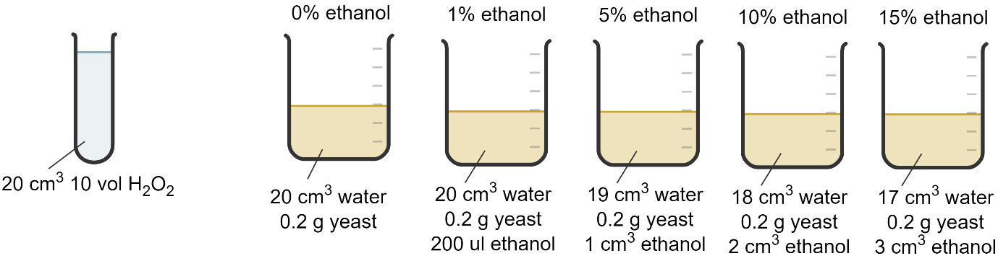
Figure 2: Materials required for the experiment.

Method
- Using a clean pair of forceps, a filter paper disc was immersed in the first yeast/ethanol suspension.
- The filter paper disc was dropped onto the surface of the hydrogen peroxide solution.
- The stopwatch was started immediately and used to time how long it took for the filter paper disc to sink and then rise fully to the top of the solution.
- The forceps were used to remove the filter paper disc and the forceps were then rinsed using water and dried.
- Steps 1-4 were repeated two further times with this inhibitor concentration.
- The experiment was then repeated with each of the inhibitor concentrations. For each inhibitor concentration, a fresh container of 20 cm³ 10 vol hydrogen peroxide was used.

Results
Ethanol concentration (%) | Time for filter paper disc to sink and then float (s)
 | 1 | 2 | 3 | Mean
0 | 13.72 | 11.29 | 12.54 | 12.52
1 | 11.84 | 10.19 | 13.23 | 11.75
5 | 13.32 | 11.59 | 10.11 | 11.67
10 | 9.23 | 10.02 | 11.20 | 10.15
15 | 10.56 | 11.97 | 11.46 | 11.33

Conclusion
The results show that ethanol, between the concentration of 1 and 15%, does not significantly inhibit catalase activity in yeast.

References
Useful references for this work include a SSERC Bulletin:
SSERC (2018), Catalase activity in immobilised yeast – effect of inhibitors, STEM Bulletin 265, pp. 2-3.
This can be accessed here https://www.sserc.org.uk/wp-content/uploads/Publications/Bulletins/265/SSERC-bulletin-265-p2_3.pdf

