Short Chemical Experiments
Acid Rain in the classroom

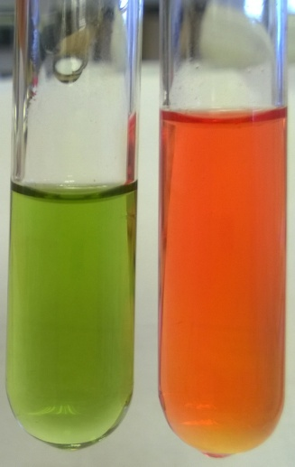
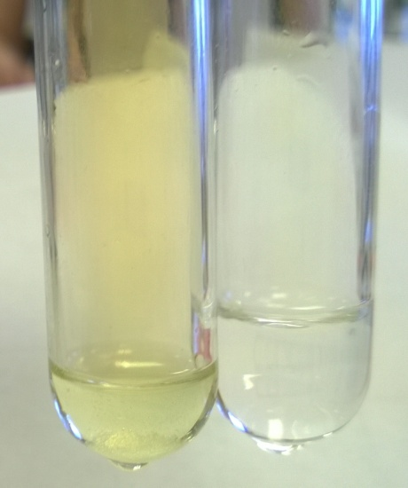
National 4 Chemistry
Chemical Changes and Structure
Acids & Alkalis
Higher Environmental Studies
Living Environment
3e Formation of acid rain and the minimisation of its impacts on biodiversity

Acid Rain in the classroom
In Europe at least, legislation to control emissions has reduced the amount of acid rain but it is still an environmental issue. As such, it is important that this can be shown in the classroom.
Here is a simple and safe method of demonstrating acid rain as caused by the three most common gases responsible: carbon dioxide, sulphur dioxide and nitrogen dioxide.
You will need:
6 test tubes and bungs | 4 syringes or Pasteur pipettes
Spatula | Dripping bottle of universal indicator
Sodium nitrate III (Nitrite) | Sodium hydrogen sulphate
Sodium carbonate or hydrogen carbonate | 1 mol l⁻¹ Hydrochloric acid

To do
1. Using the spatula, place a small amount (about ½ a spatulaful) of sodium nitrate III in the bottom of a test tube.
2. Put a similar amount of sodium hydrogen sulphate in another and sodium carbonate/hydrogen carbonate in a third.
3. Use a syringe or Pasteur pipette to add 2 cm³ of 1 mol l⁻¹ Hydrochloric acid to each tube. Immediately place a bung in the tubes.
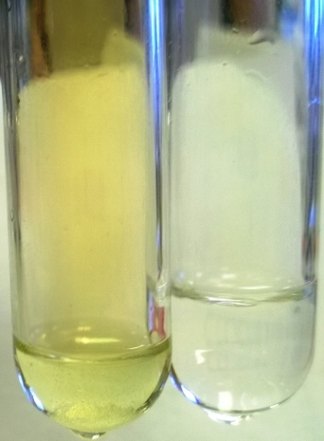
4. While waiting a few minutes, place a few cm³ of distilled water in the each of the other three test tubes.
5. Add a drop or two of universal indicator to each of the water-containing tubes.
By this time, you should see that the test tube containing the sodium nitrate III is looking noticeable brown. This is due to the production of nitrogen dioxide. (See photograph to the right)
6. Briefly take the bung out of the tube containing the sodium nitrate III and, using a syringe or Pasteur pipette, remove some of the ‘air’. Replace the bung and squeeze the gas into one of the test tubes of water/indicator. If possible, bubble it into the water. If not, put your thumb over the end and invert it (or use a bung) The indicator should go red. (see photo on next page)
NO₂ SO₂
7. Replace the bung in the reaction tube.
8. Repeat the procedure with the tube containing the sodium hydrogen sulphite and the one containing sodium carbonate or hydrogen carbonate.
You will see that carbon dioxide has less of an effect than the other gases but is still acid.
Before After

Health & Safety
Remember, Sulphur dioxide and nitrogen dioxide are toxic gases. Replace the bung immediately after using.
If you wish to do thin on a larger scale, it should be carried out in a fume cupboard.

It is possible, of course, to generate Nitrogen dioxide from copper turnings and concentrated nitric acid. There is no need to use this method, unless you are carrying out the reaction on a large scale in a fume cupboard, in which case gloves and eye protection should also be worn.

  - It is the responsibility of teachers doing this demonstration to carry out an appropriate risk assessment.

