Experimental Data Sets - Catalase
The following data sets are useful when exploring the use of catalase, an enzyme the catalyses the degradation of hydrogen peroxide to form oxygen and water. There are various methods that can be used for this protocol.
In this document, we look at the following independent variables:
- Temperature
- pH
- concentration of substrate
- tissue type

Enzymes – catalase – effect of temperature
In this experiment, a cylinder of potato was added to 3 cm³ 10 vol hydrogen peroxide incubated at various temperatures. The reaction was allowed to continue for 3 minutes and then the height of foam was measured using a ruler.
Temperature (ᴼC) | Height of foam (mm)
 | 1 | 2 | 3 | Average
4 | 20 | 20 | 30 | 23
20 | 52 | 44 | 53 | 50
40 | 81 | 82 | 90 | 84
60 | 10 | 0 | 0 | 3

Enzymes – catalase – Effect of pH
In this experiment, a cylinder of potato was added to 3 cm³ 10 vol hydrogen peroxide, 3 cm3 buffer of different pH, at room temperature. The reaction was allowed to continue for 3 minutes and then the height of foam was measured using a ruler.
pH | Height of foam (mm)
 | 1 | 2 | 3 | Average
2 | 8 | 2 | 10 | 7
4 | 5 | 13 | 5 | 8
6 | 8 | 10 | 9 | 9
8 | 38 | 42 | 29 | 36
10 | 3 | 5 | 4 | 4

Enzymes – catalase – effect of tissue type
In this experiment, tissues were immobilised using sodium alginate to form beads. The beads were then dropped onto the surface of a universal container of 2 vol hydrogen peroxide at room temperature. The time taken for the bead to fall and rise was recorded.
Tissue type | Time taken for bead to fall and rise (s)
 | 1 | 2 | 3 | Average
Melon | 71 | 68 | 82 | 74
Cucumber | 143 | 152 | 138 | 144
Cress | 18 | 25 | 17 | 20
Bean sprouts | 31 | 41 | 42 | 38

Enzyme – catalase – Effect of tissue type
In this version of the experiment, tissues of equal mass were prepared. Boiling tubes containing hydrogen peroxide and detergent were prepared and sat at room temperature. The tissues were then added to the test tubes and left for 3 minutes. The height of foam was then measured. The foam produced reflects the production of oxygen as the hydrogen peroxide is broken down.
Tissue type | Height of foam (mm)
 | Trial 1 | Trial 2 | Trial 3 | Average
Liver | 85 | 95 | 87 | 89
Potato | 55 | 58 | 50 | 54
Carrot | 28 | 20 | 25 | 24
Onion | 16 | 20 | 18 | 18

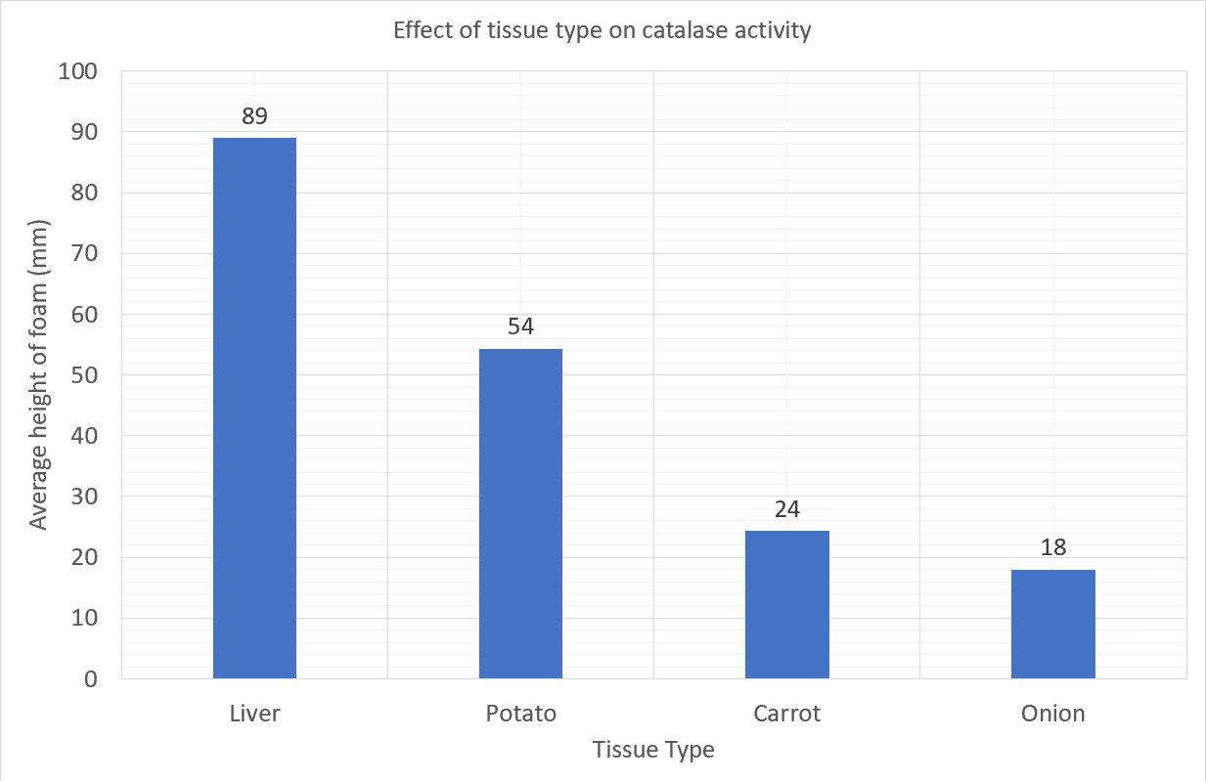

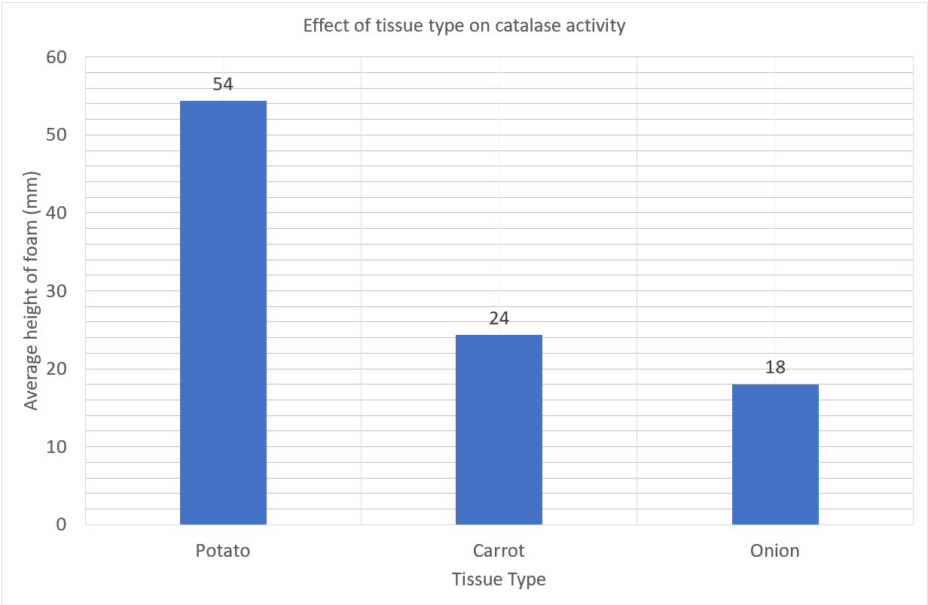

Enzyme – catalase – Effect of substrate concentration
In this experiment, cucumber was immobilised using sodium alginate to form beads. The beads were then dropped onto the surface of universal containers of various concentrations of hydrogen peroxide at room temperature. The time taken for the bead to fall and rise was recorded.
Concentration of hydrogen peroxide (vol) | Time taken for bead to fall and rise (s)
 | 1 | 2 | 3 | Average
1 | 166 | 184 | 179 | 176
2 | 143 | 153 | 161 | 152
5 | 54 | 50 | 56 | 53
10 | 34 | 24 | 30 | 29

