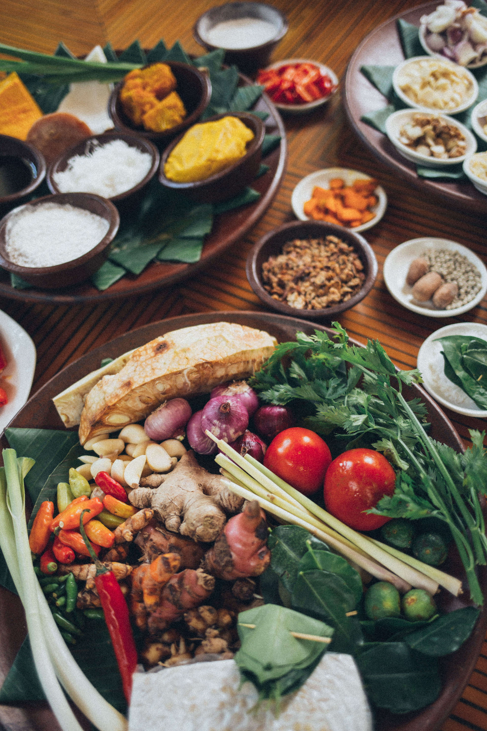

|  |
| --- |
| PupilExperiment |
| Vitamin C levelsin vegetables |
| Learner Guide |

# Background

Vitamin C is the compound ascorbic acid with the molecular formula C6H8O6.

The body uses ascorbic acid when making collagen, a protein which helps skin, bone, hair and blood vessels stick together. Ascorbic acid also helps the body absorb iron.

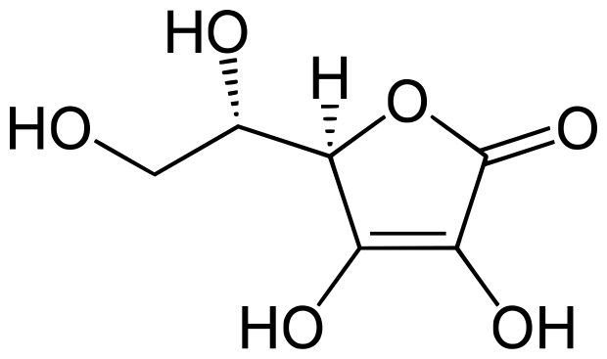

We need to take in about 90 mg each day. We can store up to one month's supply of vitamin C, but no more.

As we cannot make it in the body, we need to keep a constant supply going.

Anyone under stress needs extra vitamin C, because the body will use it up more quickly than in a non-stressed state.

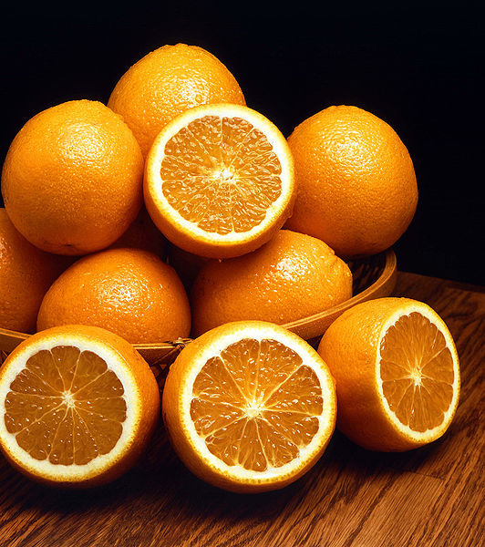

Smokers need more vitamin C, because smoking is a 'stress' on the body.

Lots of things are said about vitamin C, for example, taking large amounts is supposed to stop us getting colds and it may help us stop getting some types of cancer.

Ascorbic acid is found in many fruit juices and some vegetables such as broccoli and potatoes.

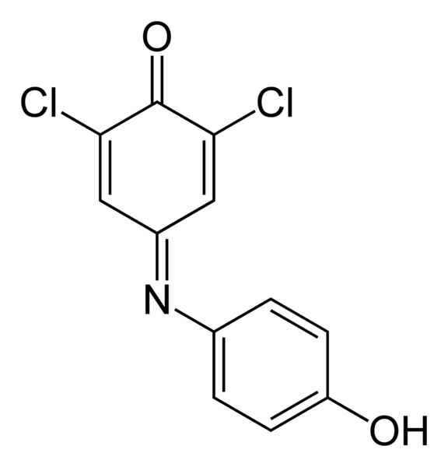

2,6-dichlorophenolindophenol (DCPIP) can be used to estimate the concentration of vitamin C in food.

DCPIP is blue when dissolved in water, is red in acid conditions, and is reduced by ascorbic acid (vitamin C) ) to a colourless compound. However, in this titration, the end point colour change will be from blue to pink due to the presence of the phosphoric(V) acid used to prepare the vegetable extract.

DCPIP should be treated as HARMFUL. (*See Risk Assessment*)

# Estimating the Vitamin C content of vegetables

This experiment uses 2,6-dichlorophenolindophenol (DCPIP) in a titration, to estimate the concentration of vitamin C in food. DCPIP is blue when dissolved in water and is red in acid conditions, and is reduced by ascorbic acid (vitamin C) to a colourless compound. However, in this titration, the end point colour change will be from blue to pink due to the presence of the phosphoric(V) acid used to prepare the vegetable extract.



## You will need:

|  |  |
| --- | --- |
| Apparatus for titration, 25 cm3 pipette, 50 cm3 burette, 250 cm3 conical flask, pipette filler | Measuring cylinders, 500 cm3 and 250 cm3 |
| Beaker, 250 cm3 | Liquidiser |
| Filter funnel and muslin for filtration | Vegetables to test, 100 g |
| 5% phosphoric(V) acid solution | A solution of 2,6-dichlorophenolindophenol (DCPIP) ***Harmful*** |

## What you do:

1. Accurately weigh out about 50 g of your vegetable and put it in a liquidiser with 250 cm3 of 5.0% phosphoric(V) acid.
2. Ensure the lid is securely fitted and liquidise at high speed.

*(The purpose of the 5% phosphoric(V) acid solution is to provide acid conditions to inactivate the enzyme ascorbic acid oxidase and to extract the ascorbic acid from the food).*

1. Filter off using a muslin filter.
2. Make up the volume of extract plus washings to 300 cm3 with deionised (not distilled) water.
3. Set up the burette filled with DCPIP.
4. Using a pipette filler, pipette 25 cm3 of the vegetable extract into a conical flask.
5. Titrate with the DCPIP indicator solution until a pink end point is reached.

*Note: If the vegetable extract solution is a greenish colour, the colour change to pink at the end point may be very difficult to see. The pink colour may appear as a brownish tinge!*

1. Stop when you think you have reached the end point and ask your teacher.
2. All titrations should be carried out in duplicate and concordant titres obtained.
3. Average your titres.
4. Repeat the experiment with other vegetables.

# Calculations the Vitamin C content of a vegetable

This depends on the fact that one mole of DCPIP will react with one mole of vitamin C.

One mole of DCPIP = 290.08g

One mole of vitamin C (ascorbic acid) = 176.13g

***Specimen calculation:***

*Suppose the DCPIP was made by dissolving exactly 0.4g in 1 litre of solution.*

*This means the concentration of DCPIP = 0.4 = 1.3789 x 10-3 mol l-1*

*290.06*

*Assuming 50g of the vegetable was used*

*Assuming the total volume of vegetable extract was 300 cm3*

*Assuming that the volume of vegetable extract used in the titration was 25 cm3*

*Assuming the average titre of DCPIP used in the experiment was 32 cm3*

*Then the calculation will be as follows:*

*Number of moles of DCPIP used in the titration = Concentration of DCPIP x the titre (litres)*

*= 1.3789 x 10-3 x 32*

*1000*

*= 4.41 x 10-5 moles*

*The number of moles of DCPIP used = The number of moles of Vitamin C*

*25cm3 of the vegetable extract contained 4.41 x 10-5 moles of vitamin C*

*Therefore 300cm3 of the vegetable extract contained 4.41 x 10-5 x 300 moles of*

*25 vitamin C*

*= 5.292 x 10-4 moles of vitamin C*

*The mass of vitamin C in 50g of the vegetable = Number of moles x Mass of 1 mole*

*= 5.292 x 10-4 x 176.13*

*= 9.3208 x 10-2 g*

*= 93.208 mg*

*So the mass of vitamin C in 100g of the vegetable = 2 x 93.208 mg*

*= 186.416 mg*

***Concentration of vitamin C in the vegetable = 186.416 mg/100 g***

# Results:

Vegetable 1: Mass of vegetable used ……. g

|  |  |  |  |
| --- | --- | --- | --- |
|  | Trial | First Run | Second Run |
| 1st Burette Reading | cm3 | cm3 | cm3 |
| 2nd Burette Reading | cm3 | cm3 | cm3 |
| Titre | cm3 | cm3 | cm3 |
| Average of the First and Second Run titres |  |  | cm3 |

Vegetable 2: Mass of vegetable used ……. g

|  |  |  |  |
| --- | --- | --- | --- |
|  | Trial | First Run | Second Run |
| 1st Burette Reading | cm3 | cm3 | cm3 |
| 2nd Burette Reading | cm3 | cm3 | cm3 |
| DCPIP Titre | cm3 | cm3 | cm3 |
| Average of the First and Second Run titres |  |  | cm3 |

Vegetable 3: Mass of vegetable used ……. g

|  |  |  |  |
| --- | --- | --- | --- |
|  | Trial | First Run | Second Run |
| 1st Burette Reading | cm3 | cm3 | cm3 |
| 2nd Burette Reading | cm3 | cm3 | cm3 |
| DCPIP Titre | cm3 | cm3 | cm3 |
| Average of the First and Second Run titres |  |  | cm3 |

Vegetable 4: Mass of vegetable used ……. g

|  |  |  |  |
| --- | --- | --- | --- |
|  | Trial | First Run | Second Run |
| 1st Burette Reading | cm3 | cm3 | cm3 |
| 2nd Burette Reading | cm3 | cm3 | cm3 |
| Titre | cm3 | cm3 | cm3 |
| Average of the First and Second Run titres |  |  | cm3 |

Vegetable 5: Mass of vegetable used ……. g

|  |  |  |  |
| --- | --- | --- | --- |
|  | Trial | First Run | Second Run |
| 1st Burette Reading | cm3 | cm3 | cm3 |
| 2nd Burette Reading | cm3 | cm3 | cm3 |
| DCPIP Titre | cm3 | cm3 | cm3 |
| Average of the First and Second Run titres |  |  | cm3 |

Vegetable 6: Mass of vegetable used ……. g

|  |  |  |  |
| --- | --- | --- | --- |
|  | Trial | First Run | Second Run |
| 1st Burette Reading | cm3 | cm3 | cm3 |
| 2nd Burette Reading | cm3 | cm3 | cm3 |
| DCPIP Titre | cm3 | cm3 | cm3 |
| Average of the First and Second Run titres |  |  | cm3 |

Now calculate the concentration of vitamin C in each vegetable using the method described. Record these answers on the next page.

Concentration of DCPIP solution =

|  |  |  |
| --- | --- | --- |
| Name of fresh vegetable | Average DCPIP titre | Concentration of vitamin C  (mg/100 g) |
|  | cm3 |  |
|  | cm3 |  |
|  | cm3 |  |
|  | cm3 |  |
|  | cm3 |  |
|  | cm3 |  |

**Space for working**

This next task looks at how much vitamin C can be lost from vegetables when they are processed.

* If need be, prepare the vegetable extracts as before
* Record its name and whether the vegetable has been boiled, frozen or canned,

(e.g. boiled cabbage)

* Titrate each vegetable extract with the DCPIP solution provided and record the average titre.
* Calculate the vitamin C content of the processed vegetable as before.
* Compare this figure to the amount of vitamin c in the fresh vegetable, and calculate the percentage loss of vitamin C on processing.

Concentration of DCPIP solution = ……………..

|  |  |  |  |  |
| --- | --- | --- | --- | --- |
| Vegetable | Titre  (cm3) | Vitamin C content  (mg/100 g) | Vitamin C content of fresh vegetable  (mg/100 g) | Percentage loss  of vitamin C on processing |
|  |  |  |  |  |
|  |  |  |  |  |
|  |  |  |  |  |
|  |  |  |  |  |

Space for working

You need to keep the following in mind when cooking vegetables.

* Since vitamin C is water-soluble it is readily leached out. Washing and boiling considerably reduce the vitamin C content.
* Boiling in a large amount of water will increase the loss; steaming, on the other hand, will reduce the loss, unless it is carried out for a long time.
* The presence of the enzyme ascorbic acid oxidase will readily destroy the vitamin C. By putting vegetables in small amounts of hot water, the enzyme is destroyed before it can have any effect.
* On the other hand, if vegetables are put in cold water and brought to the boil slowly, or if the water is cooled by putting a large amount of cold vegetables in the hot water, the enzyme can destroy a large proportion of the vitamin C before the enzyme itself is destroyed.
* If vegetables are put in briskly boiling water, although a large proportion of the vitamin C will be leached out, very little will be destroyed.
* The minimum quantity of water should be used in cooking vegetables so that large amounts of vitamin C are not dissolved. This is very important with vegetables such as cabbage, which have a large surface area from which the vitamin can be lost. With potatoes, which have a smaller surface area, and in which gelatinisation of the starch prevents the diffusion and the subsequent loss of vitamin C, cooking has a much smaller effect on the vitamin C lost.
* Cooked vegetables should not be kept hot for long periods before being eaten, because this can destroy a large proportion of the vitamin C. It has been found that approximately 25% of the vitamin C of cooked vegetables is lost on keeping hot for 15 minutes, and 75% on keeping hot for 90 minutes.

**Percentage of ascorbic acid lost in cooking**

Brussels sprouts 25–50%

Cabbage 40–60%

Cauliflower 25–40%

Potatoes 15–30%