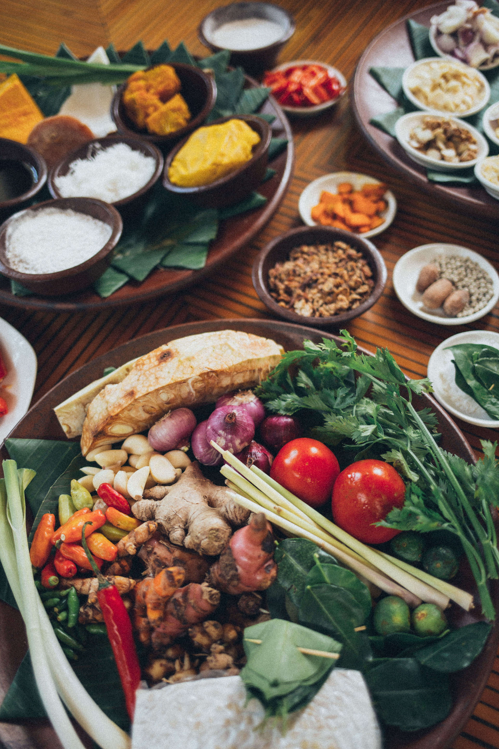

|  |
| --- |
| PupilExperiment |
| Vitamin C levelsin vegetables |
| Teacher/TechnicianGuide |

# Estimating the Vitamin C content of vegetables

## Background

Vitamin C is the compound ascorbic acid with the molecular formula C6H8O6.

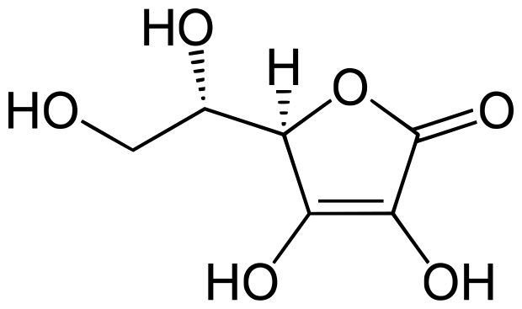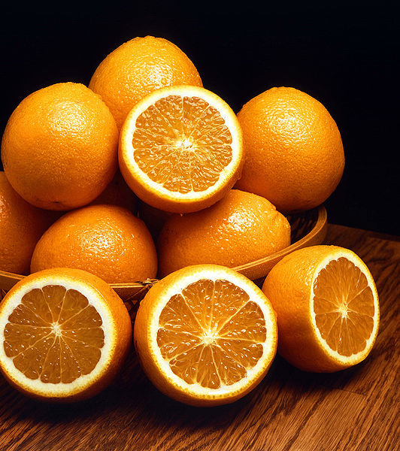

The body uses ascorbic acid when making collagen, a protein which helps skin, bone, hair and blood vessels stick together. Ascorbic acid also helps the body absorb iron.

We need to take in about 90 mg each day. We can store up to one month's supply of vitamin C, but no more.

As we cannot make it in the body, we need to keep a constant supply going.

Anyone under stress needs extra vitamin C, because the body will use it up more quickly than in a non-stressed state.

Smokers need more vitamin C, because smoking is a 'stress' on the body.

Lots of things are said about vitamin C, for example, taking large amounts is supposed to stop us getting colds and it may help us stop getting some types of cancer.

Ascorbic acid is found in many fruit juices and some vegetables such as broccoli and potatoes.

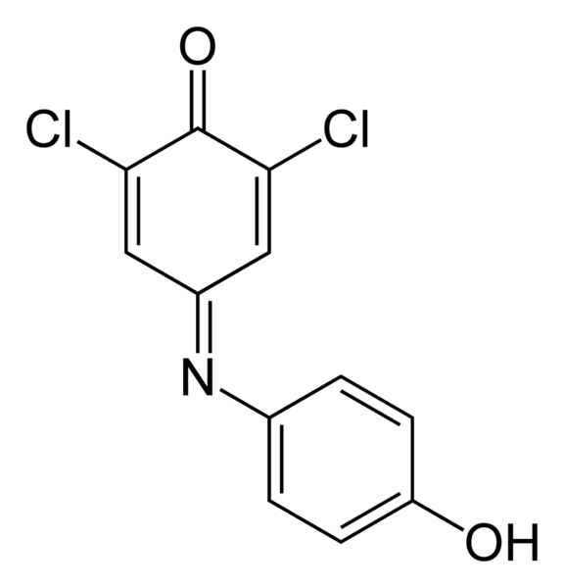

2,6-dichlorophenolindophenol (DCPIP) can be used to estimate the concentration of vitamin C in food.

DCPIP is blue when dissolved in water, is red in acid conditions, and is reduced by ascorbic acid (vitamin C) ) to a colourless compound. However, in this titration, the end point colour change will be from blue to pink due to the presence of the phosphoric(V) acid used to prepare the vegetable extract.

DCPIP should be treated as HARMFUL. (*See Risk Assessment*)

# Preparing the Solutions

All literature consulted for this experiment detailed standardising the DCPIP before the experiment using a solution of ascorbic acid. This is because the DCPIP will quickly deteriorate in solution and its concentration is needed for the calculation.

We found there was a difference in the titration for standardising the solution even between morning and afternoon, indicating the DCPIP concentration could indeed have been changing. However, ascorbic acid solution also deteriorates so this could have been a contributing factor to the DCPIP results being different. To standardise the DCPIP we recommend a fresh solution of the ascorbic acid be prepared each time.

1. Ensure a **fresh solution** of the indicator is prepared each morning or afternoon prior to doing the experiment.
2. When preparing **all** solutions (DCPIP, phosphoric(V) acid, and vegetable extracts), **it is vital that deionised water is used**. Distilled water still contains ions, and any copper (II) ions present will oxidise the ascorbic acid present leading to non-concordant titres being obtained from the vegetable extracts.

# For each group:

## Equipment

|  |  |
| --- | --- |
| Apparatus for titration, 25 cm3 pipette, 50 cm3 burette, 250 cm3 conical flask, pipette filler | Measuring cylinder, 500 cm3 and 250 cm3 |
| Beaker, 250 cm3 | Liquidiser |
| Filter funnel | Muslin for filtration |
| Vegetables to test, 100 g | A 5% phosphoric(V) acid solution prepared using deionised water |
| A solution of 2,6-dichlorophenolindophenol sodium salt (DCPIP) prepared using deionised water. HARMFUL |  |

## Instructions

1. Accurately weigh out approximately 0.4 g of the sodium salt (Mol. Wt. 290.08 g)
2. dissolve it in 1 litre of solution.
3. Accurately calculate its concentration.
4. This concentration must be made available to students for their calculations.

## Preparing the Vegetables

1. Accurately weigh out about 50 g of your vegetable and put it in a liquidiser with 250 cm3 of 5.0% phosphoric(V) acid.
2. Ensure the lid is securely fitted and liquidise at high speed.

*(The purpose of the 5% phosphoric(V) acid solution is to provide acid conditions to inactivate the enzyme ascorbic acid oxidase and to extract the ascorbic acid from the food).*

1. Filter off using a muslin filter.
2. Make up the volume of extract plus washings to 300 cm3 with deionised (**not distilled**) water.

This experiment can be repeated on cooked vegetables (10 mins cooking) and the effect of cooking on the amount of vitamin C in the vegetable can be determined. It can also be carried out on frozen or canned vegetables and the amount of vitamin C present calculated.

Cooked or frozen vegetables will have less vitamin C than fresh ones.

Samples of vegetables processed in these ways can be made available to students for them to calculate their vitamin C content, or they can be asked to prepare them.

There are various methods of cooking vegetables which affect Vitamin C content. The following should be taken into account

* Since vitamin C is water-soluble it is readily leached out. Washing and boiling considerably reduce the vitamin C content.
* Boiling in a large amount of water will increase the loss; steaming, on the other hand, will reduce the loss, unless it is carried out for a long time.
* The presence of the enzyme ascorbic acid oxidase will readily destroy the vitamin C. By putting vegetables in small amounts of hot water, the enzyme is destroyed before it can have any effect.
* On the other hand, if vegetables are put in cold water and brought to the boil slowly, or if the water is cooled by putting a large amount of cold vegetables in the hot water, the enzyme can destroy a large proportion of the vitamin C before the enzyme itself is destroyed.
* If vegetables are put in briskly boiling water, although a large proportion of the vitamin C will be leached out, very little will be destroyed.
* The minimum quantity of water should be used in cooking vegetables so that large amounts of vitamin C are not dissolved. This is very important with vegetables such as cabbage, which have a large surface area from which the vitamin can be lost. With potatoes, which have a smaller surface area, and in which gelatinisation of the starch prevents the diffusion and the subsequent loss of vitamin C, cooking has a much smaller effect on the vitamin C lost.
* Cooked vegetables should not be kept hot for long periods before being eaten, because this can destroy a large proportion of the vitamin C. It has been found that approximately 25% of the vitamin C of cooked vegetables is lost on keeping hot for 15 minutes, and 75% on keeping hot for 90 minutes.

Specimen results for fresh vegetables**:**

The Savoy Cabbage and the parsley supernatant were dark green in colour making end points difficult to see. A second filtration of the supernatant once settled after the muslin treatment may help?

The vegetables marked * had light colour supernatant and the end point was easier to see.

The end point was taken when pink colour persisted for 30s.

|  |  |  |
| --- | --- | --- |
| Name of Vegetable | Average DCPIP titre | Concentration of Vitamin C  (mg/100 g) |
| Cauliflower* | 5.60 cm3 | 32.64 |
| Brussels Sprouts * | 11.30 cm3 | 65.87 |
| Parsley | 18.65 cm3 | 108.71 |
| Potato * | 2.70 cm3 | 15.74 |
| Savoy Cabbage | 16.35 cm3 | 95.30 |
| Green Pepper * | 12.35 cm3 | 71.99 |
| White Cabbage * | 8.70 cm3 | 50.71 |

**Percentage of ascorbic acid lost in cooking**

Brussels sprouts 25–50%

Cabbage 40–60%

Cauliflower 25–40%

Potatoes 15–30%