Measurement of the permittivity of free space (ε_{o})
Using an EHT supply
This method is straight forward but requires a coulomb meter to measure the charge transferred to the plate.

Figure 1
Apparatus
Coulomb meter, variable voltage EHT supply, voltmeter, a screened lead for the flying lead that is connected to the coulomb meter, aluminium foil, capacitor plates (two 21 cm square sheets of aluminium 2 mm thick) with millimetre spacers, and a micro ammeter.
Method
Connect up the circuit shown in figure 1. The capacitor plates must be separated by an insulator. If the permittivity of free space is being measured then air is the insulator. The plates are separated by 1cm² pieces of plastic or paper. There must be a common earth connection that connects the earth of the EHT supply to the 0 V capacitor plate and the earth of the coulomb meter. To connect to the bottom capacitor plate to the earth of the EHT supply take a 10cm square of aluminium foil and fold it to give a strip ~ 1cm width. Place 4cm of one end of the aluminium strip under the bottom capacitor plate. The extra thickness ensures a good connection.
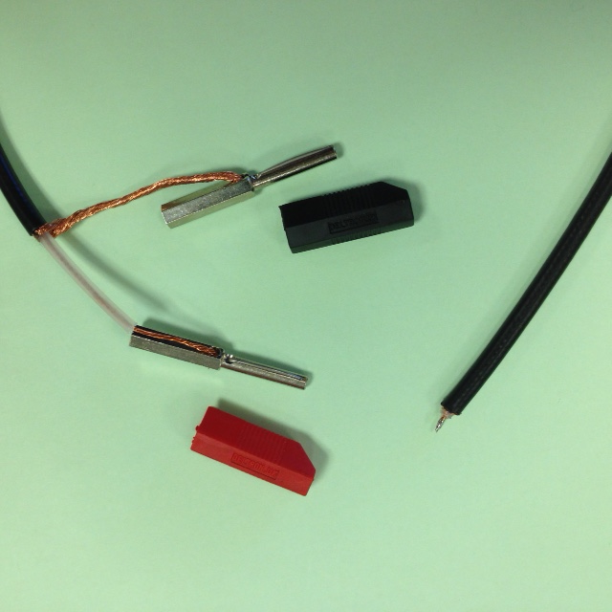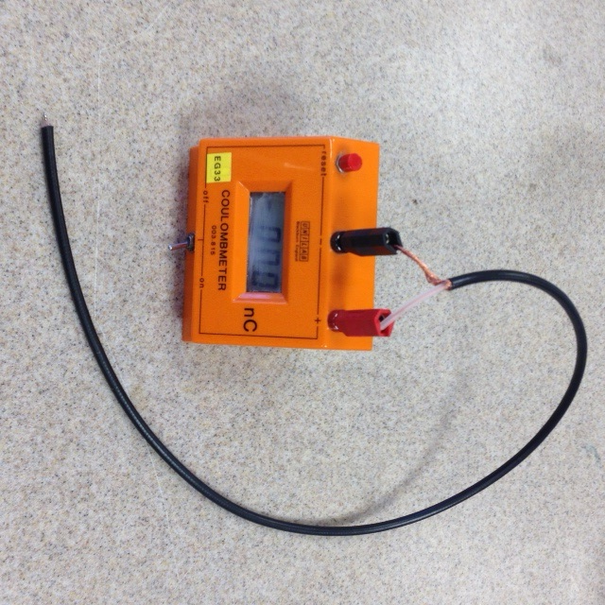The flying lead is easily constructed from a piece of coaxial cable. One end of the coaxial cable is bared so the inner wire core can touch the top capacitor plate to make a connection, see figure 1. The other end of the coaxial cable is adapted so it can be connected to the coulomb meter. The outer shield must make a good connection to the earth of the coulomb meter. The inner wire must make a good connection to the positive side of the coulomb meter, see figure 2.
Figure 2
Figure 1

An EHT supply must be used for safety. Connect up the circuit as indicated in figure 1.

Theory
ε_{o}A
Q
C = =
d
V

C capacitance of capacitor
Q charge on plates
V potential difference across plates
A area of overlap of the capacitor plates
d separation between the capacitor plates
This relationship enables many straight forward investigations.
- ε_{o} can be measured. Connect up the circuit. Adjust the voltage of the EHT supply to 20V. Touch the top plate of the capacitor with the flying lead attached to the EHT supply and remove it from the plate.
Next take the screened flying lead attached to the coulomb meter. Touch the top plate with the screened wire in the flying lead. Record the reading on the coulomb meter. Repeat for the experiment for a range of voltage values. Plot a suitable graph that will enable the capacitance of the capacitor to be calculated. Knowing the area of a plate and the plate separation the only unknown in the equation is ε_{o.}
- The relationship between the separation of the capacitor plates and the value of the capacitance can be investigated by first placing one spacer between the capacitor plates and calculating the capacitance. It is advisable to apply a range of potential differences across the capacitor plates using an EHT supply and record the charge on the plates as described previously so a suitable graph can be plotted from which the value of the capacitance can be calculated. The experiment can then be repeated with two spacers between the plates, then three and finally four spacers between the plates.
- The relationship between the area of overlap of the capacitor plates can be investigated. The same experimental set up is used. The area of overlap of the plates is changed keeping the distance between the plates the same. The capacitance for each area of overlap is found by plotting a graph of charge on the plates against the potential difference across the plates as before.

