Measurement of the permittivity of free space (ε_{o})
Using a reed switch
This method is straight forward but requires a single pole double throw reed switch. The reed switch is available from Philip Harris¹ for £19.99 while stocks last.
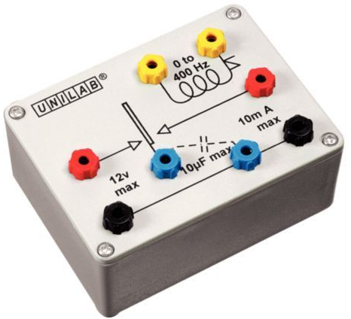

Figure 1

Apparatus
Reed switch, variable voltage low voltage supply, voltmeter, signal generator, capacitor plates (two 21 cm square sheets of aluminium 2 mm thick) with spacers, and a micro ammeter.
Method
Connect up the circuit shown in figure 1. The capacitor plates must be separated by an insulator. If the permittivity of free space is being measured then air is the insulator. The plates are separated by 1cm² pieces of business card. This ensures the capacitance is large enough to give a measurable current.
Before switching on the power supply check the reed switch is working, you can hear it vibrating. Connect the reed switch to the signal generator and set the frequency to 300Hz. Increase the output voltage of the signal generator till the reed switch starts to vibrate. You can hear this provided the room is quiet enough. Change the potential difference across the capacitor from 0.0 V to 12.0 V and for each value of the potential difference record the current on the ammeter. For a range of 0.0 V to 9.0 V the current is in the range 0.0 to 0.6 μA. To avoid over heating the reed switch do not leave it running for too long.
Current is the rate of flow of charge: current (I) = charge (Q)/time (t). Every time the reed switch touches the voltage supply (1), see figure 1, charge is transferred to the capacitor plate. Every time the reed switch touches the other pole (2), see figure 1, of the double pole single throw reed switch the capacitor discharges. The discharge current is measured using a digital multimeter set to micro amperes. The amount of charge transferred is given by Q = I x t, where t = 1/frequency of the signal generator (f).
I=Q/t = Q x f
Rearranging this formula gives Q = I/f so Q can be calculated and the pd across the plates measured. A graph can then be plotted of charge against potential difference and the gradient gives the capacitance of the capacitor since C =Q/V.
Care must be taken
1 http://www.philipharris.co.uk/products/physics/electricity- magnetism/electrostatics/b8r01326_reed-switch checked 19.05.17

