Broom stick moments of inertia experiment
The moment of inertia of a rod about three axes, its geometric centre see figure 1, an end see figure 2 and about its central long axis see figure 3.
L
L
l
d

Figure 2
Figure 1
*
s
Figure 4
h

Figure 3

Apparatus required
One broom stick cut two lengths of 0.6m, (L), strong thread, a stop watch, a knitting needle or thin rod for a pivot, a cork to cover the end of the knitting needle, and a ramp about 0.75m long and 0.5m in width if no BeeSpi v, with a BeeSpi v make a cardboard ramp and mount the BeeSpi v at its base, 4 lengths doweling of different diameters that can be cut to required lengths so the mass of each rod is the same.

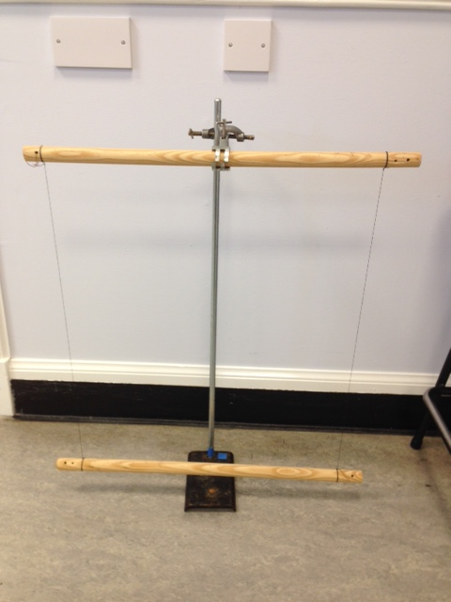
- Finding the moment of inertia of a rod about its centre
Suspend one length of broom stick 50 cm under the other lengths of broom stick with the points of suspension 0.55m apart, 0.275m each side from the centre of the rod, see figure 5. Set the bottom piece of broom stick oscillating about its centre of mass in the vertical plane, see figure 1, and time a sufficient number of oscillations so the error in the timing is acceptable. Move the points of suspension 0.05m closer together, 0.25m on each side, on both the top and the bottom rod and repeat the experiment until the separation is 0.35m.
Figure 5
Theory
It can be shown that the period of oscillation of the rod is related to the length of the vertical suspension threads (l) and the separation of the vertical threads (d).
d
θ
Mg
Figure 6
φ
l

A section of the broom stick having a mass (M) and moment of inertia I is suspended by two fine lengths of string of length (l) from another section of broom stick, see figure 6. The strings are parallel and a distance (d) apart. The tension in each string is Mg/2.
When the bottom broom stick is rotated in the horizontal plane through a small angle (θ) about its centre of mass, the end of each string supporting the bottom rod draws out an arc of length lΦ, where Φ is the angle the string moves through. Since both angles are small:
lΦ = θ(d/2) (i)
The restoring force is given by the component of the tension restoring the rod to its equilibrium position, which since the angles are small is given by:
(Mg/2)Φ substituting for Φ using equation (i) the restoring force becomes: Mgdθ/4l
The turning force acting on each end of the rod gives rise to a restoring turning force given
by: (Mgdθ/4l)d
..
The equation of motion for the rod is therefore Iθ = (Mgd²/4l)θ
The motion is simple harmonic motion giving the period of oscillation T = 2π√(4Il/(Mgd²)
The moment of inertia of the broom stick can found by plotting a graph, finding the gradient and substituting in the known values. The value calculated can then be compared with the theoretical value.
In theory I = 1/12(ML²)
A typical set of results is shown below.

- Verifying the formula for the moment of inertia of a rod about one end

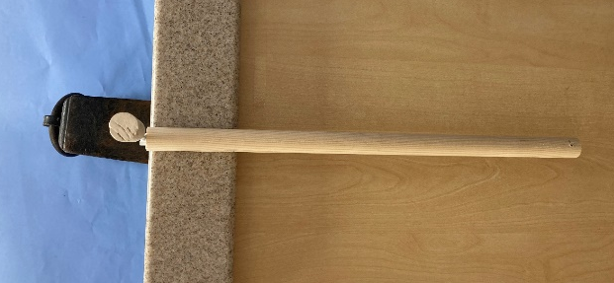

Figure 7
Figure 8

To investigate the moment of inertia of a thin rod about one end the mass of the rod must be kept constant. Get doweling of different diameters, for example 12mm, 14mm, 16mm 18mm and a length of broom stick. Cut them to lengths that give rods of the same mass. Fix a 4mm round cable clip into the end of each piece of doweling and the piece of broom stick so the centre of the cable clip is at the centre of the rod end, see figure 7.
Push a knitting needle through the cable clip and push pointed end of the knitting needle into a cork to avoid anyone being injured. Hold the knitting needle in place with a mass. Check the rod oscillates freely, see figure 8.
Theory
L/2
θ

Figure 9
Mg

For a uniform rod, the centre of mass is at its geometric centre. The restoring force for small angular displacements is given by mgθ. See figure 9 for definition of length and angles.
..
The equation of motion is therefore Iθ = turning force Mgθ(L/2)
..
Rearranging gives: θ = Mg(L/2) θ indicating the motion is simple harmonic motion.
I

The period of oscillation is therefore given by: T = 2π√I/Mg(L/2).
The moment of inertia for a rod about one end is: I =⅓ML².
Substituting for I gives: T = 2π√(⅓ML²)/ Mg(L/2) = 2π√⅓(2L/g).
The moment of inertia of a broomstick about one end can be verified by measuring the period of oscillation of the pendulum for the different lengths of rod and plotting a graph of T² against L. The value of g can also be calculated to give added verification of the relationship.

- Finding the moment of inertia of a rod about its the central axis parallel to its length
s
h
Figure 10

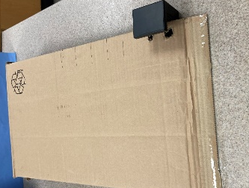

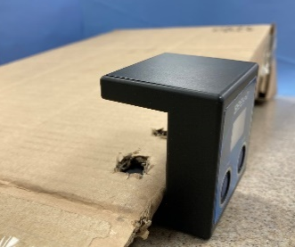

Figure 11

A piece of wood about 0.6 m long and 0.4 m wide is needed to form a ramp. The broom stick must roll down the ramp without sliding. With the ramp set to a height of 3.0 cm release the rod from the top of the ramp, see figure 10, and record the time the time taken for it to reach the bottom of the ramp. Repeat for a range of different heights. If a BeeSpi v is available, mount it at the bottom of a cardboard ramp and cut holes for the light gates, see figure 11. The rod can be released from different heights up the ramp and the speed of the rod at the bottom of the ramp can be measured. It works well with a length of 14mm doweling.
Theory
The rod of mass (M) has gravitational potential energy at the top of the ramp. As the rod rolls down the ramp with a linear speed v and an angular velocity (ω) its gravitational potential energy is transferred to both rotational and translational kinetic energy.
Mgh = ½Mv² + Iω² remembering v = ωr this can be written as:
Mgh = ½Mv² + ½I(v/r)².
If a BeeSpi v is used the equation can be rearranged to give:
h =(M + $\frac{I}{r2}$) $\frac{v2}{2Mg}$.
A straight line graph can be obtained by plotting h against v².

The moment of inertia of the rod can be determined from the gradient of the graph if other known values are substituted into the equation. This value can be compared to the theoretical value of ½Mr².
If measurement of the time to roll down the slope is the method used more analysis is needed to find the speed at the bottom of the slope.
Remembering for uniformly accelerated motion the average speed (v/2) = s/t
Mgh = ½M(2s/t)² + ½I(2s/tr)²
Mgh = 2s²/t² (M +I/r²)
The moment of Inertia of the broom stick about its central axis can be found. This can be compared with the calculated value.
If the experiment was to measure ‘g’ then substituting for I, I = ½Mr², gives:
Mgh = (2s²/t²)(M + ½M) = 3Ms²/t²
gh = 3s²/t².
A graph can be plotted of t² against 1/h and the value of g calculated to verify the relationship.
A typical set of results is shown below.

