Moment of inertia experiment
Apparatus
Retort stand, boss and clamp, half metre stick, 2.0 m cotton thread, 2 circles of thin corrugated card 0.1 m diameter made from a packaging box with a mass of ~ 4 g, Sellotape, protractor, a supply of identical 1p coins and a stopwatch.

Cardboard discs

one pence coins

Figure 1

Method
Cut circular discs 10cm in diameter from the card. Mark the centre of the disc and draw in lines radiating from the centre at 120° intervals. Along each line mark off 0.5 cm intervals, this makes the positioning of the coins very straight forward. Record the mass of the oscillating disc and the masses of the coins.
Set up the apparatus as shown in figure 1 with the threads each 0.5m in length checking the discs are horizontal. It might be necessary to use two retort stands to ensure the discs are horizontal. The mass of the disc should be about 4 g and is about the same as the mass of each coin 3.5 g.
Timing must be precise. To reduce the error to an acceptable amount a sufficient number of oscillations must be timed.

Theory
The moment of inertia of a uniform disc of mass (m_{disc}) and radius (r) about its centre is given by:
I_{disc} = ½m_{disc}r² Consider the set up when coins are placed at 120° intervals at a distance x from the centre of the cardboard disc the moment of inertia of each coin about the axis of rotation is:
I_{coin} = m_{coin} x²
The lower disc is given a twist and released. A restoring turning effect, called a couple, acts on the lower disc and as a result the disc is set into oscillation.
Restoring turning effect = I(d²θ/dt²)
I(d²θ/dt²) = - c θ where c is the couple per unit angular displacement.
(d²θ/dt²) = - (c/I)θ This result indicates the oscillation is simple harmonic motion as the angular acceleration is directly proportional to the angular displacement and in the opposite to the displacement.
The period of the oscillation can be deduced since:
angular acceleration = -ω²angular displacement, giving ω² = (c/I).
Remembering ω = 2π/T, an expression for the period can be found.
T= 2π
T= 2πMr² +3mx²)/c
T² = 4π²(Mr² +3mx²)/c (1)
Looking at the final equation:
- 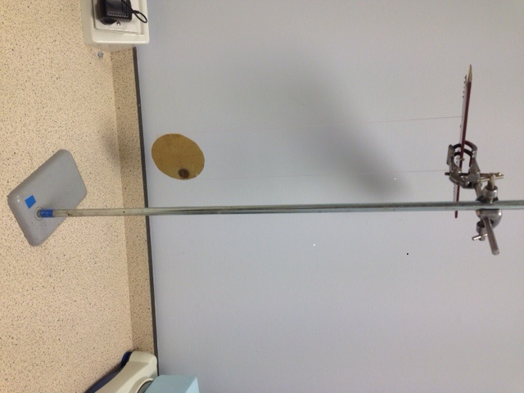The axis about which the disc rotates could be changed to the diameter of the disc by suspending the disc vertically with two coins one on either side, see figure 2, this ensures the disc is suspended in the vertical plane when supported by the two strings.

Figure 2

- The relationship between the period of oscillation and the distance the coins are from the axis of rotation (x) could be investigated as indicated by the method given.
- The relationship between the period of oscillation and mass of coins (m) a fixed distance from the axis of rotation (x) could be investigated. This could be done by piling coins on top of each other. It works well with two coins placed one on top of the other.
To check your results, find the gradient and the intercept for the line of best fit. Looking at equation 1 you can theoretically work out a relationship between the gradient and the intercept and then compare it with your experimental results.

