Measurement of the wavelength of light in water using a diffraction grating
Apparatus:
A rectangular plastic container such as a transparent storage box about 35cm by 55cm if using the photonics explorer diffraction grating, a diffraction grating, a laser and water.
Method
Figure 1
Diffraction grating

Glass rod
laser

Attach the grating to the outside of the plastic container so it is half above and half below the water surface, see figure 1. Place a glass rod horizontally in the path of the laser beam, this causes the laser beam to form a vertical line. Direct the laser so the line of laser light is half above and half below the water and normal to the diffraction grating.
Place a sheet of white paper along the opposite side of the box, this is the screen on which the position of the zero and first order positions can be marked, see figure 2.
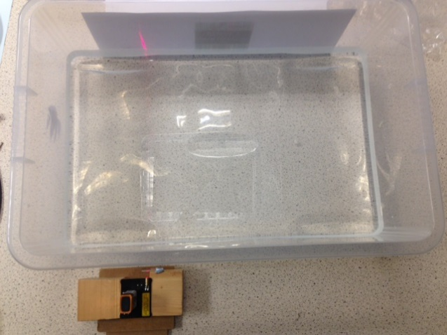

Figure 2

The line of laser light splits into two parts as a result of the section above the water being diffracted through a larger angle than the section below the water, see figure 3. This results from the fact that light travels slower in water than in air. The room will need to be darkened to see the diffracted light.

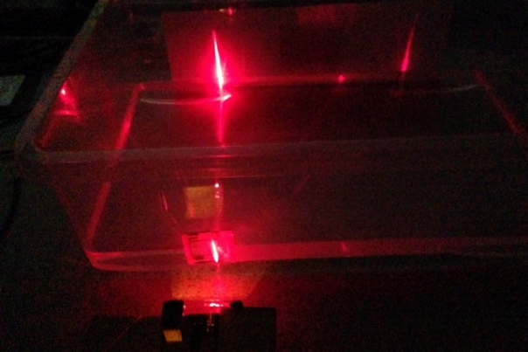

Figure 3

The photonic explorer grating will enable the first order diffraction line to be seen on the screen and its position is significantly different in water compared to air.
Theory
nλ = d Sinθ for light normally incident on a diffraction grating.
n is the order 0,1,2,3 etc,
λ is the wavelength of the light,
d is the grating spacing and
θ is the angle the light is diffracted at.
n_{water} sin θ_{water} = n_{air} sin θ_{air}
remembering λ_{water}/ λ_{air} = n_{air}/n_{water}
This gives sin θ_{water}/ sin θ_{air} = n_{air}/n_{water} = λ_{water}/ λ_{air}
This enables the refractive index of water and the wavelength of the light in water to be found.
Typical results:
Width of storage box = 35.0 ±0.1 cm
Distance from zero order to first order in water = 19.5 ±0.1 cm
Distance from zero order to first order in water = 29.5 ±0.1 cm
tan θ_{water} =19.5/35.0
tan θ_{air} = 30.7/35.0
n _{water} = sin θ_{air}/ sin θ_{water} = 1.32 ± 0.01
It is good practice to plot a graph and this could be done by placing a white plastic ruler in the tank at different distances from the grating and parallel to the grating as this would give more data points. When doing this experiment with a plastic storage box check its width at the water’s surface. Some boxes change width by 2 cm.

