Determining the Vitamin C concentration in Citrus Fruits
Aim: To compare the vitamin C concentration of citrus fruits

Introduction
In this experiment, samples of juice (containing vitamin C or ascorbic acid) are added to a conical flask containing a small volume of starch suspension (“starch indicator”). In this protocol, vitamin C is referred to as ascorbic acid, relating to the following reaction:

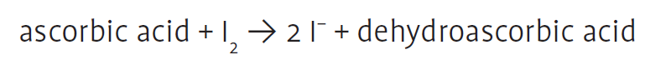

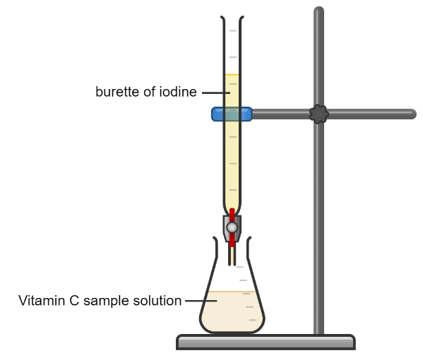
As iodine is titrated into the juice sample, the ascorbic acid is oxidised to form dehydroascorbic acid, while the iodine is reduced to iodide ions. As long as ascorbic acid is present, the iodine will be reduced.

Once all the ascorbic acid has been oxidised, the excess iodine reacts with the starch indicator, resulting in a blue-black colour indicating the end-point of the titration. The volume of iodine required to achieve the end-point is recorded as the titre, which can be related to ascorbic acid concentration.

To relate the titre to ascorbic acid concentration, a standard curve must be produced first. For the standard curve, iodine is titrated into a sample of ascorbic acid of known concentration. The titres are used to produce a standard curve. This standard curve can then be used to determine the ascorbic acid concentration in each juice sample tested.

Health & Safety
There are no significant health and safety concerns related to this protocol. The concentration of iodine used presents no significant risks, but care should be taken to avoid skin contact.

It is important to recognise if any person working around the juices has an allergy to the fruits involved, e.g. some people can be sensitive to pineapple and kiwi juice.

Step 1: Performing the titration to produce a standard curve
Materials:

Standard solutions of ascorbic acid (0.1, 0.3, 0.5, 0.7, 1 mg/ml) | Burette
Distilled water | 0.5% starch indicator solution
0.005 mol / L iodine solution | 1 cm³ pipette
10 cm³ and 25 cm³ measuring cylinders

Method
- Fill the burette until the iodine reaches the 0 cm³ mark.

- To a 100 cm³ conical flask, add 1 cm³ starch solution using a 1 cm³ pipette.

- To the same flask, use a 10 cm³ measuring cylinder to add 10 cm³ of the lowest concentration of ascorbic acid.

- To the same flask, use a 25 cm³ measuring cylinder to add 25 cm³ distilled water.

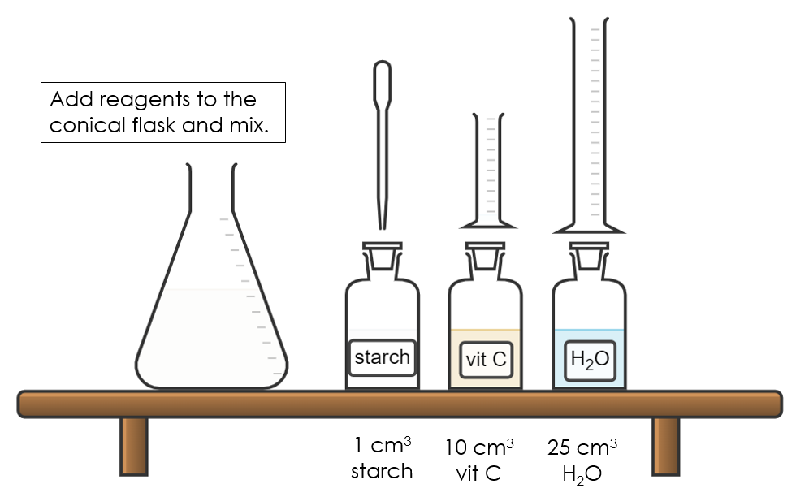
Add the reagents to the conical flask for the standard curve.

- Place the flask under the burette and very slowly titrate the iodine solution into the sample flask. Swirl after each small addition.

- The endpoint is marked by a persistent blue-black colour that does not disappear when the flask is swirled.

- Note down the titre.

- Repeat two further times (and calculate an average) OR until concordant results are achieved. For AH Biology, titration is not a required technique so it is not necessary to perform the titration to achieve concordant results – however, it should be noted that this would be the prescribed method in AH Chemistry.

- Repeat the procedure for the remaining standard solutions of ascorbic acid, working from the lowest to the highest concentration.

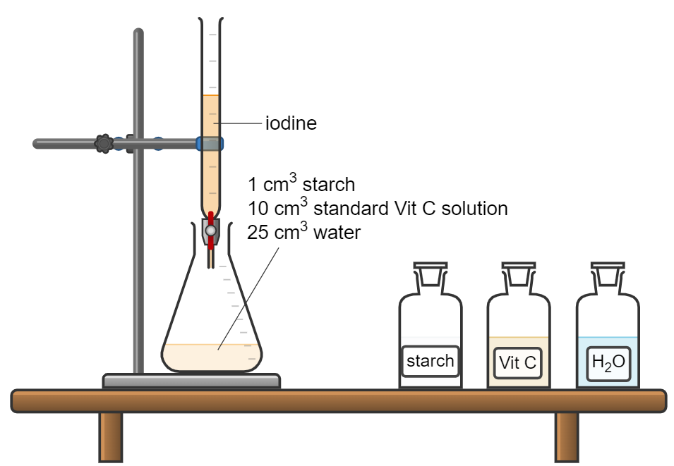
Titration of standard vitamin C solutions.

- Plot your data and note the equation of the best fit line. This is your standard curve. The standard curve will be used at the end of the protocol to estimate the concentration of vitamin C in each fruit juice.

Concentration of vitamin C standard (mg/ml) | Titre (cm³)
 | 1 | 2 | 3 | Average
0.1
0.3
0.5
0.7
1

Step 2: Preparing the fruit juices
Materials:
Juice squeezer | Variety of fruits
Muslin cloth | Beakers to store juice

Notes:
- Consider the colour of the fruit as the colour of the juice will affect your ability to determine the endpoint of the titration – lighter juices are better, e.g. lemon, lime, pineapple.
- You will need ~ 35 cm³ of juice to perform 3 titrations of each juice.

Method
- Squeeze the juice from each type of fruit.

- Pass the fruit through a piece of muslin cloth.

- Collect juice in a beaker and store at room temperature until required.

Step 3: Performing the titration of unknown samples
Materials:
Juices from Step 2 | 0.005 mol / L iodine solution
Burette | 1 cm³ pipette
Distilled water | 10 cm³ and 25 cm³ measuring cylinders
0.5% starch indicator solution

Method
- Run iodine solution through the length of the burette. Re-fill the burette until the iodine reaches the 0 cm³ mark.

- To a 100 cm³ conical flask, add 1 cm³ starch solution using a 1 cm³ pipette.

- To the same flask, use a 10 cm³ measuring cylinder to add 10 cm³ of one fruit juice.

- To the same flask, use a 25 cm³ measuring cylinder to add 25 cm³ distilled water.

- Place the flask under the burette and very slowly titrate the iodine solution into the sample flask. Swirl after each small addition.

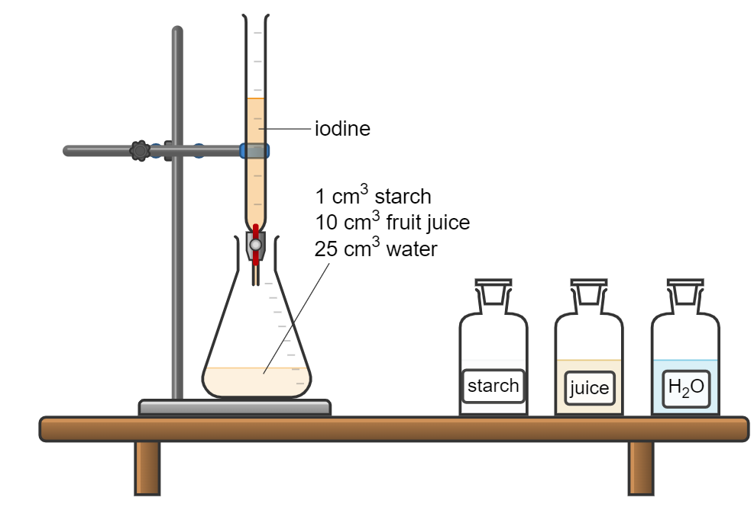
Titrate iodine into juice samples.

- The endpoint is marked by a persistent blue-black colour that does not disappear when the flask is swirled.

- Note down the titre.

- Repeat two further times (and calculate an average) OR until concordant results are achieved.

- Use your standard curve or the equation of the line to determine the concentration of vitamin C in the fruit juice.

- Repeat the process for the remaining juices.

Results

Fruit | Titre (cm³)
 | 1 | 2 | 3 | Average
Lime
Lemon
Orange
Pineapple

Vitamin C Concentration
Equation of line: ________________________

Fruit | Average Titre (cm³) | Vitamin C concentration (mg/ml)
Lime
Lemon
Orange
Pineapple

