Measurement of the refractive index of a liquid using an air cell
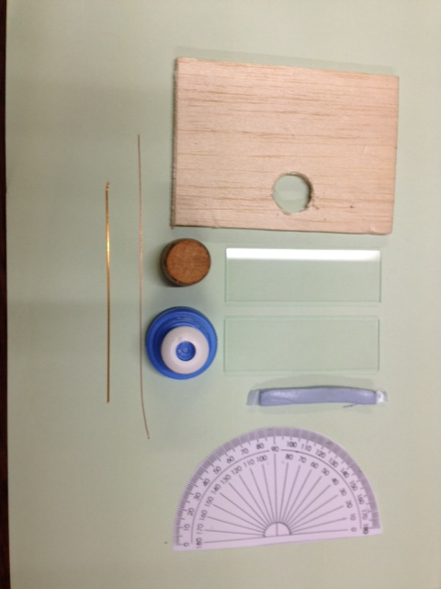

Figure 1

Apparatus: Cork, bottle top (see figure 1), 0.20 m of 26 swg wire, 0.20 m 22 swg wire,
Blu-tack or similar, 2 glass microscope slides, drawing pin, photocopy of a protractor, a piece of balsa wood and a cork borer.
How to make and mount the air cell
- Take the bottle top, pull the white section up and cut off the white circle at the top leaving a white ring, see figure 2.
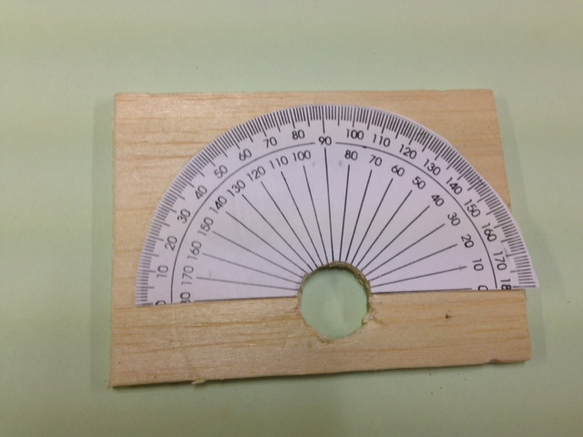

Figure 2
Figure 3

- Place the paper protractor on the balsa wood so the flat side is 2.0 cm from the edge of the balsa wood, see figure 3.
- Cut a hole in the balsa wood, using a cork borer of the right size, so the white ring on the bottle top is firmly held in position.
- Glue the paper protractor to the balsa wood taking care that it is positioned so the centre of the protractor is at the centre of the hole. Cut away the paper over the hole.

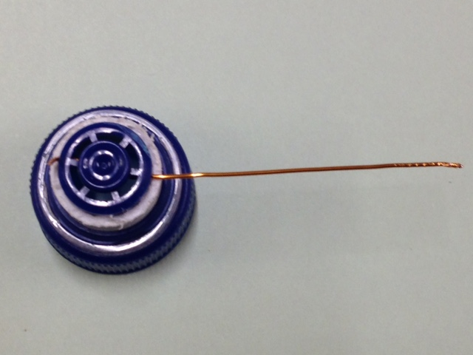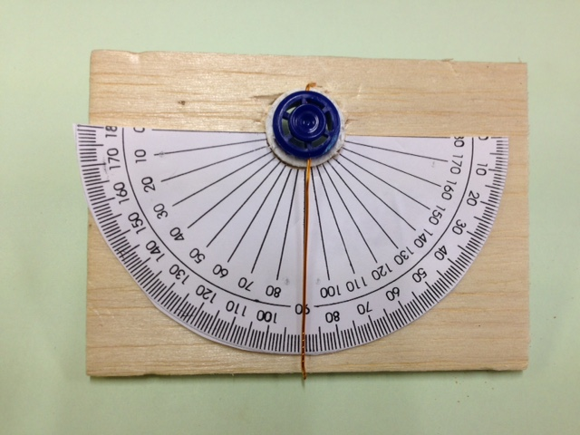

Figure 4

Figure 5

- Using the drawing pin make a hole in the blue part of the bottle top just above the white collar. Make a second hole directly opposite this hole. Thread the thick wire through both holes, making sure the wire passes through the centre of the circle so the pointer will rotate about the centre of the protractor, see figure 4. Make sure there is sufficient wire to fix it firmly in position.
- Carefully thread the pointer through the hole and glue the outer side of the white collar in position with PVA glue. The pointer should be at 90° to the air cell surface so set it at 90°, see figure 5.
- Place a microscope slide on the bench and form a rectangle of the 26 gauge wire. Make sure the wire does not overlap as this wire forms the spacer.
- Roll the Blu-tack out into a long thin tube. Place the Blu-tack well away from the wire, close to the edge of the slide and form a continuous rectangle with it, see figure 6.

Figure 7
Figure 6

- Place the second microscope slide on top of the Blu-tack and firmly squash the two slides together. Make sure no Blu-tack overlaps the wire as the wire thickness must be the width of the air gap, see figure 7. This is an air cell.
- Take a cork and check it fits firmly into the bottom of the blue part of the bottle top.
- Cut a slot about 0.5 cm deep in the cork making it wide enough to hold the air cell firmly in place, see figure 8.

Figure 8
Figure 9

- Push the cork firmly into the bottom of the bottle top. Push the air cell firmly into the slot in the cork and adjust its position so the air cell is at 90° to the pointer, see figure 9.
- Place Blu-tack on the rim of the beaker to hold the balsa wood in position. Make sure any marking on the beaker are not on the side facing the light source, see figure 10.
- Pour the liquid, the refractive index of which is required, into the beaker so that it covers at least half of the air cell.
- Position the balsa wood on top of the beaker and then when correctly positioned push firmly down to fix its position.
- Direct a monochromatic light source at 90° to the air cell. Check the beam reflects back along the same path to ensure correct alignment, see figure 11. If a LASER such as the photonics kit LASER is used the laser safety code must be adhered to. Please read: http://www.sserc.org.uk/physics/health-a-safety-home139/optical-radiation-safe-use240/control-meas-a-guidance234
- 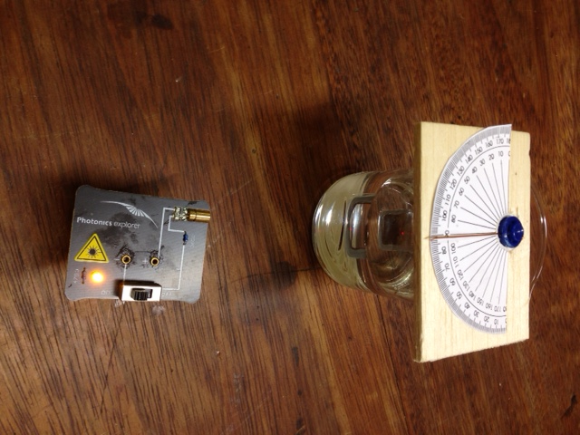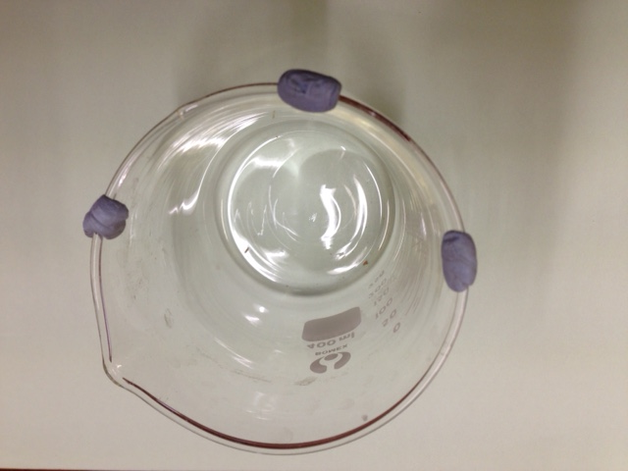Carefully rotate the pointer until the straight through beam disappears. Record the angle turned through. Knowledge of this angle enables the refractive index to be calculated.
Figure 10

Figure 11

Theory

Rotate Air cell
Blu-tack

Monochromatic light source
i
r
Air cell

Enlarging the area where the
light is incident on the air cell
makes the analysis clearer.

i
r
r
air
water
glass

The air cell is rotated through an angle i.
At the water glass boundary, according to Snell’s law,
n_{water} Sin(i) = n_{glass}Sin(r), (1)
where n is the refractive index of the material, (i) is the angle of incidence and (r) is the angle of refraction.
At the glass air boundary, Snell’s law gives:
n_{glass} Sin(r) = n_{air}Sin(90°) = 1.0 (2)

Combining equations (1) and (2) gives the following relationship:
n_{water}Sin(i) = 1.0
n_{water} = 1/Sin(i)

It is best to plot a graph and this can be done if solutions of glycerol and water are used. Solutions of 100% glycerol, 75% glycerol, 50% glycerol, 25% glycerol and 0% glycerol can be used. Ensure the solutions are well mixed to give a uniform density. The refractive index of each solution is found using the air cell. Assuming a linear relationship between the concentration of glycerol and the refractive index of the solution a graph can be plotted. The intercept of the graph will give the refractive index of water.

