Using a Separating Funnel
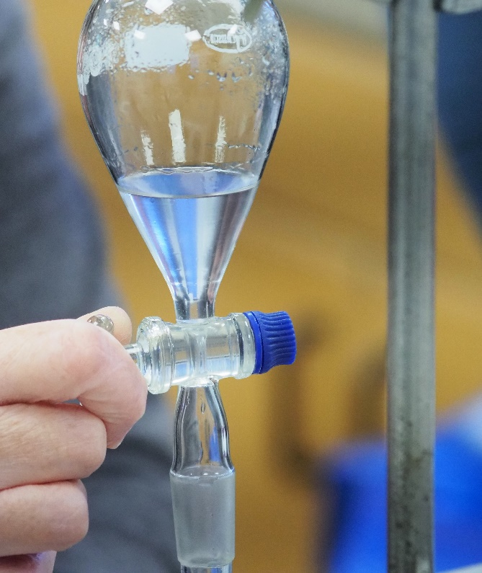
Introduction
Frequently, when synthesising or purifying organic compounds, you find yourself with a mixture of liquids that need to be separated. Assuming they are immiscible, you will find yourself with two layers. In principle, you simply decant off the top layer but this is harder to do in practice.
To make things easier, we use a separating funnel. This is a glass funnel with a tap on the bottom to control what runs out and a stopper at the top.
As is the case for pipettes and burettes, volumetric flasks are precision pieces of glassware. Grade ‘B’ is quite sufficient for school work.
Safety
There are no particular safety issues to do with the use of the funnels themselves. However, your solution may be hazardous. To determine the level of protection, and any other precautions, consult the appropriate entry in the Hazardous Chemicals Database.

Method
Preparation
It is important before you start to know which layer you want to keep. It is usually, though not always, just the one. If you don’t know already, you will need to consult a reference source to find the densities of the two liquids and you will also need to now which one has the materials you need.
A retort stand ring is a good idea to sit your separating funnel in but if you don’t have one, you can use a normal clamp-stand.
- Make sure the tap is closed before you pour anything in! Not only will it make a mess, (and possibly be hazardous) you might lose your hard-earned product!
Solvent extraction
Most commonly, you will use this apparatus to transfer a chemical from one layer to another. For instance, in the extraction of caffeine, you shake the aqueous solution with samples of the extraction solvent (commonly ethyl ethanoate)
This is usually done three times, with decreasing volumes of solvent. Eg 30 cm³ , then 20 cm³ then another 20 cm³
- Pour your liquid with the substance you want to extract into the separating funnel.
- Add your first sample of the extraction solvent.
- Put the stopper in the top of the separating funnel and take it out of the stand.
- Hold it firmly but carefully, with your fingers over the stopper to make sure it doesn’t work loose.
- Turn the funnel upside down, or on its side and swirl the contents to mix them. Do not shake them. If you do, it might cause an emulsion which means that the two layers will not separate.
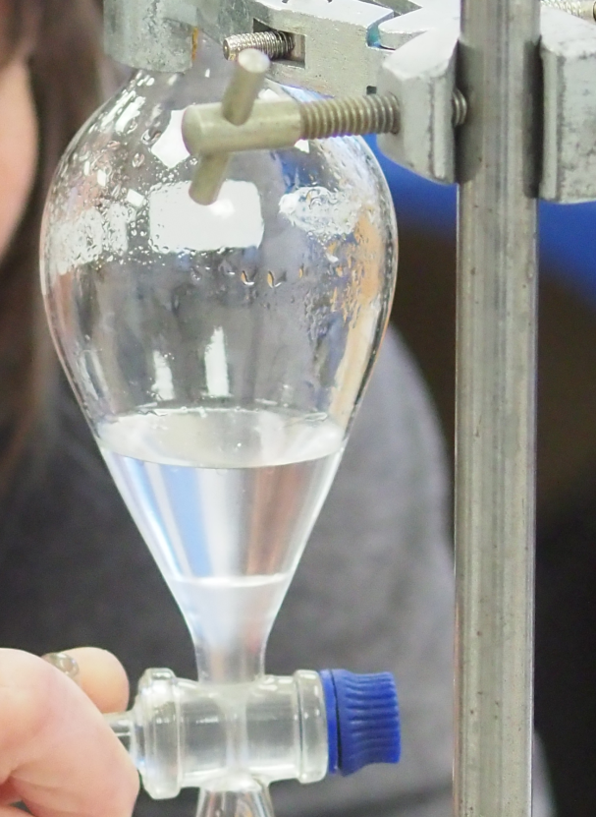
- While doing this, if you are using a volatile solvent, pressure can build up inside the separating funnel so from time to time open the tap briefly to release the pressure and then close it again.
- Once you have finished mixing it, 30s or so, put the funnel (right way up – tap down) in the clamp/ring again and leave it to allow the layers to separate.
- Once they have separated – you can see an example on the right – you need to separate the layers.
- In this case, the substance we need (the caffeine) is in the top layer.
- Place a small beaker underneath the separating funnel. Remove the stopper – otherwise nothing will flow out. And turn the tap to allow the bottom layer to fall into the beaker.
- As it gets nearer the tap, it will become easier to see the boundary. When you are close, slow down and add a drop at a time until you have just got all the bottom layer in the flask. It doesn’t matter if you let a little more through (some of the top layer) but make sure you don’t leave any of the bottom layer behind.
- Now put another clean beaker or flask under the funnel and let the top layer run out into that.
- Close the tap. Pour the bottom layer that you collected in the first beaker back into the funnel and add the second batch of extraction solvent.
- Repeat steps 4 – 13. You can mix the samples of the extraction solvent.
- Now repeat for a final time. This time you can dispose of the bottom layer.

