SCIENCE ORDERING SYSTEM
Initial Set up:
Make a new folder called “Technician Orders” on the workgroup. Then create a shortcut on the desktop of teachers and technicians PC’s using an IT admin account that points to the folder.
The Technician Orders folder set up:
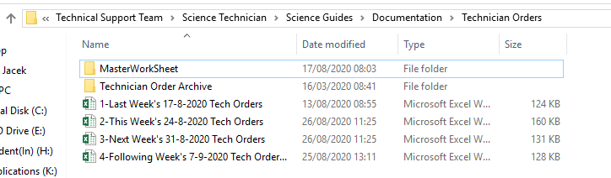
The top most subfolder is where the master spreadsheet is stored. The second subfolder is obviously the archive of previous spreadsheets and underneath are the current rotation of spreadsheets.
Every Monday morning file spreadsheet “1” into the Technician Order Archive folder then rename the remaining spreadsheets appropriately so “Next Week” becomes “This Week” etc.
Then Copy the Master from the “Master Worksheet folder and add it to the end of the rotation calling it “4-Following Week’s (Date of week beginning) Tech Orders”
The date at the top of each spreadsheets main page worksheet must also be changed.
This entire folder containing the spreadsheets can be uploaded to the technicians Onedrive via Glow and shared with the appropriate staff. Multiple staff members can work on the document at any time and this adds the flexibility of placing orders out with school hours. Glow log in details will be required to change/submit orders.

Working with the Spreadsheet:
Below is a view of the main page worksheet:
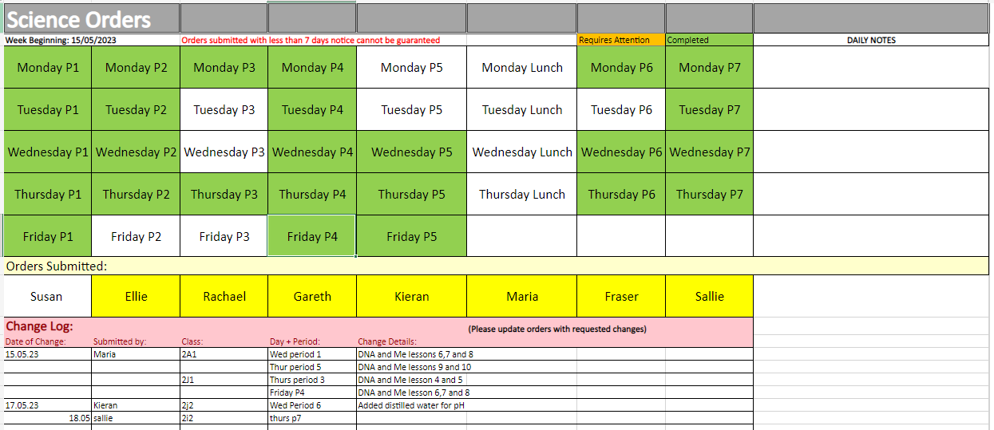
White cells = 0 orders Orange Cells = Attention required
Green Cells = Completed orders Yellow Cells = Teachers who have submitted orders
Teachers can access the period and room number by clicking on the period cell itself or by scrolling through the coloured worksheets at the bottom of the page.
Quick tip: The arrows highlighted in in the red box can be CTRL Left clicked to quickly bring you to the start/finish of the worksheet tabs. This is handy if you would like to navigate back to the main page quickly.
At the bottom of the spreadsheet is the Change Log. Teachers are asked to submit a change request here should their order change at any point or in the event of a late order being submitted. Please note the teacher must also update the order on the order worksheet not just submit a change in the changelog. The change log is only relevant for the week in which it is being filled in i.e. a change for this week should appear in this week’s change log only! In the example shown above, you can see Kieran has requested a change for his shared class with Maria this week already.
Below is a view of the order worksheet for Wednesday P1:
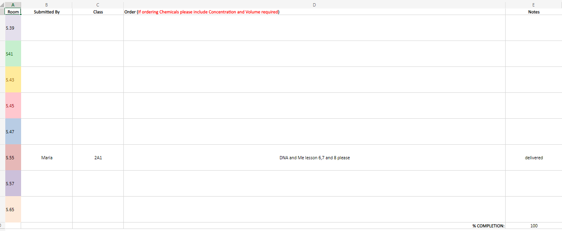
Submitting an order (Teachers):
1: Open “Technician Orders” shortcut on the desktop. (Or log into One drive via Glow to access the shared technicians folder)
2: Open spreadsheet for desired week e.g. “3-Next Week’s 31-8-2020 Tech Orders”
3: Click on desired period on the Main sheet or navigate to period worksheet using the tabs at the bottom.
Quick tip: The two little arrows in the bottom left can be CTRL Left clicked to quickly bring you to the start/finish of the worksheet tabs. This is handy if you would like to navigate back to the main page quickly.
4: Navigate to the room number for which you wish to place an order
5: Fill in your name in the “Submitted By” Column.
6: Fill in the “Class” for which you are submitting your order.
7: Fill in you order in the “Order” Column. Giving as much detail as possible i.e. number of sets required, volumes and concentrations of chemicals required.
8: Continue Submitting orders in this manner until finished.
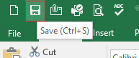
9: Save the worksheet and close.

(No saving necessary when using the glow one drive version of excel, Saving is automatic and should display “saved” in the top left hand corner of the spreadsheet as shown below. When entering text into your final cell it is important to either press ENTER or left click into another cell for data to be saved.)
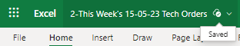
Important Note: Worksheet sharing is enabled so multiple staff can have the document open at the same time. When you save Excel will notify you if anyone has changed the worksheet recently. These changed cells will appear with a dark blue border.

Responding to orders (Technicians):
1: Open “Technician Orders” shortcut on the desktop. (Or log into One drive via Glow)
2: Open spreadsheet for desired week e.g. “3-Next Week’s 31-8-2020 Tech Orders”
3: On the Main page worksheet click any orange cells (these are cells that contain unfulfilled orders)
4: Complete the order.
5: Update the status of the order in the notes column e.g. Delivered/Delayed/Order will be delivered at the beginning of the period etc.
6: In the notes column also update the percentage completion to 100 if all orders are filled. This turns the period cells Green on the main page worksheet. It is good practice to leave a cell orange (denoting attention is required) until all hazardous chemicals/resources have been removed at the end of the period.
7: Save the worksheet and close.

(No saving necessary when using the glow one drive version of excel, Saving is automatic and should display “saved” in the top left hand corner of the spreadsheet as shown below. When entering text into your final cell it is important to either press ENTER or left click into another cell for data to be saved.)
Important Note: Worksheet sharing is enabled so multiple staff can have the document open at the same time. When you save Excel will notify you if anyone has changed the worksheet recently. These changed cells will appear with a dark blue border.

