NATIONAL QUALIFICATIONS CURRICULUM SUPPORT

Chemistry

Alcohol

Student’s Guide

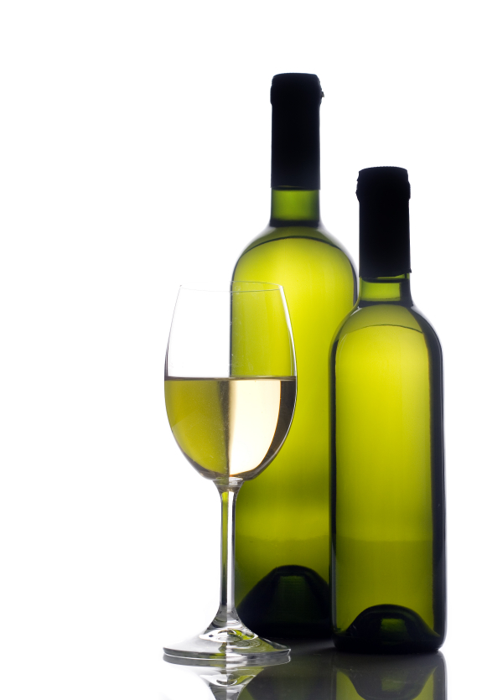[HIGHER]

The Scottish Qualifications Authority regularly reviews the arrangements for National Qualifications. Users of all NQ support materials, whether published by Learning and Teaching Scotland or others, are reminded that it is their responsibility to check that the support materials correspond to the requirements of the current arrangements.

Acknowledgement
Learning and Teaching Scotland gratefully acknowledges this contribution to the National Qualifications support programme for Chemistry.

The publisher gratefully acknowledges permission to use the following sources: image of alcopops from http://www.dailymail.co.uk/news/article-1259068/Supermarkets-push-cheap-deal-alcopops-drinks.html © Steve Stock/Alamy; image of woman drinking wine http://img.thesun.co.uk/multimedia/archive/00858/wine-drinker-280_858662a.jpg © Steve Hamblin/Alamy; image from http://fermentarium.com/lifestyle/recent-studies-lifestyle/does-sulfite-cause-red-wine-headaches © Fermentarium.

Every effort has been made to trace all the copyright holders but if any have been inadvertently overlooked, the publishers will be pleased to make the necessary arrangements at the first opportunity.

© Learning and Teaching Scotland 2011

This resource may be reproduced in whole or in part for educational purposes by educational establishments in Scotland provided that no profit accrues at any stage.

Contents

Investigation A 4

Investigation B 9

Investigation C 15

Investigation D 20

Investigation E 25

Investigation A

Do alcopops make you fat? How much sugar is in an alcopop?

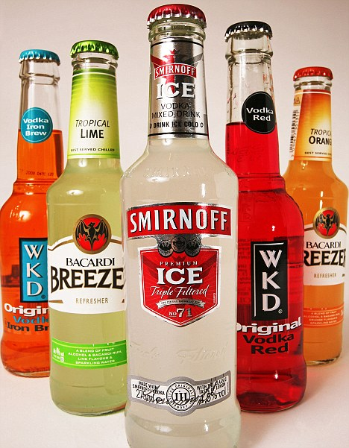Introduction

Alcopops are brightly coloured, sweetly flavoured alcoholic drinks that often appeal to a younger generation of drinker. Many consumers of alcopops are unaware that these drinks not only contain large quantities of alcohol, but also have extremely high sugar content. Your task is to carry out a practical investigation to find out exactly how much sugar is contained in some alcopops that are on sale in Scotland today.

Background research

The first stage of carrying out research in chemistry is to review what is already known about the topic of interest. Chemists use books, scientific papers, journals and the internet to carry out background research.

Your first task in the Researching Chemistry unit is to independently carry out background research into one of the focus questions listed below, which will be assigned to you by your teacher. In school, it is likely that you will carry out your background research on the internet.

Once you have completed your background research, you must then complete the unit assessment tasks and store your research evidence in a safe place.

Assessment tasks

- Record at least two sources of information relevant to your focus question. Sufficient detail should be given to allow someone else to find your sources easily. For a website, the URL as shown here is perfectly adequate https://education.gov.scot/

- Write a brief summary of the information of relevance contained in each of the sources you have identified.
Focus questions

A1 Why do manufacturers add sugar to alcopops? Suggest why this has led to public concern.

A2 What did the Australian government do to attempt to reduce the consumption of alcopops?

A3 Alcopops are allegedly marketed at a younger drinker. What evidence is there to suggest that alcohol causes more damage to a person’s health if it is consumed at a younger age?

A4 The Scottish government has recently debated setting minimum prices for alcoholic drinks. What are the pros and cons of minimum pricing?

A5 Many countries use the unit system to help people calculate the amount of alcohol they are consuming. How much alcohol is in a unit and how many units of alcohol are in a typical alcopop?

A6 Some alcopops also contain caffeine. What are the health concerns of combining alcohol and caffeine?

Advice on using the internet for background research

The web allows you to access a huge amount of information – don’t get side-tracked! Promising sites should be bookmarked so that you can return to them later. Tables, graphs and pictures can be copied into a folder. It is worthwhile spending a few moments considering which keywords may be the best to enter into your search engine. For more advice on effective web-based research see the LTS resource on http://www.ltscotland.org.uk/nationalqualifications/resources/r/nqresource_tcm4629006

Planning your investigation

The next stage in your investigation is to plan and carry out an appropriate experimental procedure that will allow you to find out how much sugar is contained in an alcopop.

Whilst planning your experimental work you must consider:

- which alcopop(s) you will investigate
- how to find out the actual sugar content in the alcopop
- which chemicals will be required
- what apparatus will be required
- the hazards that might be involved and how you will minimise risk.

Procedure: How much sugar is in an alcopop?

The sugar content of an alcopop can be measured by calculating the density of the alcopop drink and then comparing this value to the density of standard sugar solutions of known concentration.

Safety! Ethanol is highly flammable. Do not use ethanol near naked flames!

Preparing standard solutions

Alcoholic drinks are aqueous solutions of ethanol. The density of an alcoholic drink is dependent not only on the sugar concentration, but also on the concentration of ethanol present. In order to conduct a fair experiment, the concentration of ethanol in the standard solutions must therefore be kept constant.

In order to achieve this, a standard ethanol solution containing the same percentage of ethanol as the drink being studied should be prepared. For example, if the drink being studied contains 8% alcohol then you should prepare a solution which contains 8% ethanol, etc. (Note: 8% ethanol means
8 cm³ of ethanol in 100 cm³ of solution.)

A. Preparing 500 cm³ of 8% ethanol solution

Transfer 40 cm³ of ethanol into a 500-cm³ flask and make up to the mark using deionised water.

B. Preparing standard sugar solutions and determining their density

Prepare a set of standard solutions which cover the range of sugar concentrations that an alcopop is likely to have. For example, many alcopops have a sugar concentration of 7 g per 100 ml of drink (7%). It would be reasonable to prepare standard sugar solutions at the following concentrations: 4%, 5%, 6%, 7%, 8%, 9% and 10%.

Here is a simple method for preparing a 4% sugar solution. Since most alcopops contain the sugar known as sucrose, sucrose will be used throughout this experiment.

1. Measure the mass of a dry, empty 50-cm³ standard flask.

2. Accurately weigh out around 2 g of sucrose into a beaker and dissolve it in ~25 cm³ of the standard ethanol solution that was prepared in A.

3. Transfer this solution to the 50-cm³ standard flask and make up to the mark with ethanol solution.

4. Measure the mass of the 50-cm³ standard flask, which now contains the sucrose solution.

5. Calculate the density of the solution = mass of solution ÷ volume.

6. Repeat this method to prepare all the standard sucrose solutions and use the results to plot a calibration graph of density versus percentage of sucrose.

C. Determining the percentage of sugar in an alcopop

1. Measure the mass of a clean, dry beaker.

2. Using a pipette, add 25 cm³ of the alcopop to the beaker and reweigh.

3. Calculate the density of the solution = mass of solution ÷ volume.

4. Calculate the percentage of sugar in the alcopop using the calibration graph.

Reporting your results

The final stage of any scientific investigation involves reporting the results. Scientists use a wide range of communication methods to report their results, including scientific papers, laboratory reports, blogs, videos, scientific posters, podcasts, PowerPoints, web pages, etc.

Assessment task

Once you have agreed the format of your scientific communication with your teacher, you should produce a report on your investigation containing the following key features:

- a clear statement of the aim of your investigation
- a brief explanation of how the density technique can be used to determine the sugar content of alcopops
- your experimental observations and results, including the calibration graph
- a comparison of the actual and the calculated sugar content for your alcopops
- reasons why your experimental results are different from the actual results (if they are different)
- a description of any ways in which the results could be improved
- a valid conclusion, based on the evidence in your report, which relates to your aim.

Make sure you store your scientific communication in a safe place, as it will be required as evidence for your unit assessment.

Investigation B

How many units of alcohol are really in a glass of white wine?

Introduction
Many countries use the unit system to alert people to how much alcohol is in a drink. People are advised on how many units they can safely consume to avoid the damaging health effects of drinking too much alcohol or causing an accident whilst driving under the influence of alcohol. One of the problems with the unit system is that not all beers, wines and spirits are the same. For example, a glass of one type of wine may contain more alcohol units than a glass of another type of wine.

Your task is to find out how many alcohol units are in a glass of wine. You will use a standard method to calculate the concentration of ethanol in the wine and then use your research to help you convert this into the number of units of alcohol in a glass of this wine.

Background research

The first stage of carrying out research in chemistry is to review what is already known about the topic of interest. Chemists use books, scientific papers, journals and the internet to carry out background research.

Your first task in the Researching Chemistry unit is to independently carry out background research into one of the focus questions listed below, which will be assigned to you by your teacher. In school, it is likely that you will carry out your background research on the internet.

Once you have completed your background research, you must then complete the unit assessment tasks and store your research evidence in a safe place.

Assessment tasks

- Record at least two sources of information relevant to your focus question. Sufficient detail should be given to allow someone else to find your sources easily. For a website, the URL as shown here is perfectly adequate https://education.gov.scot/
- Write a brief summary of the information of relevance contained in each of the sources you have identified.

Focus questions

B1 How does the unit method for calculating the alcohol content in drinks work?

B2 What are the current UK daily and weekly guidelines for safe drinking of alcoholic drinks for men and women?

B3 What are the legal alcohol limits (blood, breath and urine) for driving in the UK?

B4 Ethanol is a known teratogen. Explain what this means.

B5 Health advice states that limits should be put on a person’s alcohol consumption. Explain the reasons for this advice.

B6 Counterfeit alcohol can be contaminated with methanol. Explain why this is dangerous to drink.

Advice on using the internet for background research

The web allows you to access a huge amount of information – don’t get side-tracked! Promising sites should be bookmarked so that you can return to them later. Tables, graphs and pictures can be copied into a folder. It is worthwhile spending a few moments considering which keywords may be the best to enter into your search engine. For more advice on effective web-based research see the LTS resource on http://www.ltscotland.org.uk/nationalqualifications/resources/r/nqresource_tcm4629006

Planning your investigation

The next stage in your investigation is to plan and carry out an experimental procedure to measure the percentages of alcohol in different white wines. Whilst planning your experimental work you should consider:

- which white wine(s) you will use
- how the team will be organised to ensure all tasks are completed in the allocated time
- how you will find out the actual percentage alcohol content of the wine(s)
- finding out about %ABV and how to convert this into units of alcohol
- finding out about the unit system and the volume of ‘one glass’
- what apparatus will be required
- which chemicals will be required
- what hazards are involved and how you will minimise risk.

Procedure: Determining the percentage alcohol content of white wine

The percentage of alcohol in a white wine can be measured by calculating the density and then comparing this value to the density of standard solutions of known percentage alcohol concentration. The alcohol found in white wine is ethanol, and therefore the percentage of alcohol quoted will actually be the percentage of ethanol.

The first step in the procedure involves plotting a calibration graph of density against percentage ethanol, using standard solutions of known ethanol concentration.

The second stage involves determination of the density of the white wine being analysed. The density is calculated by dividing the mass of the liquid by its volume. Water has a higher density than ethanol. As alcoholic drinks contain both ethanol and water, the density of an alcoholic drink such as white wine is somewhere between that of pure ethanol and that of pure water.

Once the density of the white wine being analysed has been deduced, this value can be compared to a calibration graph of solutions of known percentage ethanol, in order to calculate the percentage of alcohol in the wine.

Safety! Ethanol is highly flammable. Do not use next to flames or sparks. Safety goggles must be worn throughout this practical.

Sodium hydroxide solution is corrosive. Wash your skin immediately if you come into contact with the sodium hydroxide solution.

A. Preparation of calibration graph

1. Weigh an empty 100-cm³ standard flask.

2. Using a pipette, add 8 cm³ of ethanol to the 100-cm³ standard flask.

3. Make up to the mark with deionised water.

4. Re-weigh the flask and calculate the mass of the 8% solution.

5. Calculate the density (= mass of solution ÷ volume of solution).

6. Use steps 1 to 5 to prepare a range of standard ethanol solutions of ethanol concentrations 10%, 12%, 14%, 16% and 18%.

7. Plot a calibration graph of density versus percentage ethanol.

B. Measurement of the density of a sample of white wine

1. Pipette 50 cm³ of white wine into a 100-cm³ round-bottomed flask.

2. Make the wine slightly alkaline by adding a few drops of sodium hydroxide solution (2 mol l^{–1}).

3. Distil the solution until 25 cm³ of distillate has been collected.

4. Weigh and record the mass of a 50-cm³ standard flask.

5. Transfer the 25 cm³ of distillate plus rinsings to the 50-cm³ standard flask and make up to the mark with water.

6. Reweigh the flask and calculate the density of the wine.

7. Repeat steps 1 to 6 for another sample of this wine or another white wine.

8. Use the calculated density value to estimate the percentage of ethanol in the wine from the calibration graph.

9. Convert the percentage ethanol value calculated into units of alcohol per glass of wine.

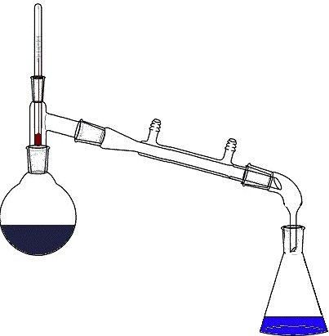
Collect 25 cm³ of distillate
Thermometer
Condenser
50 cm³ wine + NaOH (aq) + boiling chip
Heat from a heating mantle

Reporting your results

The final stage of any scientific investigation involves reporting the results. Scientists use a wide range of communication methods to report their results, including scientific papers, laboratory reports, blogs, videos, scientific posters, podcasts, PowerPoints, web pages, etc.

Assessment task

Once you have agreed the format of your scientific communication with your teacher, you should produce a report on your investigation containing the following key features:

- a clear statement of the aim of your investigation
- a brief explanation as to how the density method can be used to determine the percentage of ethanol in a white wine
- a brief explanation of why the wine has to be distilled
- a brief explanation as to why the wine has to be made alkaline
- your experimental observations and results, including the calibration graph
- a comparison of the actual and calculated ethanol content of your white wine(s)
- reasons why the experimental results are different from the actual results (if they are different)
- a description of any ways in which the results could be improved
- a valid conclusion, based on the evidence in your report, which relates to your aim.

Investigation C

How does the SO₂ concentration in wine compare with that in cider?

Introduction

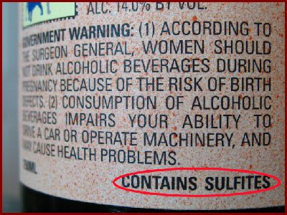Sulphur dioxide (SO₂) has been added as a preservative to alcoholic drinks for centuries. Manufacturers refer to all sulphur compounds added to drinks as ‘sulphites’. The quantity of sulphites in wine is strictly controlled by legislation. Despite this, concern has recently been expressed that sulphites in wine can sometimes lead to undesirable health effects. As a result, many drinks manufacturers are trying to reduce sulphite concentration.

Analytical chemists have developed methods to accurately calculate the sulphite concentration in alcoholic drinks. These methods allow them to verify that the drink contains enough preservative to be kept fresh for a reasonable time, that it will not taste foul as a result of containing too much preservative and that the sulphite content is within legal limits.

Your task in this investigation is to measure the sulphite concentration in a wine and a cider by converting all the sulphites to SO₂, and then to compare this concentration to European legal limits for sulphite content in alcoholic drinks.

Background research

The first stage of carrying out research in chemistry is to review what is already known about the topic of interest. Chemists use books, scientific papers, journals and the internet to carry out background research.

Your first task in the Researching Chemistry unit is to independently carry out background research into one of the focus questions listed below, which will be assigned to you by your teacher. In school, it is likely that you will carry out your background research on the internet.
Once you have completed your background research, you must then complete the unit assessment tasks and store your research evidence in a safe place.

Assessment tasks

- Record at least two sources of information relevant to your focus question. Sufficient detail should be given to allow someone else to find your sources easily. For a website, the URL as shown here is perfectly adequate https://education.gov.scot/

- Write a brief summary of the information of relevance contained in each of the sources you have identified.

Focus questions

C1 What happens to a wine or cider if preservatives are not used?

C2 Which chemicals are used to add SO₂ to wines and ciders?

C3 What are the EU and WHO limits for SO₂ content in wine?

C4 The concentration of SO₂ in wines and ciders is often expressed as parts per million or ppm. What does this mean?

C5 Why are some people concerned about the use of SO₂ as a preservative in drinks?

C6 Some drinks makers add caffeine to alcoholic drinks. Explain why people are concerned about these drinks.

Advice on using the internet for background research

The web allows you to access a huge amount of information – don’t get side-tracked! Promising sites should be bookmarked so that you can return to them later. Tables, graphs and pictures can be copied into a folder. It is worthwhile spending a few moments considering which keywords may be the best to enter into your search engine. For more advice on effective web-based research see the LTS resource on http://www.ltscotland.org.uk/nationalqualifications/resources/r/nqresource_tcm4629006

Planning your investigation

The next stage in your investigation is to plan and carry out an experimental procedure to measure and compare the concentration of SO₂ in wine and cider. Whilst planning your experimental work you should consider:

- which wine and cider you will use
- how you can find out the actual SO₂ concentration
- what apparatus will be required
- which chemicals will be required
- what hazards are involved and how you will minimise risk.

Procedure: Determining the SO₂ concentration in wine and cider

SO₂ concentration can be determined via the following redox titration, using starch as indicator:

SO₂ (aq) + I₂ (aq) + 2H₂O (l) → 4H⁺ (aq) + SO₄^{2–} (aq) + 2I– (aq)

If a standard iodine solution of known concentration is added to a sample of an alcoholic drink, the iodine will react with any SO₂ present.

Once all of the SO₂ has been used up in the reaction, the remaining iodine will react with the starch to give a blue–black colour, indicating the end-point of the reaction.

The concentration of SO₂ in the alcoholic drink can be calculated since
1 mole of iodine reacts with 1 mole of SO₂ according to the balanced equation above.

Alcoholic drinks contain two different types of SO₂, namely free SO₂ and combined SO₂. However, in this investigation you will be measuring total SO₂, where:

total SO₂ = (free SO₂ + combined SO₂)

Safety! Wear safety goggles throughout the practical investigation.

Sulphuric acid and sodium hydroxide solutions are corrosive. Handle with care. Wash splashes immediately with running water.
Iodine solution is harmful. Handle with care. Wash splashes immediately with running water.

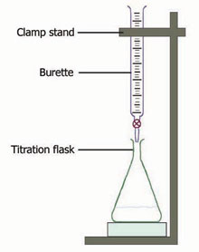
Wine, sulphuric acid and starch
Standard iodine solution

Determination of total SO₂

1. Using a measuring cylinder, put 25 cm³ of sodium hydroxide solution
(1 mol l^{–1}) into a 250-cm³ conical flask.

2. Add a 25 cm³ sample of wine from a pipette.

3. Swirl the flask gently and leave to stand for approximately 15 minutes.

4. Add 10 cm³ of sulphuric acid (2 mol l^{–1}) and 2 cm³ of starch solution to the flask.

5. Titrate with iodine solution (0.005 mol l^{–1}). The end-point is indicated by the appearance of a blue–black colour that persists for about 2 minutes.

6. Repeat until concordant results are obtained.

7. Calculate the number of moles of total SO₂ present in 25 cm³ of wine. Convert this into a mass (in mg) of SO₂ per litre and compare your results to the manufacturer’s data.

8. Repeat steps 1 to 7 for the sample of cider.

Reporting your results

The final stage of any scientific investigation involves reporting the results. Scientists use a wide range of communication methods to report their results, including scientific papers, laboratory reports, blogs, videos, scientific posters, podcasts, PowerPoints, web pages, etc.

Assessment task

Once you have agreed the format of your scientific communication with your teacher, you should produce a report on your investigation containing the following key features:

- a clear statement of the aim of your investigation
- a brief explanation of how the iodine titration can be used to determine the SO₂ concentration
- your experimental observations and results
- a comparison of the actual and calculated SO₂ concentrations for the wine and cider samples
- reasons why the experimental results are different from the actual results (if they are different)
- a description of any ways in which the results could be improved
- a valid conclusion, based on the evidence in your report, which relates to your aim.

Investigation D

Do white wines from different countries have different SO₂ concentrations?

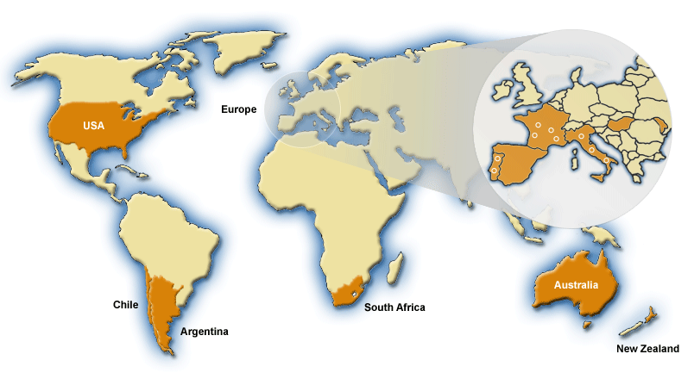Introduction

Sulphur dioxide (SO₂) has been added as a preservative to alcoholic drinks for centuries. Manufacturers refer to all sulphur compounds added to drinks as ‘sulphites’. The quantity of sulphites in wine is strictly controlled by legislation. Despite this, concern has recently been expressed that sulphites in wine can sometimes lead to undesirable health effects. As a result, many drinks manufacturers are trying to reduce sulphite concentration.

Analytical chemists have developed methods to accurately calculate the sulphite concentration in alcoholic drinks. These methods allow them to verify that the drink contains enough preservative to be kept fresh for a reasonable time, that it will not taste foul as a result of containing too much preservative and that the sulphite content is within legal limits.

Your task in this investigation is to calculate the SO₂ concentration in white wines from different countries and then to compare these concentrations with European legal limits.

Background research

The first stage of carrying out research in chemistry is to review what is already known about the topic of interest. Chemists use books, scientific papers, journals and the internet to carry out background research.

Your first task in the Researching Chemistry unit is to independently carry out background research into one of the focus questions listed below, which will be assigned to you by your teacher. In school, it is likely that you will carry out your background research on the internet.
Once you have completed your background research, you must then complete the unit assessment tasks and store your research evidence in a safe place.

Assessment tasks

- Record at least two sources of information relevant to your focus question. Sufficient detail should be given to allow someone else to find your sources easily. For a website, the URL as shown here is perfectly adequate https://education.gov.scot/

- Write a brief summary of the information of relevance contained in each of the sources you have identified.

Focus questions

D1 Why is SO₂ added to wines?

D2 Are the limits for SO₂ in wine the same in all countries?

D3 Some people are sensitive to sulphites in wine. How are they affected?

D4 Preservatives in wine are given an E number. What is an E number and which E numbers are used to show the presence of sulphites in wine?

D5 Many scientists claim that sulphite-free wines do not exist. Explain this claim.

D6 The Scottish parliament has been debating setting minimum prices for alcoholic drinks. What are the pros and cons of setting minimum prices for alcoholic drinks?

Advice on using the internet for background research

The web allows you to access a huge amount of information – don’t get side-tracked! Promising sites should be bookmarked so that you can return to them later. Tables, graphs and pictures can be copied into a folder. It is worthwhile spending a few moments considering which keywords may be the best to enter into your search engine. For more advice on effective web-based research see the LTS resource on http://www.ltscotland.org.uk/nationalqualifications/resources/r/nqresource_tcm4629006.

Planning your investigation

The next stage of your investigation is to plan and carry out an experimental procedure to allow you to measure and compare the SO₂ content in white wines from different countries.

Whilst planning your experimental work you should consider:

- which white wines will you use and how will you ensure a fair comparison
- how you can find out the actual SO₂ concentration in the wine
- what apparatus will be required
- which chemicals will be required
- what hazards are involved and how you will minimise risk.

Procedure: Determining SO₂ concentration in white wines

SO₂ concentration can be determined via the following redox titration, using starch as indicator:

SO₂ (aq) + I₂ (aq) + 2H₂O (l) → 4H⁺ (aq) + SO₄^{2–} (aq) + 2I– (aq)

If a standard iodine solution of known concentration is added to a sample of an alcoholic drink, the iodine will react with any SO₂ present.

Once all of the SO₂ has been used up in the reaction, the remaining iodine will react with the starch to give a blue–black colour, indicating the end-point of the reaction.

The concentration of SO₂ in the alcoholic drink can be calculated since
1 mole of iodine reacts with 1 mole of SO₂ according to the balanced equation above.
Alcoholic drinks contain two different types of SO₂, namely free SO₂ and combined SO₂. However, in this investigation you will be measuring total SO₂, where:

total SO₂ = (free SO₂ + combined SO₂)

Safety! Wear safety goggles throughout the practical investigation.
Sulphuric acid and sodium hydroxide solutions are corrosive. Handle with care. Wash splashes immediately with running water.
Iodine solution is harmful. Handle with care. Wash splashes immediately with running water.

Wine, sulphuric acid and starch
Standard iodine solution

Determination of total SO₂

1. Using a measuring cylinder, put 25 cm³ of sodium hydroxide solution
(1 mol l^{–1}) into a 250-cm³ conical flask.

2. Add a 25 cm³ sample of wine from a pipette.

3. Swirl the flask gently and leave to stand for approximately 15 minutes.

4. Add 10 cm³ of sulphuric acid (2 mol l^{–1}) and 2 cm³ of starch solution to the flask.

5. Titrate with iodine solution (0.005 mol l^{–1}). The end-point is indicated by the appearance of a blue–black colour that persists for about 2 minutes.

6. Repeat until concordant results are obtained.

7. Calculate the number of moles of total SO₂ present in 25 cm³ of wine. Convert this into a mass (in mg) of SO₂ per litre and compare your results to the manufacturer’s data.

8. Repeat steps 1 to 7 for the other wine(s).

Reporting your results

The final stage of any scientific investigation involves reporting the results. Scientists use a wide range of communication methods to report their results, including scientific papers, laboratory reports, blogs, videos, scientific posters, podcasts, PowerPoints, web pages, etc.

Assessment task

Once you have agreed the format of your scientific communication with your teacher, you should produce a report on your investigation containing the following key features:

- a clear statement of the aim of your investigation
- a brief explanation of how the iodine titration can be used to determine SO₂ content
- your experimental observations and results
- a discussion of reasons why the wines have different SO₂ concentrations (if they do)
- a comparison of the actual and calculated SO₂ concentrations for the wines
- a discussion of reasons why the experimental results are different from the actual results (if they are different)
- a description of any ways in which the results could be improved
- a valid conclusion, based on the evidence in your report, which relates to your aim.

Investigation E

How does the concentration of SO₂ in a dry white wine compare with that in a sweet white wine?

Introduction

Sulphur dioxide (SO₂) has been added as a preservative to alcoholic drinks for centuries. Manufacturers refer to all sulphur compounds added to drinks as ‘sulphites’. The quantity of sulphites in wine is strictly controlled by legislation. Despite this, concern has recently been expressed that sulphites in wine can sometimes lead to undesirable health effects. As a result, many drinks manufacturers are trying to reduce sulphite concentration.

Analytical chemists have developed methods to accurately calculate the sulphite concentration in alcoholic drinks. These methods allow them to verify that the drink contains enough preservative to be kept fresh for a reasonable time, that it will not taste foul as a result of containing too much preservative and that the sulphite content is within legal limits.

Your task in this investigation is to measure and compare the SO₂ concentration in a dry white wine and a sweet white wine and then to compare these concentrations with European legal limits.

Background research

The first stage of carrying out research in chemistry is to review what is already known about the topic of interest. Chemists use books, scientific papers, journals and the internet to carry out background research.

Your first task in the Researching Chemistry unit is to independently carry out background research into one of the focus questions listed below, which will be assigned to you by your teacher. In school, it is likely that you will carry out your background research on the internet.

Once you have completed your background research, you must then complete the unit assessment tasks and store your research evidence in a safe place.
Assessment tasks

- Record at least two sources of information relevant to your focus question. Sufficient detail should be given to allow someone else to find your sources easily. For a website, the URL as shown here is perfectly adequate https://education.gov.scot/
- Write a brief summary of the information of relevance contained in each of the sources you have identified.

Focus questions

E1 Why is sulphur dioxide added to wines?

E2 What is the difference between a dry wine and a sweet wine?

E3 What other foods and drinks contain sulphites?

E4 Why are some people concerned about SO₂ in wine?

E5 Why should pregnant woman not drink alcohol?

E6 Health scientists have reported that drinking wine may have health benefits. What are these benefits?

Advice on using the internet for background research

The web allows you to access a huge amount of information – don’t get side-tracked! Promising sites should be bookmarked so that you can return to them later. Tables, graphs and pictures can be copied into a folder. It is worthwhile spending a few moments considering which keywords may be the best to enter into your search engine. For more advice on effective web-based research see the LTS resource on http://www.ltscotland.org.uk/nationalqualifications/resources/r/nqresource_tcm4629006.asp.

Planning your investigation

The next stage of your investigation is to plan and carry out an experimental procedure to allow you to measure and compare the SO₂ content in a dry white wine and a sweet white wine.

Whilst planning your experimental work you should consider:

- which white wines you will use and how will you ensure a fair comparison
- how to find out the actual SO₂ concentrations in the wines
- what apparatus will be required
- which chemicals will be required
- what hazards are involved and how you will minimise risk.

Procedure: Determining the SO₂ concentration in wines

SO₂ concentration can be determined via the following redox titration, using starch as indicator:

SO₂ (aq) + I₂ (aq) + 2H₂O (l) → 4H⁺ (aq) + SO₄^{2–} (aq) + 2I– (aq)

If a standard iodine solution of known concentration is added to a sample of an alcoholic drink, the iodine will react with any SO₂ present.

Once all of the SO₂ has been used up in the reaction, the remaining iodine will react with the starch to give a blue–black colour, indicating the end-point of the reaction.

The concentration of SO₂ in the alcoholic drink can be calculated since
1 mole of iodine reacts with 1 mole of SO₂ according to the balanced equation above.

Alcoholic drinks contain two different types of SO₂, namely free SO₂ and combined SO₂. However, in this investigation you will be measuring total SO₂, where:

total SO₂ = (free SO₂ + combined SO₂)

Safety! Wear safety goggles throughout the practical investigation.
Sulphuric acid and sodium hydroxide solutions are corrosive. Handle with care. Wash splashes immediately with running water.
Iodine solution is harmful. Handle with care. Wash splashes immediately with running water.

Wine, sulphuric acid and starch
Standard iodine solution

Determination of total SO₂

1. Using a measuring cylinder, put 25 cm³ of sodium hydroxide solution (1 mol l^{–1}) into a 250-cm³ conical flask.

2. Add a 25 cm³ sample of dry white wine from a pipette.

3. Swirl the flask gently and leave to stand for approximately 15 minutes.

4. Add 10 cm³ of sulphuric acid (2 mol l^{–1}) and 2 cm³ of starch solution to the flask.

5. Titrate with iodine solution (0.005 mol l^{–1}). The end-point is indicated by the appearance of a blue–black colour that persists for about 2 minutes.
6. Repeat until concordant results are obtained.

7. Calculate the number of moles of total SO₂ present in 25 cm³ of dry white wine. Convert this into a mass (in mg) of SO₂ per litre and compare your results to the manufacturer’s data.

8. Repeat steps 1 to 7 for the sweet white wine.

Reporting your results

The final stage of any scientific investigation involves reporting the results. Scientists use a wide range of communication methods to report their results, including scientific papers, laboratory reports, blogs, videos, scientific posters, podcasts, PowerPoints, web pages, etc.

Assessment task

Once you have agreed the format of your scientific communication with your teacher, you should produce a report on your investigation containing the following key features:

- a clear statement of the aim of your investigation
- a brief explanation of how the iodine titration is used to determine SO₂ content
- your experimental observations and results
- a comparison of the calculated SO₂ concentrations for the dry and sweet white wines
- a discussion of any reasons why the wines might have different concentrations of SO₂ (if they do)
- a discussion of reasons why the experimental results are different from the actual results (if they are different)
- a description of any ways in which the results could be improved
- a valid conclusion, based on the evidence in your report, which relates to your aim.

