Food Security

At the moment nearly a billion people are hungry, and many more suffer from malnutrition. The world’s population is growing and agriculture will need to produce much more food over the next 40 years.

A recent report predicts that by 2050, demand for food may rise by 70%. This report and many other similar studies describe the need for “sustainable intensification” – greater crop yields rather than having more land where crops are grown.

C:\Users\Marjorie\AppData\Local\Microsoft\Windows\Temporary Internet Files\Content.IE5\ALMAHNOL\MC900197889[1].wmfThere cannot be one solution to this issue - we need to improve the soil, the farming practise and the crops themselves. We also need to consider better transport of foods and less waste.

The sensible use of fertilisers is likely to be an important part in the effort to increase crop yields.

FERTILISERS

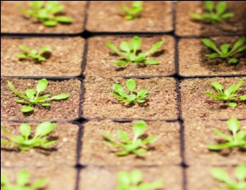Fertilisers are used to improve plant growth. If you have a healthy soil, it is often not necessary to use fertilisers, but using them may make plants grow faster and gives crops a higher yield. Fertilisers are also used where plants are showing signs of nutrient deficiency such as leaf yellowing.

Healthy soil structure and pH are just as important as fertiliser application in the prevention of plant nutrient deficiencies.

Fertilisers contain concentrated sources of plant nutrients in chemical or organic form. Most contain major plant nutrients, which plants need in relatively large amounts.

Most fertilisers are based on the three major plant nutrients:   
**Nitrogen (N):** For green leafy growth  
**Phosphorus (P):** For healthy root and shoot growth  
**Potassium (K):** For flowering, fruiting and general hardiness

All fertilisers should quote their N:P:K ratio on the product packaging. For example, a ratio of 20:20:20 indicates a balanced fertiliser.

An example - if a 100g bag of fertilizer has an N:P:K ratio of 5:7:4, it contains 5g of nitrate, 7g of phosphate 4g of potassium and 84g of filler.

Question:

If you had 200g of fertiliser and the NPK ration was 10:20:40, what would it contain?

|  |
| --- |
|  |

There are two main types of fertilisers: inorganic or synthetic (man-made) and organic (derived from plant or animal).

**C:\Users\Marjorie\AppData\Local\Microsoft\Windows\Temporary Internet Files\Content.IE5\CS1SI1V5\MC900215957[1].wmfInorganic/synthetic fertilisers:** These are synthetic, artificial forms of plant nutrients or naturally occurring mined minerals. Inorganic fertilisers are usually more concentrated and faster acting than organic fertilisers. Examples of inorganic fertilisers include: Growmore and Tomorite.

**C:\Users\Marjorie\AppData\Local\Microsoft\Windows\Temporary Internet Files\Content.IE5\D0Z8OIYE\MC900233594[1].wmfC:\Users\Marjorie\AppData\Local\Microsoft\Windows\Temporary Internet Files\Content.IE5\3VI2AAT3\MC900329190[1].wmfOrganic fertilisers:** These come from plant or animal sources and contain plant nutrients in organic form. Organic products tend to be slower acting, as large organic molecules have to be broken down by soil organisms before the nutrients within them are released for plant use. Examples of organic fertilisers include: seaweed, hoof & horn, dried blood, fish and bone meal.

Question

Describe 3 differences between organic and synthetic fertilisers

|  |
| --- |
|  |

**Why use fertilisers?** Although not always essential if plenty of well-rotted organic matter is available, fertilisers are extremely useful in maintaining soil fertility and increasing crop yields. Here is a graph showing as example:

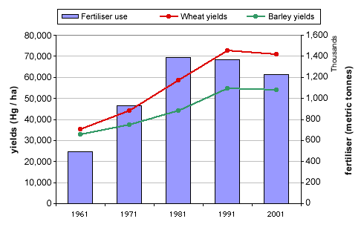**Fertiliser Use and Crop Yields (UK)** http://www.fao.org/ag/save-and-grow/en/1/index.html

1. What effect has increasing fertiliser use had on yields of wheat and barley?
2. Describe the effect on crop yield of reducing fertiliser use from 1991-2001.
3. The fertilisers used in this study are described as NPK – what does this mean?
4. Why is nitrogen a component of fertilisers?
5. Apart from fertilisers what else is important to help crops to grow well?
6. Adding more fertiliser to fields than the plants need to grow well can cause environmental problems. Describe what these might be.

|  |
| --- |
|  |

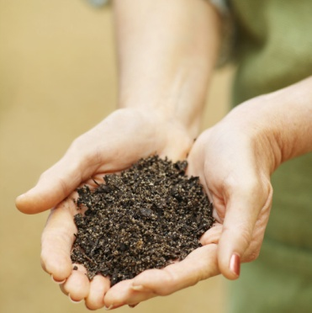

Healthy soil structure and pH are just as important as fertiliser application in the prevention of plant nutrient deficiencies. Soil conditioners such as manure and compost help the soil to form into crumbs with spaces for air and water between them, making nutrients, water and air all more available to plant roots. Lime is an alkali and is added to some soils to make it less acidic which means that the nutrients are more available to the plants.

**ACTIVITIES:**

Practical Activity: - Plant Nutrient Deficiencies - effects of NPK on plant growth in mung beans.

Design a Fertiliser: - Discover some of the issues surrounding growing different crops in different areas and work out what the fertiliser needs are.

**WEB LINKS**

<http://www.allotment.org.uk/gardening/fertiliser/npk>

<http://www.rhs.org.uk/advicesearch/profile.aspx?PID=304#section1>

<http://www.fertilizer101.org/>