Plant Growth __________________________________________________________
Investigating Nutrient Deficiency in Mung Bean Plants
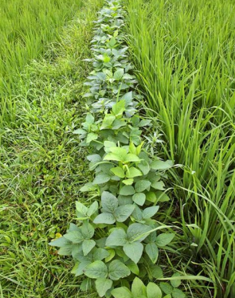
Background
Mung beans are native to India and grown extensively throughout the tropics as a food source. They are legumes and provide an excellent source of protein and potassium in the diet. They are also eaten as bean sprouts.
Mung beans and rice
In some countries mung bean plants are grown alongside rice in padi fields as they have extensive roots which help retain soil and, being leguminous, they add nitrogen to soil.
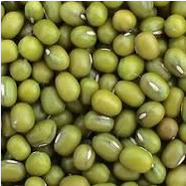
Mung beans are cheap, reliable and easy to germinate. Germinated mung beans can be grown quickly in a range of water culture solutions. Standard Sach’s solutions can be used for this. Distilled water makes a good comparison.
(Sach’s solutions are available from from Scientific and Chemical, Philip Harris, Timstar etc.)
Within a few days learners will see differences in the growth and development of seedlings and can make comparisons and draw conclusions relating to mineral deficiency symptoms and requirements for healthy growth. The seedlings will grow for 10 – 14 days.
At SSERC we used still and time lapse photography to capture images of seedling growth.
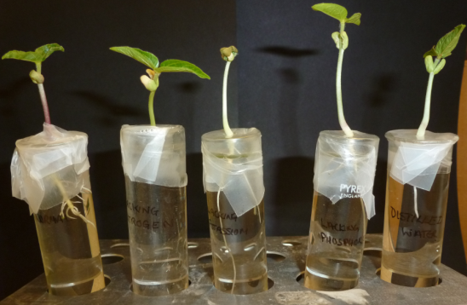

The aims of the activities involved in this practical are:
- To investigate how lack of chemical nutrients – nitrogen, phosphorous and potassium – affects the growth and development of mung bean plants.
- To identify mineral deficiency symptoms associated with lack of particular nutrients.
Preparation
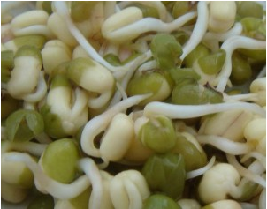
Two days prior to setting up the investigation with culture solutions, place the mung beans in a flat dish, or tray. Each student (or group) will need 5 seedlings, so use enough beans to allow for the failure of some to germinate successfully. Moisten the beans (without soaking them) and cover loosely with muslin, or something similar, which will allow air to circulate. Place in a warm incubator for 1 – 2 days.
Once small radicles (roots) appear the seedlings should be gently tipped onto paper towels. Students should select 5 that are at a similar stage of development.
Setting up the investigation
Materials
- 5 boiling tubes.
- Test tube rack.
- Parafilm™ (or foil).
- Scissors.
- Marker pen.
- 5 germinated mung beans.
- A bright light source.
- A range of culture solutions:
1. Complete culture
2. Culture lacking Nitrogen (N)
3. Culture lacking Phosphorous (P)
4. Culture lacking Potassium (K)
5. Distilled water

Method
- Label the test tubes 1 – 5 to show which culture medium is present.
- Fill each test tube with its corresponding culture medium.
- Cover each test tube with parafilm (or foil).
- Gently push down the centre of the parafilm (or foil) in each test tube to make an upside down cone shape which will act as a ‘well’ so that the culture medium can be easily topped up.
- Make a little hole in the centre of each well.
- Carefully place a mung bean seed into each well and gently push the radicle through the hole into the culture medium. The seed should be on top of the parafilm (or foil) and the radicle will be dipping into the liquid below. Top up with culture medium if necessary.
- Place the test tubes in a rack and leave under bright light.
Discussion
Pupils could be invited to make predictions about what might happen in relation to growth and development in each scenario.
Results
The seedlings should be examined after 3, 7 and 10 days growth. Comparisons between the growth achieved in each culture medium and in distilled water can be made. (See Investigating Growth in Mung Bean Plants Results Table)
Conclusions
Using the results of the investigation, together with the mineral deficiency help cards (and perhaps photographs) pupils can draw conclusions about mineral deficiency symptoms and why particular minerals are required for healthy growth and development.
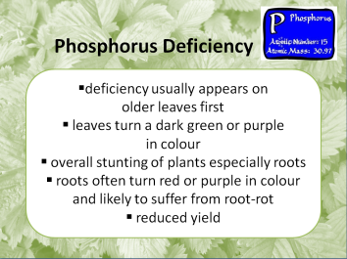
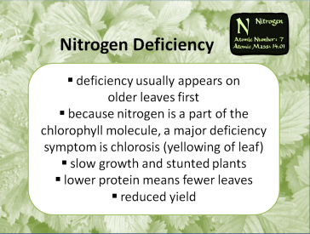
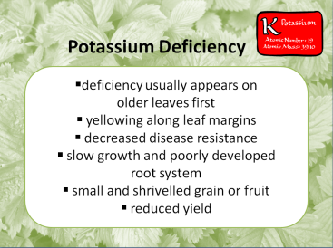
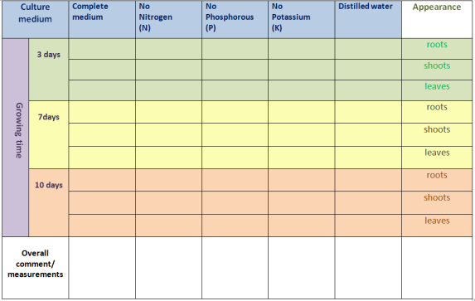

This protocol was adapted from one kindly provided by Roger Delpech of The
Haberdashers' Aske's Boys' Schools (Elstree).
Designing a Fertiliser Resources:
Fred the Farmer, Risa the Rice Farmer, Hermione the Horticulturalist. This activity comprises a set of cards with characters and scenarios giving learners a context together with a task to complete in small groups. There is a suggested website for each character / problem where learners might carry out further research. This activity highlights the idea that fertilisers are customised and that ‘designing a fertiliser’ to maximise crop production is complicated.
What the NPK means in fertiliser – this is an information sheet for learners. It contains a web reference for further research.
http://www.allotment.org.uk/gardening/fertiliser/npk
Food security – this provides further information, and some problem solving activities, relating to fertilisers and their role in food security.
The Nitrogen and Living Things – a Complicated Story… This is a set of cards summarising the need for nitrogen in living things and the cycling of nitrogen between the atmosphere and living things.
Time lapse images
We used the following time lapse software:
- WebcamTimelapse – a free tool for creating videos with a webcam. This can be downloaded to a laptop and used with the Veho VMS - 001, 20-200 Magnification Digital Microscope.
http://www.tnlsoftsolutions.com/timelapsehome.php
- iMotion HD - a free iPhone app.
https://itunes.apple.com/gb/app/id421365625

