

|  |
| --- |
| Chemical Demonstrations  This reaction can be applied to curriculum for excellence.  *Through experimentation, I can identify indicators of chemical reactions having occurred. ...*  **SCN 3-19a**  N4 Chemistry in Society  *- Materials* |
| Dehydrated Snow |

**Introduction**



A nice little experiment to show a physical change.

The granules are made of either sodium polyacrylate* with a molecular weight of over 1 million.

There are sodium carboxylate groups along the carbon chain.

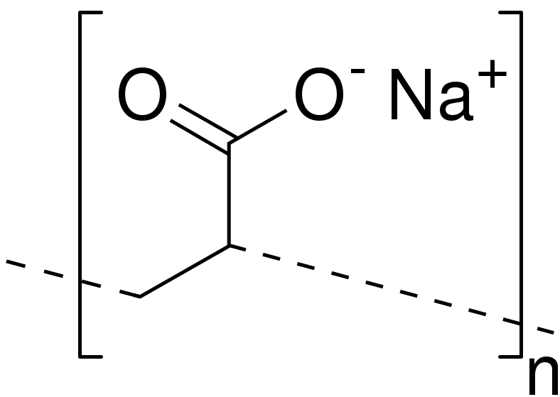

When water is added to the polymer, the sodium ions migrate leaving negatively charged carboxylate groups on the chain. The negative charges repel each other so the chains unwind and the polymer increases in volume.

At the same time, there is an electrostatic attraction between the ions and the water molecules. Many water molecules are attracted to the carboxylate groups and are electrostatically held to them. The polymer absorbs water!

*\* At the time of writing it seems several preparations use polyacrylamide instead of sodium polyacrylate. As yet we have not found details of the mechanism involved for this.*

**What you will need**

10g of artificial snow (sodium polyacrylate granules).

A 250 cm3 measuring cylinder full of water.

A 250 cm3 empty beaker.

A large basin or container to catch the ‘rehydrated’ snow.

**The demonstration**

1. You can make a great play of talking about snow being frozen water, what the word ‘dehydrate’ means and ask what would you be left with if you dehydrated some snow.
2. Now explain you are going to prove them wrong by producing a bag of ‘dehydrated snow’ which you are going to reconstitute by adding water.
3. Pour the contents of the bag into the empty beaker.
4. Now get a volunteer from the audience to hold the beaker and the container under it.
5. Pour the whole 250 cm3 of water at once into the beaker containing the granules and watch the amazement as it swells up and overflows like snow into the large container.
6. The ‘snow’ can be handled safely and feels just like real snow.
7. For a really good effect, use very cold water. The ‘snow’ will be cold.
8. Use hot water and the ‘snow’ is hot!
9. It can be spread out and dried on a windowsill and reused 2-3 times.

Magic Snow – Available under a variety of names on the internet (Amazon for instance) or from mindsetsonline (prices vary but approx £10.00 for 100g)

**It is the responsibility of teachers doing this demonstration to carry out an appropriate risk assessment.**