Observing plasmolysis using the Veho^{tm} USB Microscope
Materials:

1 red onion
1 pair forceps
1 scalpel
1 white tile
1 Plastic Pasteur pipette
1 cocktail stick
Microscope slides
Blu tack^{tm}
Distilled water
Rock salt crystals
USB microscope and PC
Distilled water
Absorbent paper towel

Method:
- Remove the two ends of the onion and as many layers as is necessary to expose a fresh and unblemished layer.
- Using the scalpel, cut a square shape approximately 1cm x 1cm in the fresh layer of onion (figure 1).
- Using the forceps tease away the red epidermis from the onion tissue and place this explant onto a microscope slide.
- Take two small pieces of Blu tack and work them into spheres. Place one sphere at each end of another microscope slide and place over the onion tissue (figure 2).
- Using a Pasteur pipette, flood the gap between the slides with distilled water. The piece of onion tissue will move when this is done. If necessary, use a cocktail stick to move it to a more central position.
- Using the USB microscope, locate the piece of tissue and focus on the edge. The cell cells are easily observable at a magnification of around x 20.
- Select 4-6 rock salt crystals which are flat enough to fit through the gap between the two microscope slides.
- Slip the crystals into the distilled water between the microscope slide. This will result in the tissue being surrounded by a strong sodium chloride solution. The difference in water concentration between the solution inside the cells and the surrounding solution will cause water to move out of the cells resulting in plasmolysis within a few minutes.

Hints and Tips
Reverse plasmolysis can also be observed with this set up. The salt solution should be bled out using an absorbent paper towel and replaced with fresh distilled water.
The field of view of the microscope, as displayed on the laptop, is in a different orientation to the slide that you are looking at.
To minimise the time taken for the effects of plasmolysis to be seen, sliding rock salt crystals between the slides on more than one side is recommended.

Figure 1: Removal of onion epidermis.
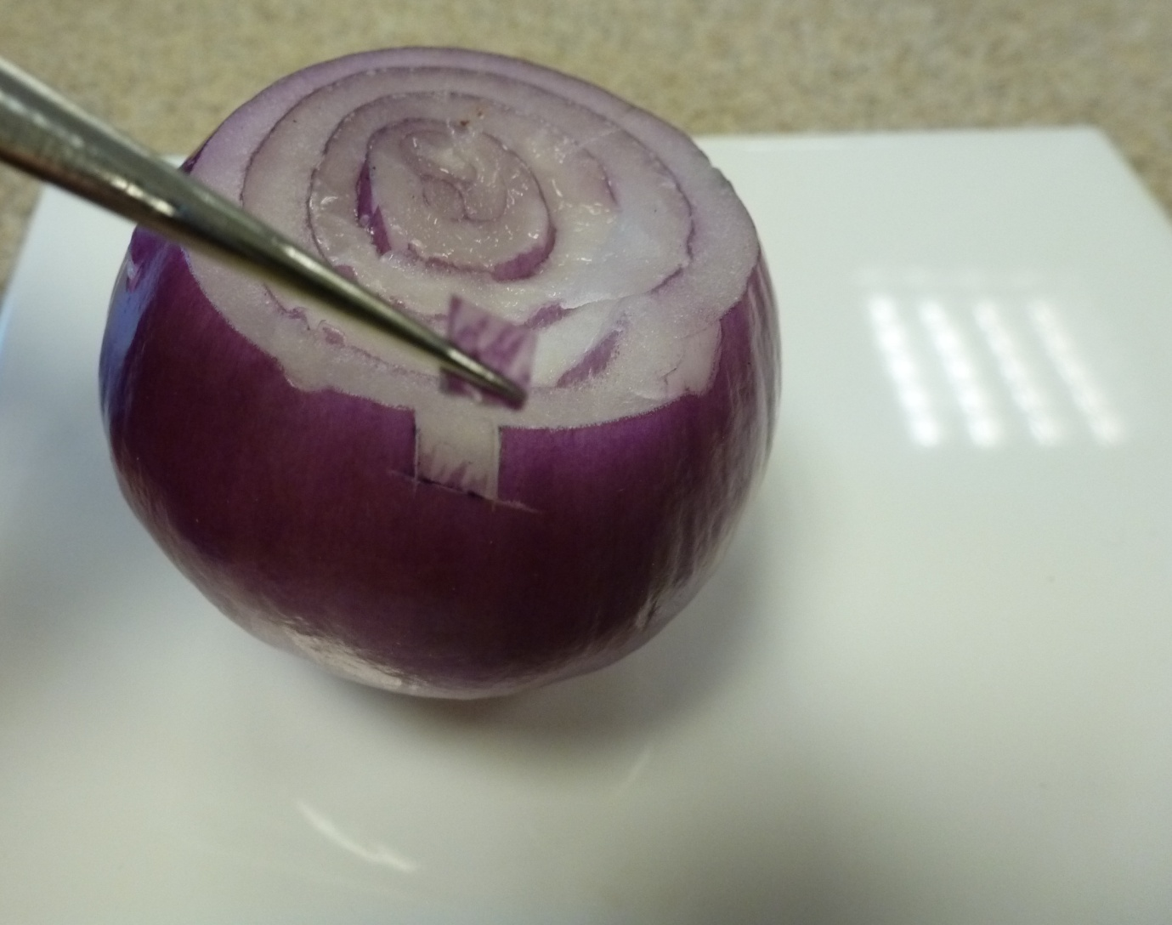

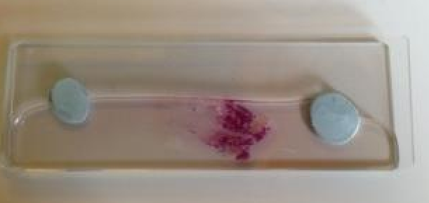
Figure 2: Onion on lower slide; slides held separate by Blu-tack.

