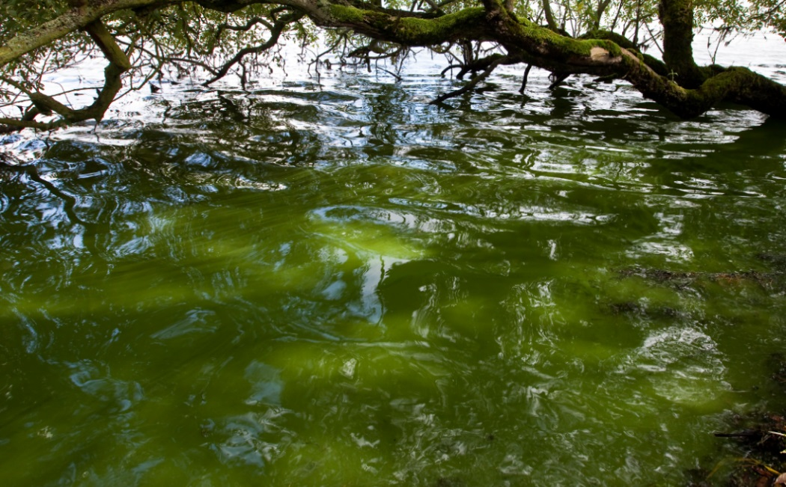
Fertiliser and the growth of algae
Teacher / technician guide

National 5
Biology

National 5 Biology
Fertiliser and the growth of algae
Teacher / Technician Guide
This activity can be used to:
- provide evidence for the assignment at National 5
- provide an opportunity to study the relationship between unwanted nitrates from, for example fertiliser, and the growth of algal population in waterways

Curriculum links
Life on Earth
Mandatory Knowledge | Depth of knowledge required / Teaching notes | Suggested activities
5. Food production  c. Fertilisers can leach into fresh water, adding extra, unwanted nitrates. This will increase algal populations which can cause algal blooms. Algal blooms reduce light levels, killing aquatic plants. These dead plants, as well as dead algae, become food for bacteria which increase greatly in number. The bacteria use up large quantities of oxygen, reducing the oxygen availability for other organisms. |  | Investigate the effect of fertiliser concentration on algal growth.

Background information
Algal blooms can occur when there is a combination of warm water (which is still or slow moving) and a high concentration of nutrients from sources like sewage or fertiliser run-off from local fields. As well as looking and smelling unpleasant, algal blooms can cause health problems for those who come in direct contact with them. Cyanobacteria (blue-greens) in some blooms produce toxins which are dangerous to humans, animals and many of the organisms which live in the water.

The increase in nutrient concentration that leads to algal blooms is known as eutrophication. Eutrophication is a process that happens naturally in some ecosystems. Eutrophication can also be increased by human activity when, for example, fertilisers from fields are washed into rivers, streams and ponds. Generally fertilisers contain high levels of nitrogen, phosphorous and potassium and if these are washed by rain from fields into a waterway they will provide the additional nutrients which can lead to an increase in algal and plant populations. Warm weather exacerbates the problem by further promoting the growth of these populations.
The organisms which make up algal blooms that form in high nutrient conditions live for only a short time resulting in large quantities of dead and decaying organic matter. The decay process involves rapid growth of bacteria which use up dissolved oxygen in the process of respiration. Levels of dissolved oxygen in the waterways are thus severely reduced and, being deprived of oxygen, fish and other organisms die.
The following practical activites, using house plant fertiliser, can serve as a model to represent algal blooms in a large body of water.

This practical activity is based on an investigation which is outlined in, Algae: a practical resource for secondary schools (Society for General Microbiology, 2012).
Algae are grown in distilled water and in fertiliser solution. Students can compare the size of the algal populations over time by measuring absorbance of the algal cultures using a colorimeter. A suggested supplementary activity is to observe the cultures directly using a microscope. The ‘hanging drop’ method is a cheaper alternative to using a cavity slide and coverslip. See the accompanying Hanging Drop Help Card.

Some students might also compare algal growth over time by estimating population size by carrying out direct cell counts using a haemocytometer.

Notes on the method
The Student Activity Guide provides protocols for setting up and carrying out investigations into the growth of a population of freshwater algae. It is possible to use the basic method to investigate different variables: fertiliser concentration; fertiliser type. It would also be possible for different groups within the same class to carry out one of these investigations using different types of algae.

See the Student Activity Guide
The use of conical flasks, loosely stoppered with cotton wool, will reduce evaporation since the investigation is to proceed for 10 days – 14 days.
- Flasks should be left close to a light source. The lamp can be turned off at night, or left on constantly. Flasks should be swirled regularly.
- Absorbance is measured using a colorimeter set at 665 nm. In this case absorbance is a measure of the extent to which light is scattered by the cells in suspension.
- The ‘control cuvettes’ used for ‘blank’ colorimeter measurements should be retained and frozen in between measurements. This is to reduce bacterial contamination which might cloud the liquids. The cuvettes will need time to thaw each time prior to taking readings.
- It is possible that some students might estimate population size by carrying out cell counts directly using a haemocytometer.
- It would be good experimental practice to set up repeat experiments. Where this is not possible, student results may be shared.

Materials for each group of pupils
- 50 cm³ measuring cylinder
- 4 x 250 cm³ conical flask
- Cotton wool
- 1 x 5 cm³ syringe
- Distilled water
- Suitable liquid plant fertiliser (x 3 if investigating fertiliser type)
- Access to a colorimeter
- 4 x cuvette for preparing ‘control cuvettes’
- 4 x cuvette for each occasion on which colorimeter readings are taken
- 5 x 1 cm³ plastic pipette for setting up the cultures (x 7 if investigating fertiliser type)
- 4 x 1 cm³ plastic pipette for each occasion on which colorimeter readings are taken
- Access to a discard jar containing the appropriate concentration of VirkonTM
- Stock algae culture
- Marker pen

Materials for preparing the hanging drop
Using the hanging drop method for observing the algae under the microscope avoids the use of fragile coverslips and avoids the expense of cavity slides. This method will allow the students to observe the difference in size of the algal populations.
See the Preparing a Hanging Drop help card.

For each group of pupils
- Microscope
- Two glass microscope slides
- Lens tissue
- Pipette
- Blu-takTM
- Paper towels

Haemocytometer counts
Instructions for counting cells using a haemocytometer can be found on the SSERC website. There are instructions for using a glass haemocytometer, or disposable plastic haemocytometer:

http://www.sserc.org.uk/biology-resources/microbiological-techniques265/enumerating-micro-organisms141

Notes on results

- Algal growth will not continue at its original rate over time because nutrients will eventually run out.
- Since algae require light energy in order to photosynthesise only a certain number of organisms can be sustained in a given space since light to some will be blocked out by other members of the population.

Safety guidance
In terms of Safety in Microbiology: A Code of Practice for Scottish Schools and Colleges (SSERC, 2012), working with algae as set out in the Student Activity Guide has little, if any, known risk; it is work at level 1. However, hands should be washed prior to and on completion of the activities involved in this practical work. Similarly, benches should be swabbed with 1% bleach prior to and on completion of the work.

Discard jars containing the appropriate concentration of VirkonTM should be made available for sterilising used pipettes, cuvettes and microscope slides.
Used algal cultures should be sterilised by autoclaving before they are discarded. Or, VirkonTM (an equal volume of 1% solution) can be added to cultures and left for 24 hours prior to disposal as liquid waste to the sink.
http://www.sserc.org.uk/images/Publications/Biology/SSERC-Safety_in_Microbiology_Code_of_Practice.pdf

There is a generic risk assessment appended to this guide.

Suitable algal cultures
If students are going to use the hanging drop method of observing the algae populations, Euglena gracilis is a good species to use because the difference in the observed number of organisms over time is somehow more dramatic than that of non-motile species as the Euglena are seen swimming around. If students are going to carry out direct counts using a haemocytometer, non-motile species such as Chlorella vulgaris, or Scenedesmus quadricauda are appropriate to use.

Suppliers of algal cultures

Algae | Scientific and Chemical | Blades Biological | Sciento | Timstar
Euglena gracilis

Chlorella vulgaris

Scenedesmus quadricauda

www.sciento.co.uk
www.blades-bio.co.uk
www.scichem.com
www.timstar.co.uk
Algae can be purchased along with algal growth media. In each case follow the supplier’s instructions for preparing a stock culture of algae.

Possible websites for Fertilisers and the Growth of Algae activity

http://www.odec.ca/projects/2013/beso13s/Results.html
http://2014hs.igem.org/Team:UCL_Academy/Algae_Experiments
http://www.chemeurope.com/en/whitepapers/126294/how-physics-discovered-toc.html
http://www.sserc.org.uk/images/Biology/Higher_Biol/SQA/Production_Microorganisms_final.pdf
http://www.bbc.co.uk/education/guides/ztb2pv4/revision/2
http://www.bbc.co.uk/schools/gcsebitesize/science/edexcel/problems_in_environment/pollutionrev4.shtml
https://www.sciencedaily.com/terms/eutrophication.htm
http://www.water-pollution.org.uk/eutrophication.html
http://www.nature.com/scitable/knowledge/library/eutrophication-causes-consequences-and-controls-in-aquatic-102364466
https://www.sciencedaily.com/terms/algal_bloom.htm
http://2014.igem.org/wiki/images/8/80/Nitrate20graph-2.jpg

Step 1 | Step 2 | Step 3 |  | Step4
List Significant hazards here: | Who might be harmed and how? | What are you already doing? | What further action is needed? | Action by whom? | Action by when? | Done
Contamination by unknown organisms in cultures | Students, teacher, technician | Working with the guidance in  The Code of Practice: Safety in Microbiology for Scottish Schools and Colleges (SSERC, 2012)  - Wash hands prior to and on completion of activities  - Swab benches prior to and on completion of activities  - Dispose of used pipettes, syringes, cuvettes to discard jar containing VirkonTM  - Dispose of used cultures by autoclaving, or adding VirkonTM for 24 hours prior to disposal as liquid waste to sink
Activity assessed | Fertiliser and the growth of algae
Date of assessment
Date of review (Step 5)
School
Department
SSERC Risk Assessment
2 Pitreavie Court, South Pitreavie Business Park, Dunfermline KY11 8UU
tel : 01383 626070 fax : 01383 842793
e-mail : sts@sserc.org.uk web : www.sserc.org.uk

Description of activity:

Investigation of the effect of houseplant liquid fertiliser on the growth of algal populations.

Conical flasks are set up each containing AN algal culture together with varying concentrations of liquid fertiliser. Samples are taken at regular intervals, over a period of 10-14 days, for colorimeter readings, haemocytometer counts or for preparing ‘hanging drops’.

Additional comments:

This is a generic risk assessment. Teachers should adapt it, if necessary, to their own sets of circumstances. The risk assessments have been written
assuming that the activities will be carried out as described in the accompanying pupil material and technician guides, in school science
laboratories with single-level, mainstream N5 classes comprising no more than 20 S4 students.

