

|  |
| --- |
| Chemistry Investigations |
| An Iron Clock Reaction |

**Introduction**

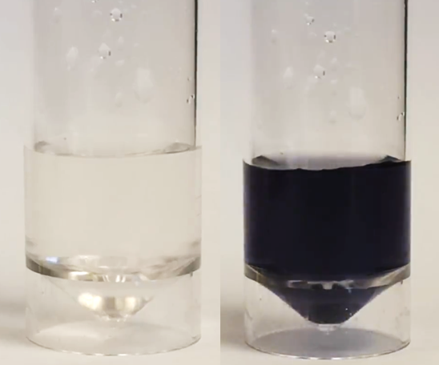

CfE Level 3

Through experimentation, I can identify indicators of chemical reactions having occurred. I can describe ways of controlling the rate of reactions and can relate my findings to the world around me **SCN 3-19a**

National 4 – Chemical Changes and Structure

Rates of reaction

CfE Higher –

Chemical Changes and Structure

Controlling the rate

Chemistry in Society

Getting the most from reactants

Clock reactions are amongst the most dramatic and visually pleasing chemical demonstrations[1].

Typically after a clock reaction has been started there is a period during which no noticeable change takes place and then a change (often in colour) occurs. This sudden and unexpected nature of the change gives clock reactions their charm and visual appeal.

The activity described here is an alternative to the iodine clock reaction.

Oxidation of iodide by iron III ions in an acidic medium is a reaction that can easily be transformed into a clock reaction. Thiosulphate is used as a limiting reagent and starch as an indicator for I3− ions.

**Each group will need**

|  |  |
| --- | --- |
| **‘Normal’ scale** | **microscale** |
| 1 x 100 cm3 conical flask or beaker | 1 x bijou or other small vial |
| 2 x 25 cm3 measuring cylinder – or 1 that is washed out | 2 x Pasteur pipettes |
| Magnetic stirrer (optional) | Timer |
| 25 cm3 (for each run) of solutions A and B | A few cm3 (for each run) of solutions A and B |
| To make solutions A & B (both) | |
| Potassium iodide | Sodium thiosulphate |
| 0.3 mol l-1 Nitric acid | Iron nitrate-9-water |
| Distilled water | Starch |

**Preparation**

Prepare a 0.4% solution of starch.

**Solutions**

Solution A Dissolve 1.01g of iron III nitrate-9-water in 100 cm3 of 0.3 mol l-1 nitric acid

Solution B Dissolve 0.71g of potassium iodide and 0.079g of sodium thiosulphate in 100 cm3 of 0.4% starch solution

**Safety**



The nitric acid is a skin/eye irritant. Wear eye protection.

**It is the responsibility of teachers doing this demonstration to carry out an appropriate risk assessment.**

**To do**

‘Normal’ scale

1. Measure out 25 cm3 of solution A and add to a 100 cm3 beaker/flask
2. Place on a magnetic stirrer (if available) and start stirring.
3. Measure out 25 cm3 of solution B
4. Add solution B to the beaker/flask and simultaneously start the timer.
5. Watch the flask until the colour changes. Stop the timer and record the time.

Microscale

1. Measure out 1 cm3 of solution A (with a Pasteur pipette) and add to a bijou or other vial
2. Measure out 1 cm3 of solution B (with another Pasteur pipette or rinse the first one well)
3. Add solution B to the bijou/vial and simultaneously start the timer.
4. Watch the flask until the colour changes. Stop the timer and record the time.

It is also possible to do this on a real microscale as a ‘drop’ reaction on a sheet. See ‘Microscale Iron Clock’ for details.

**Results**

For these concentrations at room temperature, the delay is 10 – 15 seconds.

**What is happening?**

The solution goes an initial pale purple on combining the solutions. This is due to the [Fe(S2O3)]+ ion.

1. Fe3+ (aq) + S2O3 2+ (aq) ⮀ [Fe(S2O3)]+ (aq) *(purple)*

Iron 3+ will oxidise the iodide to form the I3- ion – being reduced to Fe2+ in the process

1. 2Fe3+ (aq) + 3I- (aq) 🡪 2Fe2+ (aq) + I3- (aq)

This will react with starch for form the familiar blue black complex BUT the thiosulphate ions react with the I3- ions first, reducing them back to I-. The ‘using up’ of the free thiosulphate shifts the equilibrium in 1) to the left, reducing the concentration of the purple iron-thiosulphate complex so the purple colour gradually fades.

1. I3- (aq) + 2S2O32+ (aq) 🡪 3I- (aq) + S4O62+ (aq)

These two reactions continue until there is no thiosulphate left. At this point the I3- ions can now react with the starch and the blue-black colour suddenly appears.

1. 2I3- (aq) + starch 🡪 starch-­I5- + I- (aq) *(Blue/black)*

1. From J Chem Ed Vol 85 No8 Aug 2008 p1123 Kinetics and Mechanism of Iodide Oxidation by Iron(III): A Clock Reaction Approach - Jurica Bauer and Vladislav Tomišic´