Chemistry Investigations
Treat ‘em to Tchaikovsky

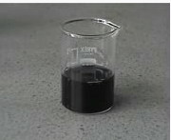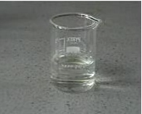
Introduction
Clock reactions are amongst the most dramatic and visually pleasing chemical demonstrations.
The activity described here is based on the so-called iodine clock reaction. When a solution of hydrogensulphite (or bisulphite) ions (HSO₃-) is mixed with a solution of iodate (IO₃-) ions and a starch solution, the mixture remains colourless for a time and then suddenly turns blue. The clock period (the time from mixing to colour change) can be changed by varying the concentrations of the reactants.
Whilst the chemistry of the iodine clock reaction is quite complex the effect of concentration on the rate can be readily shown and appreciated.
The aim in this particular activity is to create a series of solutions for which the clock period has been predicted based upon analysis of experimental data which you will generate.
Whilst you will principally be working in pairs each group’s contribution to the overall activity is equally important.
Each pair is provided with 2 flasks containing a known volume of distilled water (the actual volume is marked on the flask). Soluble starch (1.0 cm³) has been added to each of these 2 flasks.

Each group will need

2 x 250 cm³ conical flasks (with defined volumes of distilled water and starch) and bungs | 2 x 250 cm³ conical flasks, clean and dry with rubber bungs
2 x Pasteur pipette (3 cm³) | Access to a balance (0.1 g is fine)
1 x Variable pipette set to dispense exactly 3 cm³ (+ 6 pipette tips)* | 1 x Variable pipette set to dispense exactly 1 cm³ (+ 6 pipette tips)*
10 cm³ of 4% starch solution | 8 x test tubes (or other containers) each containing 8 cm³ of 0.038 mol l⁻¹ iodic acid solution.
20 cm³ (approx) of H₂SO₃ solution | Distilled water
+ marker pen, stop watch / timer, calculator, graph paper, ruler, pencil.

* If these are not available, use other pipettes – but the quantity added is important for the accuracy of the experiment.

To do
To ensure the accuracy of this experiment, it is important that the temperature remains constant. So make sure you hold the flasks by the neck so the contents are not heated by your hands.

Stage 1
- Each group has been given a number – make sure you know what yours is
- Add exactly 3.0 cm³ of H₂SO₃ solution to each of the two flasks containing water and starch.
Accurate timing is essential – make sure you know how to operate the timers beforehand
- Take one of the tubes containing iodic acid. Pour the iodic acid into the flask, starting the timer at the same time. Swirl to mix and put down on the bench
- Watch the flask until the colour changes. Stop the timer and record the time.
- Repeat steps 3 and 4 for the other flask prepared in step 2.
- Record the data, yours and that of the rest of the class, in table 1 (below)
Your teacher may ask you to enter the times into the appropriate place in a class spreadsheet and a graph can be plotted automatically.
You may or may not be asked to plot the graph yourself – If so, as you will see from the exemplar later, this is one of the few occasions where time does not go on the ‘x’ axis.

Table 1. Clock periods generated by the various groups

Volume of water in flask, cm³ | Clock period, s | Volume of water in flask, cm³ | Clock period, s
125 (Group 1) |  | 140 (Group 6)
125 (Group 1) |  | 145 (Group 6)
130 (Group 2) |  | 145 (Group 7)
130 (Group 2) |  | 145 (Group 7)
130 (Group 3) |  | 150 (Group 8)
135 (Group 3) |  | 150 (Group 8)
135 (Group 4) |  | 150 (Group 9)
135 (Group 4) |  | 155 (Group 9)
140 (Group 5) |  | 155 (Group 10)
140 (Group 5) |  | 155 (Group 10)

Example graph of class results
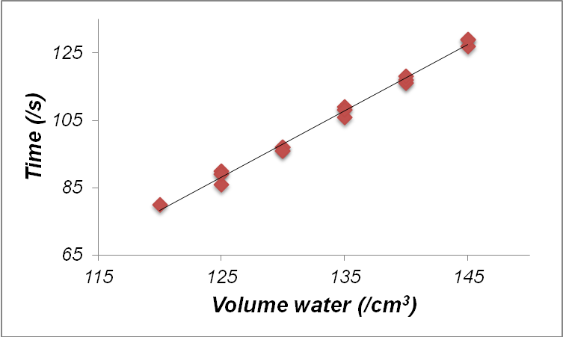Under the conditions used the reaction time is reasonably linear with respect to water volume. Typically at volumes below about 110 cm³ the reaction time is non-linear:

Stage 2
- Now use the graph you or the computer generated to work out what time volume of water you should put in their flasks to achieve a target times for your group as given in Table 2 (below)
Each group has two different target times, one flask for each pupil.
- You will then need to accurately measure out the amount of water to add to each flask. For this you will use a balance, assuming that water has a density of 1 g/^{cm3}.
- They then add 1.0 cm³ of starch solution to each flask (as accurately as possible.
.
- Now place your flask where told to by the teacher and get your tubes (one each) of iodic acid ready to put in when told to..
- At a given signal, while the music is playing, all of you will pour the iodic acid into your flasks at the same time, swirl and put them down.
- Watch and see how close to the cannon fire, the flasks change colour.

Table 2. Clock times required

Group number | Target Time (/s) | Flask Number | Group number | Target Time (/s) | Flask Number
Group 1 | 74 | 1 | Group 6 | 87 | 11
Group 1 | 76 | 2 | Group 6 | 87 | 12
Group 2 | 79 | 3 | Group 7 | 88 | 13
Group 2 | 81 | 4 | Group 7 | 88 | 14
Group 3 | 82 | 5 | Group 8 | 90 | 15
Group 3 | 83 | 6 | Group 8 | 92 | 16
Group 4 | 85 | 7 | Group 9 | 93 | 17
Group 4 | 85 | 8 | Group 9 | 96 | 18
Group 5 | 86 | 9 | Group 10 | 120 | 19
Group 5 | 86 | 10 | Group 10 | 120 | 20

Safety
The chenicals used in this experiment are, at the concentrations used, all of no significant hazard.

