Chemical Investigations
Gravimetric analysis of Nickel in a salt
Pupil Guide
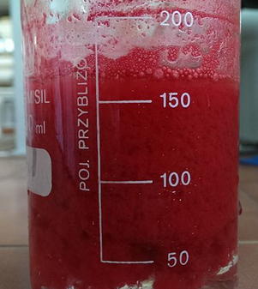
Image by Asphalt91 (slightly cropped) via Wikimedia Commons under a Creative Commons License
Introduction
Gravimetric analysis can be used to determine the nickel content of a nickel(II) salt. This can be achieved by reacting the nickel(II) ions with dimethylglyoxime (butanedione dioxime) in the presence of a slight excess of ammonia to form an insoluble complex:
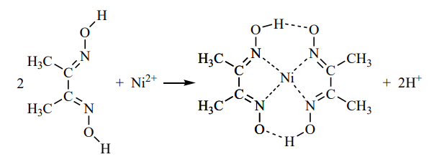
Nickel II dimethylgyloximate
Dimethylglyoxime

The complex, nickel(II) dimethylglyoximate, is filtered from the reaction mixture, dried and weighed.

Safety
Dimethyl glyoxime is a flammable solid and the solution in ethanol is highly flammable – keep away from sources of ignition.
The solid is toxic if ingested but the 0.1 mol l⁻¹solution is of low hazard other than its flammability.
Nickel chloride is toxic if inhaled or swallowed. It is a carcinogen (if inhaled) and a mutagen and reproductive toxin. It is also a skin irritant and sensitiser and a target organ toxin of the lungs. The solution retains most of these hazards.
Wear goggles and gloves when handling it and avoid raising dust.
2 mol l⁻¹ ammonia causes serious eye damage and gives off irritating fumes
Wear goggles and work in a well-ventilated laboratory.

You will need
Hydrated nickel(II) chloride | Ammonia 2 mol l⁻¹
Dimethylglyoxime 0.1 mol l⁻¹ in ethanol | Hydrochloric acid 2 mol l⁻¹
Beaker 500 cm³ | Measuring cylinder(s) 10/100 cm³
Buchner funnel & flask | Pump for Buchner funnel
Access to balance (0.001g if possible) | Weighing bottle
Access to oven | Dessicator
Hot plate | thermometer
Stirring rod | Pasteur pipette

To do
- Transfer approximately 0.5 g of hydrated nickel(II) chloride to a weighing bottle and weigh the bottle and contents.
- Add about 20 cm³ of deionised water to a 500 cm³ beaker and transfer the bulk of the nickel salt to the water.
- Reweigh the bottle with any remaining salt.
- Stir the mixture until the solid dissolves and add about 20 cm³ of 2 mol l⁻¹ hydrochloric acid.
- Dilute the mixture with deionised water to about 200 cm³.
- Heat the solution to 70–80°C on a hot plate and add approximately 50 cm³ of 0.1 mol l⁻¹ dimethylglyoxime in ethanol.
- Add 2 mol l⁻¹ ammonia solution dropwise and with constant stirring until a permanent red precipitate is obtained. Add a further 5 cm³ of the ammonia solution to provide a slight excess.
In all, you should have added about 30 cm³ of ammonia solution.
- Heat the beaker and contents on a steam bath for about 30 minutes
When the precipitate has settled test the clear liquid for complete precipitation by adding a few drops of the dimethylglyoxime and ammonia solutions. If more red precipitate appears then add about 5 cm³ of 0.1 mol l-1 dimethylglyoxime solution followed by about 3 cm³ of 2 mol l⁻¹ ammonia.
If no more precipitate appears the reaction has finished . . .
- Remove the beaker from the steam bath and allow it to cool to room temperature.
- Dry and weigh a filter paper to fit in the Buchner funnel
- Filter off the precipitate by vacuum filtration and wash the precipitate with a several portions of deionised water.
- Dry the filter paper and precipitate in the oven at 120°C for about 1 hour and then transfer to a desiccator.
- Once it has cooled to room temperature, reweigh.
- Calculate the percentage by mass of nickel in the sample of the hydrated nickel(II) chloride.
- Compare this experimental value with the calculated theoretical percentage by mass of nickel.

If you want to be extra accurate (and have the apparatus), you can use a sintered glass crucible for filtering the mixture.
Once it has dried, heat the crucible and contents to constant mass, i.e. reheat for about 15 minutes in the oven at 120°C, cool in the desiccator and reweigh until two successive readings are within 0.002 g of each other or within 0.01 g of each other if the balance is only accurate to 0.01 g.
What is happening?
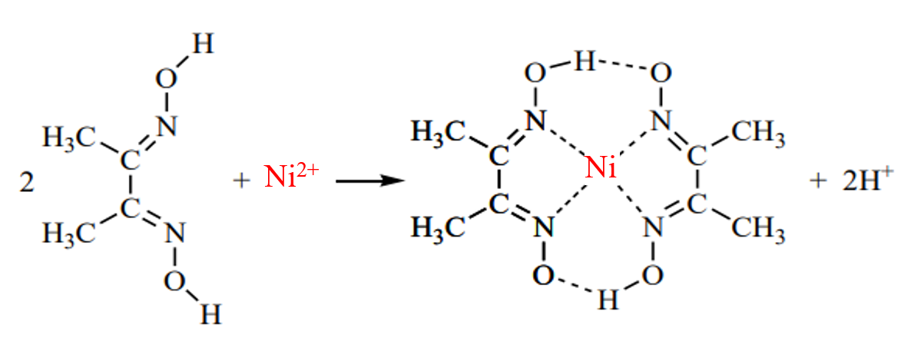
The above reaction occurs due to donation of the electron pairs on the four nitrogen atoms, not by electrons on the oxygen atoms.
The reaction is performed in an alkaline solution, due to the ammonia, to prevent the pH of the solution from falling too low.
If the pH drops below about pH 5 the equilibrium of the above reaction favours the formation of the nickel (Il) ion, causing the dissolution of complex.

