Microscale Chemistry
Ion migration
Teacher guide

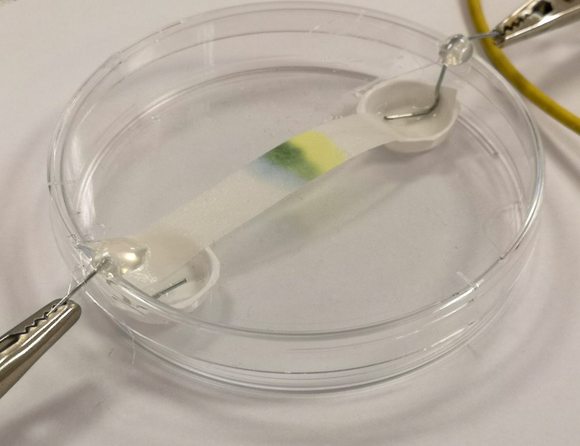

Curriculum for Excellence.
By contributing to experiments and investigations, I can develop my understanding of models of matter and can apply this to changes of state and the energy involved as they occur in nature. SCN 3-05a
National 4 – chemical change and structure
Atomic Structure and Bonding related to properties of materials.
National 5 – chemical change and structure
Atomic Structure and Bonding related to properties of materials.

Introduction
A demonstration to show the movement of coloured ions when an electric current is applied has been around since at least the 1960s.
The experiment used copper chromate as this contains both brightly coloured cations (copper – blue) and anions (chromate – yellow). The experiment, however, was rather fiddly to prepare and set up and took at least 30 minutes to produce results.
More recently, however, CLEAPSS developed a simpler, faster version. This newer version is smaller scale still and is also safer – as the whole process takes place inside a Petri dish.
Health & Safety
The copper chromate solution and the electrolyte are best both prepared in a fume cupboard. Chromates and dichromates are toxic and carcinogenic and should be handled with care.
If it is just a single, teacher demonstration, the amount of ammonia given off is small enough that the electrolyte can be added on the open bench.
If this is being carried out by a class, it would be prudent to add the chromate and the electrolyte in the fume cupboard and they can take the covered Petri dish back to their bench, thus avoiding exposure to ammonia.
You will need
1 prepared petri dish
Petri dish | 2 x Blisters from Indigestion tablets
2 small paper clips | Glue*
Pliers (optional)
copper chromate solution**
0.25g Copper sulphate | 0.2g potassium dichromate
1 cm³ 880 ammonia | Vial or small test tube & bung
Electrolyte (2% ammonium chloride in 2 mol l⁻¹ ammonia | Power supply or 9v battery plus connecting leads
Pasteur pipettes | Filter paper
Scissors

Preparation
- Remove the lid from your Petri dish.
- Cut out 2 blisters from the tray of indigestion tablets and glue them inside the Petri dish on opposite sides, close to the edge. Do not use a hot-melt glue-gun for this – they will melt.
- Take your 2 paper clips and open them up into an S shape (see right). Using pliers will help get the bends close to right angles, which is helpful. These are your electrodes. You may need to trim the end of the wire as well. It is important that the lower, small end is small enough to fit inside the blister – as shown
- Place the lid on the petri dish and, looking down from above, make a mark above the outer edge of the blister. (see right)
- Take a 3rd paper clip or anything similar, heat it in a flame briefly and melt two small holes in the lid where you made the marks.
- Insert the first of your bent paper clips through this hole and adjust the position so it sits in the bottom of the blister. Glue it in place. You may have to support it while the glue sets. This time a hot-melt glue-gun is ideal as it cools rapidly.
- Repeat with the other paper clip.
- You should end up with something that looks a little like this.

Preparing the copper chromate solution.
- Weigh out 0.25 g of copper sulphate-5-water, place in a small vial or test tube.
- Weigh out 0.2g potassium dichromate and add it to the copper sulphate
- Measure out 1 cm³ of 880 ammonia (this is best done in a fume cupboard) and add it to the solids.
- Replace the lid or bung and agitate until the solution dissolves.
It is in fact a very dark green which you can see if you hold it up to the light. This is merely an optical effect from the mixture of the blue copper and the yellow chromate ions.
Ammonia is used as this causes the copper to form the dark blue tetra-ammine complex which is soluble and much easier to see than the normal, light blue hexa-aqua complex.
The experiment
Preparation
- Cut a piece of filter paper narrower than the blisters and long enough to stretch across the Petri dish.
- Prepare your ammonium chloride/ammonia electrolyte if you have not already.
Method
- Place your filter paper so it spans the Petri dish with the two ends in each of the blisters – adding 1 drop of water at each end will make the paper easier to push into the blisters.
- Add 1 drop of your copper chromate mixture to the middle of the filter paper
- Add 10 drops or so of the electrolyte to each of the blisters and one or 2 along the length of the strip of filter paper. Just enough that it is all damp but not soaking.
- Place the prepared lid with its electrodes on top of the petri dish – making sure the 2 paper-clip electrodes are in fact touching the electrolyte.
- Connect the 2 electrodes to your power pack or battery and wait.

The setup should look something like this
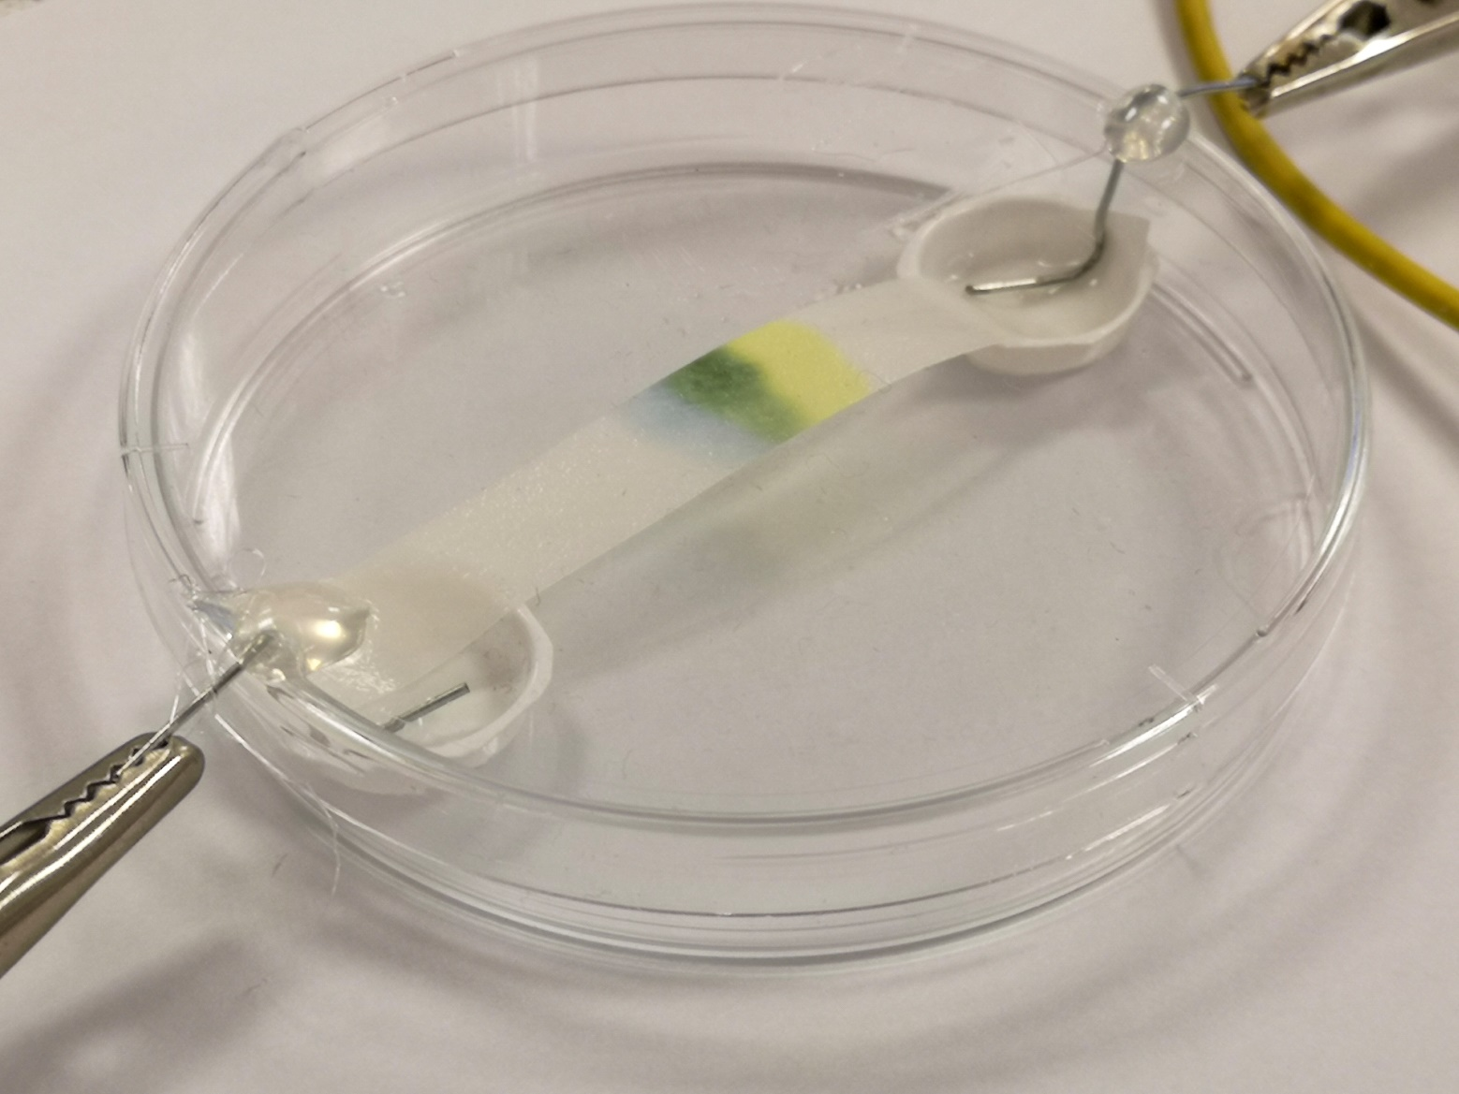
Results
After a few minutes you should see the colours starting to separate.
It will take about 15-20 minutes, however, to get a good separation – as in the image above.
You will see that the blue copper ions, which are positive, have moved towards the negative electrode, while the yellow chromate ions, which are negative, have moved towards the positive electrode.
What is happening?
Mixing copper sulphate and potassium chromate in solution creates copper chromate. This is a brown solid that is practically insoluble in water. The precise chemical nature of this precipitate does not appear to be straightforward.
Mixing the solids in concentrated ammonia, however, releases the ions, forming tetraammino copper ions [Cu(NH₃)₄] ²⁺ ions and chromate ions CrO₄ ²⁻ ions. (in alkaline conditions, dichromate (Cr₂O₇) becomes chromate CrO₄) Being soluble, these can move in solution – towards the opposite charge. It has the added advantage that the tetraammino copper ions are a more intense, darker blue than the aqueous copper ions so are more visible.

https://2g1hrx40gw3t1oo1bvqfy70u-wpengine.netdna-ssl.com/wp-content/uploads/2020/08/221-Ion-Migration.pdf

