Chemical Demonstration
Triboluminescent
Crystals
Teacher/Technician Guide
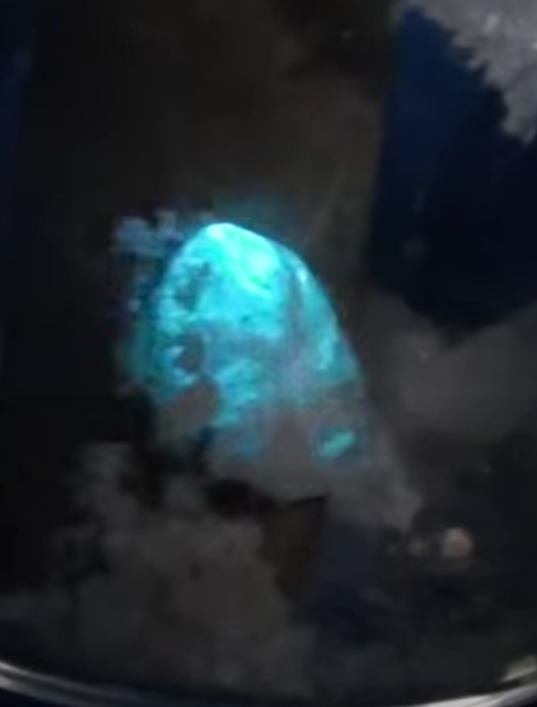

Introduction
Triboluminescence is a phenomenon in which light is generated when a material is mechanically pulled apart, ripped, scratched, crushed, or rubbed. The phenomenon is not fully understood, but appears to be caused by the separation and reunification of static electrical charges. Triboluminescence can be observed when breaking sugar crystals and peeling adhesive tapes. (from Wikipedia)
Triboluminescence was first recorded by Francis Bacon in 1605 when breaking the sugar crystals. Since then, triboluminescence has been found in many solids, such as rocks, quartz, alkaline halide, molecular crystals, and some organic materials. It is estimated that nearly 50% of inorganic compounds and 30% of organic molecular solids may show triboluminescence.
In most cases the light emitted is very faint and you need to have your eyes properly dark-adapted but this demonstration produces crystals that will emit light that is clearly visible - in subdued lighting at least.
You will need
copper thiocyanate | triphenylphosphine
pyridine | Methylbenzene (toluene) - optional
Access to a balance – preferable 3dp | Small beaker

Method
- Weigh out 0.121g of copper thiocyanate and 0.262g of triphenylphosphine and place in a small beaker.
Working in a fume cupboard
- Add to it 5 – 10 cm³ of pyridine.
- Heat the solution until dissolved.
- Turn off the heating and allow to evaporate until crystals form.
- Remove the supernatant and wash the crystals 3 times with 3 cm³ portions of toluene*.
- Allow to dry.
* If you just want to show the phenomenon, you can skip this step – it still works.

The demonstration
Place a small amount in a small vial or test tube and ‘bash’ with a glass rod or pencil.
‘Grinding’ it with a circular motion works best.
You will see flashes of blue light – this is best done in subdued light but does not need complete darkness.

Hints
Once the crystals are ground up small, they stop working – however, you can regenerate them by simply dissolving in pyridine and re-evaporating.

