Pupil

Experiment

Synthesis of Sudan I

Teacher/Technician Guide
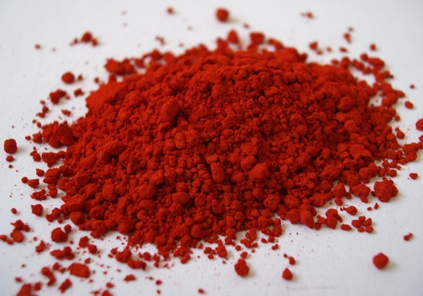

(Addition of Benzenediazonium Ion to 2-Naphthol)
Many synthetic dyes, often called diazo dyes, are based on diazonium chemistry that has been used for over 100 years in synthetic chemistry, and this experiment is an example of the synthesis of one such dye, 1-phenylazo-2-naphthol or more simply Sudan I.
Sudan I is an intensely orange-red solid that is added to colourise waxes, oils, petrol, solvents, and polishes. Sudan I has also been adopted for colouring various foodstuffs, especially curry powder and chili powder, although this is now banned in Europe due to fears of carcinogenicity.
The reaction involves two steps, the first being the preparation of a solution of the diazonium salt, benzenediazonium chloride, 2, from aniline,
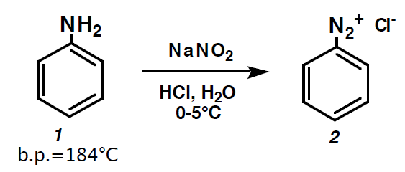
In the second step, the solution of 2 is added to 2-naphthol, to produce the diazo dye,
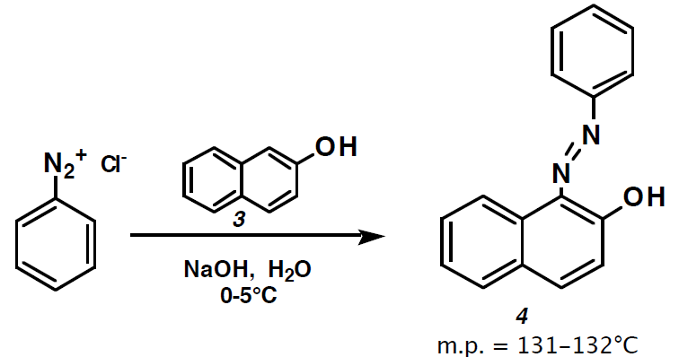

The dye can be analysed by visible light spectrophotometry.

You will need

Access to an ice bath | Access to vacuum filtration apparatus
3 cm³ & 1 cm³ pasteur pipettes | Stirring rod
Watch glass | Universal for mixing
5 cm³ of Solution 1 | 7.5 cm³ of solution 2
5 cm³ of Solution 3 | KI/Starch paper

Preparation
Solution 1
Sodium 2-naphtholate solution
Dissolve 40 mg (0.04g) of 2-naphthol, in 5 cm³ of 0.5 mol l⁻¹ NaOH. Set aside in an ice bath to cool until ready for use.
Solution 2
Benzene diazonium chloride.
- Measure out 50 cm³ of distilled water first.
- place 5 g of freshly distilled aniline in a beaker and add a roughly equal amount of distilled water: swirl to mix.
- Then add 25 cm³ of concentrated hydrochloric acid. This will produce heat and some fumes. Work in a fume cupboard or a well-ventilated lab.
- And finally add the remainder of the 50 cm³ of distilled water
- If it has not dissolved already then warm and agitate this solution to dissolve the aniline hydrochloride and then cool it in an ice bath to 0°C.
It is important to keep the reaction cooled to 0°C since, above 5°C, diazonium salts can form aryl radicals.
Solution 3
Sodium nitrate(II) (nitrite) solution
Dissolve 4g of sodium nitrate(II) in 50 cm³ of distilled water.

All the solutions should all be cooled on ice.

To do
Step 1 – preparation of the benzene diazonium chloride solution

- Add the sodium nitrite solution drop-wise to the acidic diazonium chloride solution while maintaining the reaction at ice bath temperature.
- Agitate the solution by stirring or swirling the reaction tube the reaction tube
- Five minutes. after the addition of the sodium nitrite solution is complete, test the reaction solution for excess nitrous acid, HNO₂,
- Touch a small drop of it on the tip of a microspatula (or use a cocktail stick) to a piece of KI/starch (starch iodide) paper.
- If the test is positive (immediate purple colour), add urea, a few crystals at a time with cooling and agitation. Test with KI/starch paper again and continue adding urea a few crystals at a time until the KI/starch test is negative.

Step 2 – Preparation of the Azo dye
- Add a small piece of ice to the ice cold solution of sodium 2-naphtholate (Solution 1).
- Dropwise, add the benzene diazonium chloride solution you prepared in step 1 while keeping both solutions on ice at 0-5°C. Agitate the reaction tube by stirring with a spatula or glass rod to ensure complete mixing.
- The reaction initially forms a blood red solid, but this changes to a reddish orange precipitate as the pH becomes acidic with the addition of the diazonium chloride/sodium nitrite solution.
- After complete addition, leave the reaction mixture at ice bath temperature for 15 min. with occasional agitation.
- Filter the mixture by vacuum filtration, washing twice with about 5 cm³ of cold, distilled water.
- Leave to dry.
- Once dry, weigh the crude dye product, and set aside a small amount for a mp determination.
- Recrystalize the crude product from ethanol.
Do NOT heat the dye too much because you will turn your nice red dye into a black-brown mess.
- Filter, dry, and weigh the product.
Typical yields are about 40 to 50% (or 30 to 40 mg). Determine the m.p’s of this and the crude product.
Extension - Visible Light Absorption
Prepare a dilute solution for analysis
- dissolve about 1 mg of the red product in 2 cm³ of 30% KOH
- add 100 cm³ of methanol and mix.
Use a suitable spectrophotometer to take a visible spectrum between 350 nm and 750 nm.
After running the visible spectrum of this basic solution, add a drop of concentrated hydrochloric acid to the sample cuvette and mix.
Check that the solution is acidic with pH paper, and run another absorption spectrum. You should see a shift in the spectrum as the pH is changed.
If any peak is too high, dilute the solution with methanol

Synthesis of Sudan I – Technician Guide.
Each Group will need

Access to an ice bath | Access to vacuum filtration apparatus
3 cm³ & 1 cm³ pasteur pipettes | Stirring rod
Watch glass | Small beaker or vial for mixing
5 cm³ of Solution 1 | 7.5 cm³ of solution 2
5 cm³ of Solution 3 | KI/Starch paper
Access to vacuum filtration apparatus | Ethanol (IDA) for recrystallisation)

Solution 1
Each group needs about 5 cm³
Dissolve 0.4g naphthalene-2-ol in 50 cm³ of 1 mol l⁻¹ sodium hydroxide.
Chill in an ice bath

Solution 2
Each group needs about 7.5 cm³
5 cm³ of aniline
Add 50 cm³ of distilled water and
25 cm³ of concentrated HCl
Warm and stir to dissolve aniline HCl (if needed)
Chill in an ice bath

Solution 3
Each group needs about 5 cm³
Dissolve 4g of Sodium nitrate II (nitrite) in
50 cm³ of distilled water
Chill in an ice bath

Adapted from K. L. Williamson, Macroscale and Microscale Organic Experiments, 2nd Ed. 1994, Houghton Mifflin,

