|  |
| --- |
| Microscale Chemistry |
| Photochemical catalysis |

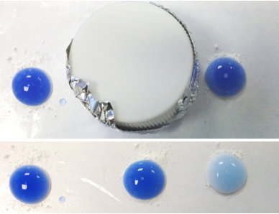

CfE Higher – Chemical change and structure

*Catalysts*

CfE Advanced higher

Inorganic and Physical Chemistry

*Catalysis by transition metals*

# Introduction

Purification of water and air is a constant challenge to chemists and biologists. One promising new line of research uses photocatalysis involving titanium dioxide.

Exposing TiO2 to UV radiation in an aqueous environment can lead to the formation of highly oxidising species derived from oxygen, which are capable of converting organic material (e.g. bacteria) to harmless inorganic by-products.

It has the added advantage that TiO2 is plentiful and cheap and uv light is readily and freely available from sunlight.

The version here uses a microscale approach to ensure that the reaction happens quickly.

## You will need

|  |  |
| --- | --- |
| Reaction sheet | DCPIP solution |
| TiO2 powder | Pasteur pipette(s) |
| spatula | Other oxides eg SiO2, Al2O3 (optional) |
| Hand-held uv light (or sunshine) |  |

## To Do

### Preparing the DCPIP solution

Stock DCPIP solution – 0.05g in 100 cm3 of distilled/deionised water.

Reaction mixture – 1 cm3 stock DCPIP solution, 5 cm3 distilled/deionised water, 8 drops propan-1,2,3-triol (glycerol)

### The experiment

1. Place 5 drops of the DCPIP reaction mixture in each of the circles marked.
2. Add, according to the instructions on the sheet,
   1. TiO2 to 2 circles
   2. SiO2 / Al2O3 and/or other oxides to the other drops.
3. Cover one of the drops as a control – a bottle top works well for this.
4. Support a small uv light with a clamp and hold it about 10 cm above the sheet (or expose the sheet to sunlight).
5. Leave for 5 – 10 minutes until you see a clear colour change.

### Results

You should clearly see that only one of the drops of blue liquid has changed colour – the one with TiO2 that was exposed to the uv light.

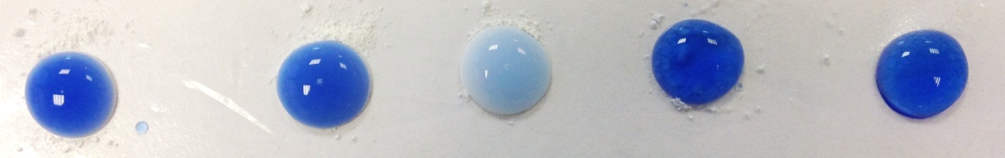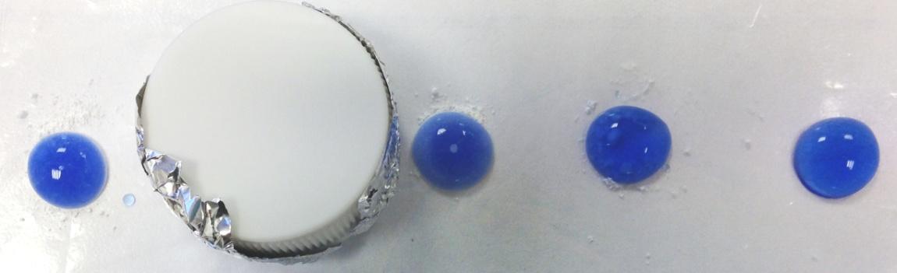

## What is happening?

When TiO2 absorbs UV radiation it can promote an electron from the valance to the conductance band. This results in the formation of a “free electron” and a “positive hole” (Figure 1). The electrons can be donated to an appropriate acceptor and the “positive holes” can accept electrons from an appropriate donor. In this way TiO2 can both reduce and oxidise chemical species in solution.

Exposing TiO2 to UV radiation in an aqueous environment can lead to the formation of highly oxidising species derived from oxygen and water (highlighted in red in the diagram below). The hydroxyl radical (OH**.**) is a particularly powerful oxidising agent capable of converting organic material (e.g. bacteria) to benign inorganic by-products. For these reasons several researchers are examining the use of TiO2 in air/water purification.

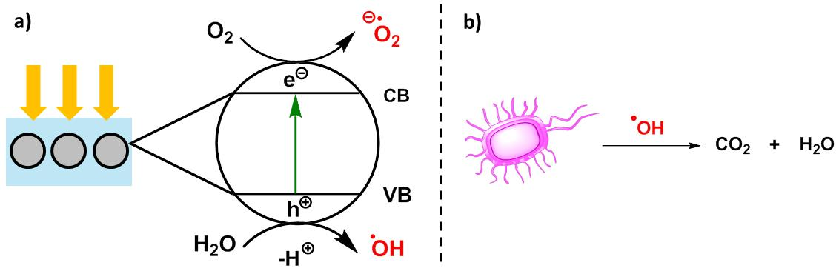

TiO2 catalysed formation of superoxides and hydroxyl radicals in water.

Conversion of organic material to benign by-products as a method for water purification.

In this experiment we will examine the use of TiO2 as a photocatalyst.

We will excite TiO2 with UV radiation in the presence of the organic dye 2,6-dichlorophenolindophenol (DCIP). The dye is able to accept electrons from TiO2 leading to a colour change.



Glycerol is also present in the reaction mixture and acts as a “sacrificial electron donor”. Glycerol is ultimately oxidised through a complex pathway to carbon dioxide and water.

# Extensions

Sacrificial electron donors you can investigate the effect of having no glycerol (Just add 1 drop of the stock DCPIP solution to 5 drops of water.

Other dyes Try the same experiment with other redox dyes such as methylene blue. Do they work?

Photocatalysis

Use a Pasteur pipette to place 5 drops of your photocatalytic solution in each of the circles **A to E** below.

In circle F, add 5 drops of distilled/deionised water and 1 drop of DCPIP stock solution

Add a spatula tip of the TiO2 powder (or SiO2 / Al2O3) to each of circles **B – F** as shown.

Place a bottle top over circle 2 – to keep the uv light out.

|  |  |  |  |  |  |
| --- | --- | --- | --- | --- | --- |
| A | B | C | D | E | F |
|  |  |  |  |  |  |
| No TiO2 - light | TiO2 - Dark | TiO2 - Light | SiO2 - Light | Al2O3 - Light | SiO2 – Light  (no glycerol) |

Either - Shine a uv light on it using a small, hand-held light (ideally held in a clamp)

OR - place the sheet in the sunshine (being careful not to spill anything)

Wait for 5-10 minutes and observe any changes.

*(Use the extra circles below for any further investigations you wish to make)*

|  |  |  |  |  |  |
| --- | --- | --- | --- | --- | --- |
| A | B | C | D | E | F |
|  |  |  |  |  |  |
|  |  |  |  |  |  |

|  |  |  |  |  |  |
| --- | --- | --- | --- | --- | --- |
| A | B | C | D | E | F |
|  |  |  |  |  |  |
|  |  |  |  |  |  |