

|  |
| --- |
| Chemistry Investigations |
| Treat ‘em to Tchaikovsky |

**Introduction**

CfE Level 3

Through experimentation, I can identify indicators of chemical reactions having occurred. I can describe ways of controlling the rate of reactions and can relate my findings to the world around me **SCN 3-19a**

National 4 – Chemical Changes and Structure

Rates of reaction

CfE Higher –

Chemical Changes and Structure

Controlling the rate

Chemistry in Society

Getting the most from reactants

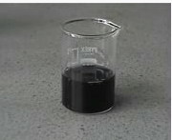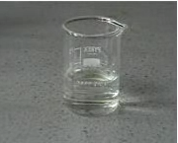

Clock reactions are amongst the most dramatic and visually pleasing chemical demonstrations[1].

Typically after a clock reaction has been started there is a period during which no noticeable change takes place and then a change (often in colour) occurs. This sudden and unexpected nature of the change gives clock reactions their charm and visual appeal.

The activity described here is based on the so-called iodine clock reaction. When a solution of hydrogensulphite (or bisulphite) ions (HSO3-) is mixed with a solution of iodate (IO3-) ions and a starch solution, the mixture remains colourless for a time and then suddenly turns blue. The clock period (the time from mixing to colour change) can be changed by varying the concentrations of the reactants.

Whilst the chemistry of the iodine clock reaction is quite complex the effect of concentration on the rate can be readily shown and appreciated. The aim in this particular activity is to create a series of solutions for which the clock period has been predicted based upon analysis of experimental data which the pupils will generate.

Whilst they will principally be working in pairs each group’s contribution to the overall activity is equally as important.

Each pair is provided with 2 flasks containing a known volume of distilled water (the actual volume is marked on the flask). Soluble starch (1.0 cm3) has been added to each of these 2 flasks.

**Each group will need**

|  |  |
| --- | --- |
| 2 x 250 cm3 conical flasks (with defined volumes of distilled water and starch) and bungs | 2 x 250 cm3 conical flasks, clean and dry with rubber bungs |
| 2 x Pasteur pipette (3 cm3) | Access to a balance (0.1 g is fine) |
| 1 x Variable pipette set to dispense exactly 3 cm3 (+ 6 pipette tips)* | 1 x Variable pipette set to dispense exactly 1 cm3  (+ 6 pipette tips)* |
| 10 cm3 of 4% starch solution | 8 x test tubes (or other containers) each containing 8 cm3 of 0.038 mol l-1 iodic acid solution. |
| 20 cm3 (approx) of H2SO3 solution | Distilled water |
| + marker pen, stop watch / timer, calculator, graph paper, ruler, pencil. |  |

* If these are not available, use other pipettes – but the quantity added is important for the accuracy of the experiment.

H2SO3 solution Prepare 250 cm3 of a 0.2 mol l-1 solution of Sodium hydrogen sulphite (NaHSO3)

Prepare 250 cm3 of 0.1 mol l-1 sulphuric acid.

Mix the two solutions.

# To do

To ensure the accuracy of this experiment, it is important that the temperature remains constant.

* Allow all reagents to equilibrate at room temperature.
* Make sure the flasks are held by the neck so the contents are not heated by pupils’ hands.

**Stage 1**

1. Each group is given a number
2. Add exactly 3.0 cm3 of H2SO3 solution to each of the two flasks containing water and starch.
3. Take one of the tubes containing iodic acid. Pour the iodic acid into the flask, starting the timer at the same time. Swirl to mix and put down on the bench

Accurate timing is essential – make sure pupils know how to operate the timers beforehand,

1. Watch the flask until the colour changes. Stop the timer and record the time.
2. Repeat steps 3 and 4 for the other flask prepared in step 2.
3. The times should be entered into the appropriate place in a class spreadsheet and the graph plotted. (It is also a good idea for pupils to record the data themselves in table 1 (below)

**Table 1. Clock periods generated by the various groups**

|  |  |  |  |
| --- | --- | --- | --- |
| *Volume of water in flask, cm3* | *Clock period, s* | *Volume of water in flask, cm3* | *Clock period, s* |
| *125 (Group 1)* |  | *140 (Group 6)* |  |
| *125 (Group 1)* |  | *145 (Group 6)* |  |
| *130 (Group 2)* |  | *145 (Group 7)* |  |
| *130 (Group 2)* |  | *145 (Group 7)* |  |
| *130 (Group 3)* |  | *150 (Group 8)* |  |
| *135 (Group 3)* |  | *150 (Group 8)* |  |
| *135 (Group 4)* |  | *150 (Group 9)* |  |
| *135 (Group 4)* |  | *155 (Group 9)* |  |
| *140 (Group 5)* |  | *155 (Group 10)* |  |
| *140 (Group 5)* |  | *155 (Group 10)* |  |

**Stage 2**

1. Pupils use the graph generated above to work out what time volume of water they should put in their flasks to achieve a target time as given in Table 2 (below)

Each group has two different target times, one flask for each pupil.

1. Pupils then use a balance to accurately measure out the amount of water to add to each flask– assuming that water has a density of 1 g/cm3
2. They then add 1.0 cm3 of starch solution to each flask (as accurately as possible.

The reason for the specific timings given is that they are designed to go along with a recording of Tchaikovsky’s 1812 overture – To be precise, they are designed to coincide with the firing of the cannons in the final section.

1. Get the music ready and prepare the pupils to add their tubes of iodic acid to the flask on your signal – It is preferable to arrange the flasks, and pupils so everyone can see all the flasks.
2. At the end of the long descending section, get all the pupils to pour the iodic acid into their flasks at once, swirl and put them down. (at 1m 25s)
3. Watch and see how close to the cannon fire, the flasks change colour.

**The Chemistry**

The overall process can be represented[2] by the following sequence of reactions:

|  |  |
| --- | --- |
| IO3- (aq) + 3 HSO3- (aq) 🡪 I- (aq) + 3 SO42- (aq) + 3 H+ (aq) | **(1)** |
| IO3- (aq) + 8 I- (aq) + 6 H+ (aq) 🡪 3 I3- (aq) + 3 H2O | **(2)** |
| I3- (aq) + HSO3- (aq) + H2O (l) 🡪 3 I- (aq) + SO42- (aq) + 3 H+ (aq) | **(3)** |
| 2 I3- (aq) + starch (blue) starch-I5- complex + I- (aq) | **(4)** |

In reaction (1) hydrogensulphite ions reduce iodate ions to iodide ions and

in reaction (2) these iodide ions are oxidized by iodate ions to triiodide ions.

At this point the solution contains triiodide and starch which are the components of the blue starch-iodine complex whose formation co-occurs in reaction 4.

**However**, reaction 3 is so rapid that the formation of the blue complex is prevented.

Once all of the hydrogensulphite has been consumed then reaction 4 is no longer suppressed and the blue complex forms. So, the solution remains colourless whilst there is still hydrogensulphite present. Once the hydrogensulphite is gone the blue colour appears.

Under the conditions used the reaction time is reasonably linear with respect to water volume. Typically at volumes below about 110 cm3 the reaction time is non-linear:

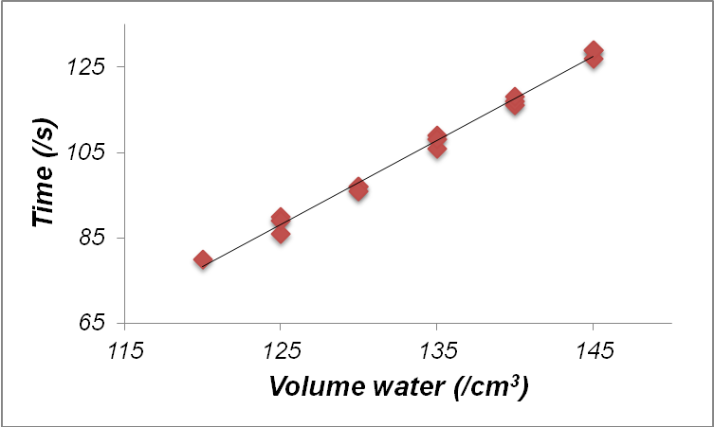

This reaction is based on an article of the same name by: Mark Whitman (1983), J. Chem. Educ., 60, 229**Table 2. Clock times required**

|  |  |  |  |  |  |
| --- | --- | --- | --- | --- | --- |
| ***Group number*** | ***Target Time (/s)*** | ***Flask Number*** | ***Group number*** | ***Target Time (/s)*** | ***Flask Number*** |
| *Group 1* | *74* | *1* | *Group 6* | *87* | *11* |
| *Group 1* | *76* | *2* | *Group 6* | *87* | *12* |
| *Group 2* | *79* | *3* | *Group 7* | *88* | *13* |
| *Group 2* | *81* | *4* | *Group 7* | *88* | *14* |
| *Group 3* | *82* | *5* | *Group 8* | *90* | *15* |
| *Group 3* | *83* | *6* | *Group 8* | *92* | *16* |
| *Group 4* | *85* | *7* | *Group 9* | *93* | *17* |
| *Group 4* | *85* | *8* | *Group 9* | *96* | *18* |
| *Group 5* | *86* | *9* | *Group 10* | *120* | *19* |
| *Group 5* | *86* | *10* | *Group 10* | *120* | *20* |

**Safety**

**Carry out in a well-ventilated area**



Wear eye protection. Consider wearing gloves

**It is the responsibility of teachers doing this demonstration to carry out an appropriate risk assessment.**

1. Shakhashiri, B.Z. (1992), Clock Reactions in *Chemical Demonstrations: A Handbook for Teachers of Chemistry* *Volume 4,* pp 3-89, University of Wisconsin Press, Madison
2. Shakhashiri, B.Z. (1992), Clock Reactions in *Chemical Demonstrations: A Handbook for Teachers of Chemistry* *Volume 4,* pp 3-89, University of Wisconsin Press, Madison.