Chemical Investigations
Reactions of Metals with Oxygen
Pupil Guide
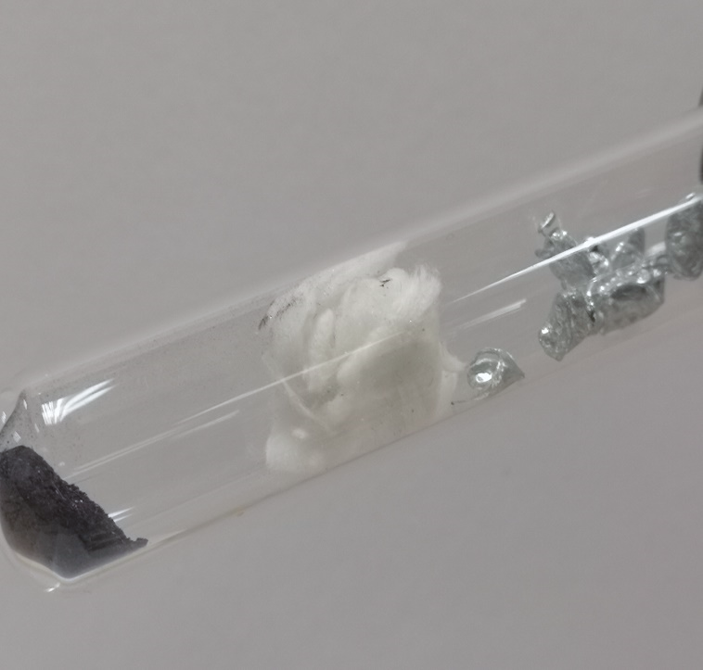

Reactions of Metals with Oxygen
UNIT 3 PPA 3
INTRODUCTION
Some metals, like potassium and sodium, are highly reactive but others, like platinum and gold, are unreactive. The majority of metals however lie between these two extremes.
We can put metals in order of reactivity by comparing their reactions with a variety of chemicals. In this experiment their reactions with oxygen will be compared. Potassium permanganate will be used to provide the oxygen - it does this when it decomposes on heating.
The aim of this experiment is to place zinc, copper and magnesium in order of reactivity by observing the ease with which they react with oxygen.
Different Metals
Each group will need
dry test tubes | clamp stand and clamp
Bunsen burner and heating mat | mineral wool
tongs
samples of zinc, copper and magnesium | potassium permanganate

Safety
Wear eye protection.

Procedure
Your teacher/lecturer will demonstrate the experiment using one of the metals.
- To a dry test tube add potassium permanganate crystals to a depth of about 1 cm.
- Place a loose plug of mineral wool immediately above the potassium permanganate crystals.
- Clamp the test tube at the mouth and in a horizontal position. Make sure that the mouth of the test tube is not pointing at anyone.
- Add a piece of zinc to the test tube placing it about half-way along the tube. Make sure the zinc is well separated from the potassium permanganate.
- Heat the contents of the test tube as demonstrated by your teacher/lecturer.
- Observe the metal as it reacts with oxygen and record your observations.
- Repeat steps 1 - 6 with copper and then with magnesium. Each time record your observations
Results sheet
State the aim of the experiment clearly indicating the factor you are investigating.

Procedure
Draw a labelled diagram of the assembled apparatus.

Results
Complete the following table:

Conclusion
State the conclusion of the experiment.

