Chemical Investigations
Factors affecting Voltage
Teacher/Technician Guide
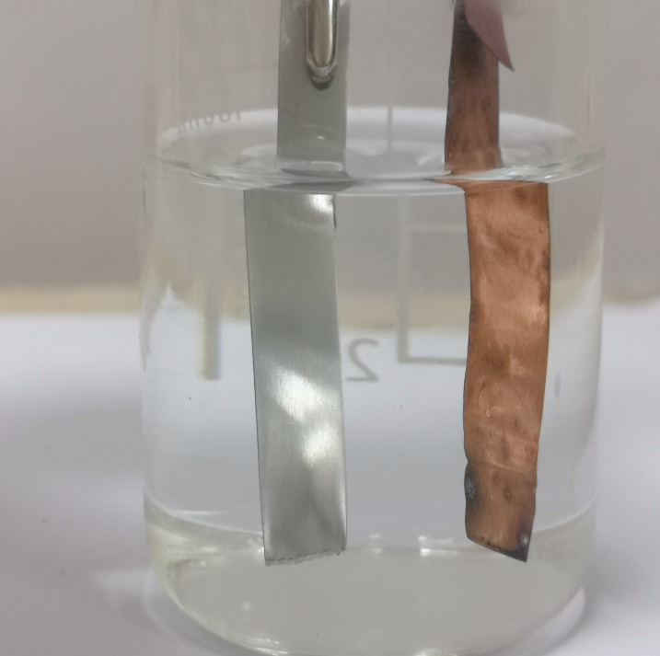

Factors affecting Voltage
UNIT 3 PPA 2
INTRODUCTION
A cell is a device in which a chemical reaction is used to produce electricity. One type of cell, known as a simple cell, can be made by dipping two different metals into a solution which is able to conduct a current of electricity. The metals are the electrodes of the cell and the conducting solution is called the electrolyte. By connecting the two electrodes to a voltmeter, the voltage which the cell generates can be measured.
The aim of this experiment is to investigate a factor which might affect the size of the voltage generated by a simple cell.
Some factors which could be investigated include:
- the metals used
- the electrolyte used
- the concentration of the electrolyte.
From the first two in this list of factors choose one to investigate and proceed to the appropriate section below.
Different Metals
Each group will need
beaker with electrode holder | connecting wires
voltmeter | emery paper
rods of copper, zinc and iron* | 0.1 mol l⁻¹ sodium chloride solution

* Foil could be used instead
Safety
There are no significant hazards with this experiment.

Procedure
- Half fill the beaker with sodium chloride solution.
- Clean the copper and zinc rods with emery paper and wash them. Insert these rods into the electrode holder and place it in the beaker. Make sure the rods are dipping into the sodium chloride solution.
- Connect the rods to the voltmeter and measure and record the voltage generated by the cell.
- To obtain duplicate results, remove the rods and repeat steps 2 and 3.
- Repeat the experiment two more times: first with the copper and iron rods and then with the zinc and iron rods. Each time measure and record the voltage generated by the cell and obtain duplicate results.
Different Electrolytes
Each group will need
beaker with electrode holder | connecting wires
voltmeter | emery paper
rods of copper and zinc* | sodium chloride solution
0.1 mol l⁻¹ Hydrochloric acid | 0.1 mol l⁻¹ Sodium hydroxide solution

* Foil could be used instead

Safety
There are no significant hazards with this experiment.

Procedure
- Half fill the beaker with sodium chloride solution.
- Clean the copper and zinc rods with emery paper and wash them. Insert these rods into the electrode holder and place it in the beaker. Make sure the rods are dipping into the sodium chloride solution.
- Connect the rods to the voltmeter and measure and record the voltage generated by the cell.
- To obtain duplicate results, remove the rods and repeat steps 2 and 3.
- Repeat the experiment two more times: first with the hydrochloric acid as electrolyte and then with the sodium hydroxide solution. Each time measure and record the voltage generated by the cell and obtain duplicate results.

