Chemical Investigations
Preparation of a Salt
Teacher/Technician Guide
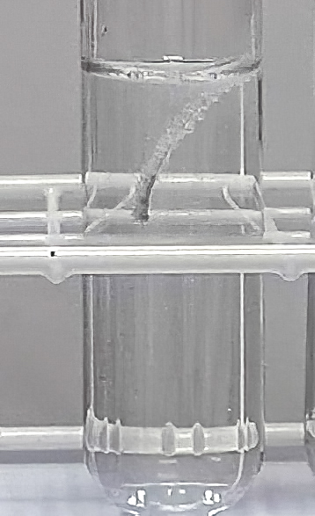

Preparation of a Salt
UNIT 3 PPA 1
INTRODUCTION
A salt is formed when the hydrogen ions of an acid are replaced by metal ions or ammonium ions. For example, if the hydrogen ions in sulphuric acid were replaced by magnesium ions then the salt magnesium sulphate would be formed.
The aim of this experiment is to prepare a pure sample of magnesium sulphate.
Making magnesium sulphate can be achieved in a number of ways. These include reacting an excess of magnesium or magnesium carbonate with sulphuric acid. An excess has to be used to make sure all the acid is used up. If any acid remained then the salt would be impure.
The fact that a gas is produced on reacting magnesium or magnesium carbonate with an acid allows us to tell when all the acid has been consumed. At this point no more bubbles of gas will appear and the excess magnesium or magnesium carbonate will remain as a solid in the reaction mixture.
Decide which method you will use to make magnesium sulphate (reacting magnesium with sulphuric acid or reacting magnesium carbonate with sulphuric acid) and then proceed as outlined below.
Each group will need
50 – 100 cm³ measuring cylinder | 100 cm³ glass beaker
glass rod | filter funnel and paper
250 cm³ conical flask | evaporating basin
tripod | Bunsen burner and heating mat
hand lens | 0.5 mol l⁻¹ sulphuric acid
0.5g magnesium turnings or
1.5g magnesium carbonate

Safety
Sulphuric acid is an irritant. Wear eye protection.
Avoid breathing in any acid mist. This experiment should be carried out in a well-ventilated room or in a fume cupboard.

Procedure
- Using a measuring cylinder add 20 cm³ of dilute sulphuric acid to the beaker.
- Add a spatulaful of magnesium or magnesium carbonate to the acid and stir the reaction mixture with the glass rod.
- If all the solid reacts add another spatulaful of magnesium or magnesium carbonate and stir the mixture.
- Continue adding the magnesium or magnesium carbonate until no more bubbles of gas are produced and some of the solid remains unreacted.
- Place the filter funnel in the neck of the conical flask. Fold the filter paper and insert it in the funnel.
- Carefully pour the reaction mixture into the filter paper.
- When the filtration is complete, transfer the salt solution from the conical flask into the evaporating basin.
- Place the evaporating basin on the tripod and carefully heat the salt solution until about half the water has boiled off.
- Let the basin cool before transferring it to a safe place. Leave it until your next lesson to allow the solution to crystallise slowly.
- Transfer the crystals onto a piece of filter paper. Examine them with a hand lens and draw one of the crystals.

