Chemical Investigations
Hydrolysis of Starch
Pupil Guide
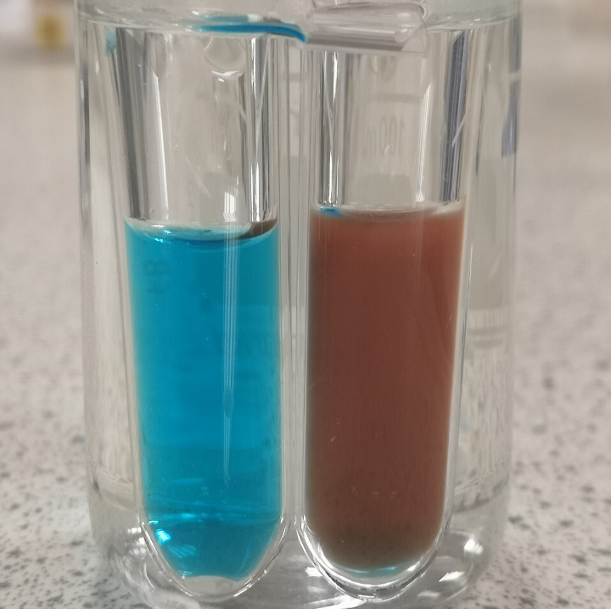

Hydrolysis of Starch
UNIT 2 PPA 3
INTRODUCTION
Starch is a condensation polymer made from glucose monomer units. When these large starch molecules react with water they break down into smaller sugar molecules. The starch is said to be hydrolysed. We can tell if starch has been hydrolysed by testing for the small sugar molecules that are formed in the process. This can be achieved by heating the reaction mixture with Benedict's solution. Benedict's solution is blue but turns cloudy orange if certain sugar molecules† are present.
Starch hydrolysis is a very slow reaction but it can be speeded up by using an enzyme or an acid as catalyst.
The aim of this experiment is to hydrolyse starch in the presence of either an enzyme or an acid and to demonstrate that the enzyme or acid catalyses the reaction.
Decide which catalyst (the enzyme or the acid) you are going to use and then proceed to the appropriate section below.
† Not all sugars give a positive test with Benedict's solution but those formed in starch hydrolysis do.

Enzyme catalysis
Each group will need

test tubes and rack | large glass beaker
syringes | thermometer
mineral wool | Bunsen burner and heating mat
Tripod | starch solution
amylase (enzyme) solution | Benedict's solution

Safety
Wash off any solutions on skin straight away.

Procedure
- Half fill the beaker with water and heat it until it reaches about 40 °C but no more.
- Using a syringe add 3 cm³ of starch solution to each of two test tubes.
- To one of the test tubes add 1 cm³ of water from a syringe - this will be the control. To the other test tube carefully add 1 cm³ of amylase solution.
- Place both test tubes in the beaker of warm water and leave them for 5 minutes.
- After 5 minutes, use a syringe to add 2 cm³ of Benedict's solution to each test tube.
- Keep the test tubes in the beaker of water and then heat the water until it boils.
- Observe and record what happens to the Benedict's solution in each test tube.

Acid catalysis
Each group will need

test tubes and rack | large glass beaker
syringes | thermometer
mineral wool | Bunsen burner and heating mat
Tripod | starch solution
dilute hydrochloric acid | Benedict's solution
sodium hydrogencarbonate

Safety
Wash off any solutions on skin straight away.

Procedure
- Using a syringe add 10 cm³ of starch solution to each of two small beakers.
- To one of the beakers add 1 cm³ of water from a syringe - this will be the control. To the other beaker add 1 cm³ of dilute hydrochloric acid.
- Place the beakers on the tripods and heat the reaction mixtures until they boil. Continue gentle boiling of the mixtures for 5 minutes and then remove the Bunsen burners.
- Take great care in this next step since the mixture will froth up quite violently.
- Using a spatula add a tiny amount (equivalent to half a pea) of sodium hydrogencarbonate† to the beaker containing the acid/starch mixture. It is not necessary to add sodium hydrogencarbonate to the other mixture.
† The sodium hydrogencarbonate is added to neutralise the acid catalyst since Benedict's test won't work in acidic conditions.
- Continue adding tiny amounts of sodium hydrogencarbonate until no more bubbles of gas are produced.
- Using a syringe add 5 cm³ of Benedict's solution to each beaker and heat the reaction mixtures.
- Observe and record what happens to the Benedict's solution in each beaker.

Results sheet
State the aim of the experiment clearly indicating which catalyst you used.

Procedure
What control was used and why was it necessary?

How were you able to tell if the starch had been hydrolysed?

Results
Complete the following table.

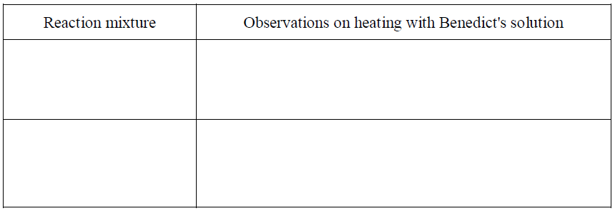
Conclusion
State the conclusion of the experiment.

