Chemical Investigations
Cracking
Teacher/Technician Guide
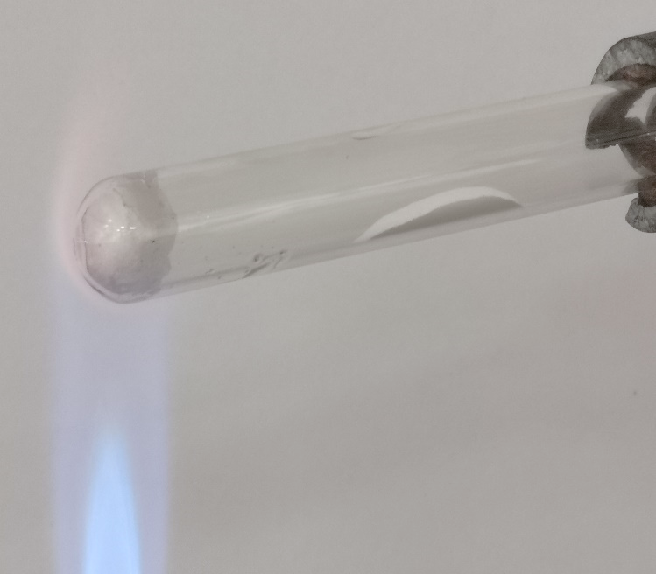

Cracking
UNIT 2 PPA 2
INTRODUCTION
Cracking is an industrial process in which alkanes are split into a mixture of smaller molecules some of which are unsaturated.
Cracking is important for two reasons:
it converts long-chain alkanes from crude oil into shorter alkanes for which there is a greater demand
it produces unsaturated hydrocarbons which are important starting materials in the manufacture of plastics.
High temperatures are needed to crack alkanes and this is expensive. However, if a catalyst is used the process can be carried out at much lower temperatures.
The aim of this experiment is to crack liquid paraffin (a mixture of alkanes of chain length C20 and greater) and to demonstrate that some of the products are unsaturated.
Each group will need

2 x test tubes and rack | stopper fitted with glass delivery tube
clamp stand and clamp | Bunsen burner and heating mat
mineral wool* | tongs
~ 1cm³ liquid paraffin | 0.5g aluminium oxide catalyst**
~ 3cm³ 0.02 mol l⁻¹ bromine solution***
* Scrunched up filter paper could be used as an alternative and safer reservoir for the liquid paraffin. Heating should be discontinued when the paper shows the first signs of charring.
** Aluminium silicate, steel wool and broken pieces of unglazed porcelain can be used as substitutes for the aluminium oxide catalyst.
*** The risk is low but an even safer alternative is potassium manganate VII solution.

Safety
The Experiment should be carried out in a well-ventilated laboratory or a fume cupboard.
Bromine fumes can be given off from bromine water but the quantity will be small and the dilute solution means this is not a significant hazard.
Wear eye protection when heating the sample.
Avoid breathing the gases produced in the cracking process.
The gaseous products could be bubbled through bromine solution contained in a fermentation lock - this will reduce the possibility of 'suck-back'.
A safer alternative is to carry this out on a microscale – a method is available on the SSERC website

Procedure
- Add liquid paraffin to a dry test tube to a depth of about 1 cm.
- Add a plug of mineral wool to soak up and support the liquid paraffin.
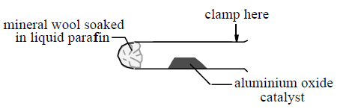
- Clamp the test tube at its mouth and in a horizontal position.
- Add a spatulaful of aluminium oxide catalyst to the middle of this test tube.
- Add bromine solution to a second test tube to a depth of about 3 cm and place it in the test tube rack.
- Fit the stopper and delivery tube to the clamped test tube and arrange the apparatus so that the end of the delivery tube is dipping into the bromine solution.
DO NOT START HEATING YET.
- Check with your teacher/lecturer that the apparatus is assembled correctly.
- Check with your teacher/lecturer that you know how to avoid 'suck-back' and what to do if 'suck-back' does occur.
- Heat the catalyst strongly for several seconds and then flick the flame onto the mineral wool for a few seconds in order to vapourise some of the liquid paraffin.
- 1Continue heating the catalyst and from time to time transfer the heat to the mineral wool. At the same time observe what is happening to the bromine solution.
- When a change has been observed in the bromine solution and before you stop heating, lift the clamp stand so that the delivery tube is removed from the bromine solution. This will prevent the possibility of 'suck-back'.

