SSERC Risk Assessment (revised version March 2018)
(based on HSE’s INDG 163 ‘Risk assessment - A brief guide to controlling risks in the workplace’)

2 Pitreavie Court, South Pitreavie Business Park, Dunfermline KY11 8UU
tel : 01383 626070 e-mail : enquiries@sserc.org.uk web : www.sserc.org.uk

Activity assessed | Int2 PPA2-2 - Cracking
Date of assessment | 8th July 2022
Date of review (Step 5)
School
Department

Step 1 | Step 2 | Step 3 | Step 4
List Significant hazards here: | Who might be harmed and how? | What are you already doing?  What further action is needed? | Actions
 |  |  | by whom? | Due date | Done
Liquid paraffin and aluminium oxide are of no significant hazard
Bromine is corrosive to skin and eyes and very toxic if inhaled. | Technician preparing bromine water. | Wear goggles (BS EN166 3) and gloves. Work in a fume cupboard.  (or use an in situ method to generate it.)
0.02 mol l⁻¹ bromine solution is of no significant hazard.
Be careful to avoid suck back | Pupil carrying out experiment. | Do not have tube dipping into bromine water unless you are actively heating the solution
The mixture of gases produced has a variety of hazards but quantities are small. | Pupil carrying out experiment by inhalation. | Work in a well-ventilated laboratory. Avoid inhaling fumes as far as possible.

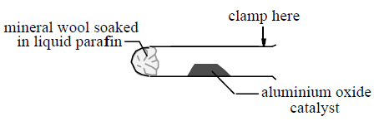
Description of activity:

Liquid paraffin fumes are passed over hot aluminium oxide and the gaseous products tested.

Additional comments:

A safer alternative is to carry this out on a microscale – a method is available on the SSERC website

