Chemical Investigations
Testing for Unsaturation
Teacher/Technician Guide
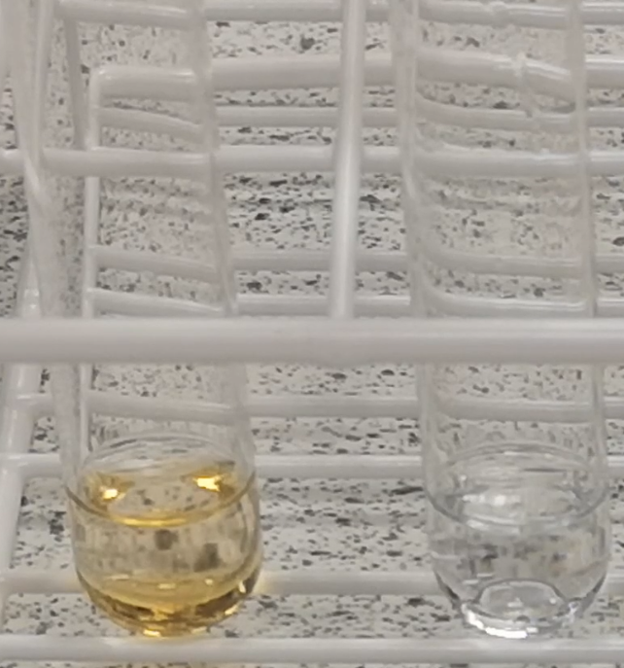

Testing for Unsaturation
UNIT 2 PPA 1
INTRODUCTION
Alkanes and cycloalkanes are described as saturated hydrocarbons because the carbon-carbon bonds they contain are all single covalent bonds. Hydrocarbons which contain at least one carbon = carbon double bond are said to be unsaturated.
The presence of unsaturation in organic compounds can be shown by using bromine solution. It has an orange/red colour as a result of the bromine molecules it contains. When bromine solution is shaken with an unsaturated hydrocarbon the bromine molecules 'add on' across the carbon=carbon double bonds and the reaction mixture rapidly turns colourless. When a saturated hydrocarbon and bromine solution are mixed the orange/red colour remains.
The aim of this experiment is to test for unsaturation in four different hydrocarbons labelled A (C₆H₁₄), B (C₆H₁₂), C (C₆H₁₂) and D (C₆H₁₀) and in the light of the results suggest a possible structure for each one.
You will need

test tubes and rack | ~ 1cm³ of hydrocarbons A, B, C and D
~ 2 cm³ 0.02 mol l⁻¹ bromine solution* | Pasteur pipette**

* The risk is low but an even safer alternative is potassium manganate VII solution.
** Pasteur pipettes are not needed if the bromine water is in dropping bottles.
Hydrocarbons
A = Hexane
B = Hex-1-ene
C = Cyclohexane
D = Cyclohexane
Safety
Bromine fumes can be given off from bromine water but the quantity will be small and the dilute solution means this is not a significant hazard.
All the hydrocarbons are highly flammable and irritating to the eyes, skin and lungs. In addition, hydrocarbons A and D are harmful. As with the bromine water, the quantities are small
Work in a well ventilated lab.

Procedure
For each of the hydrocarbons A, B, C and D follow the procedure outlined below:
- Add the hydrocarbon to a test tube to a depth of about 0.5 cm.
- To the hydrocarbon add about 10 drops of bromine solution.
- Shake the contents of the test tube by 'waggling' it. Do not place your thumb on the mouth of the test tube.
- Record your observations.
- Repeat for the rest of the samples

