Chemical Investigations
Testing for Unsaturation
Pupil Guide
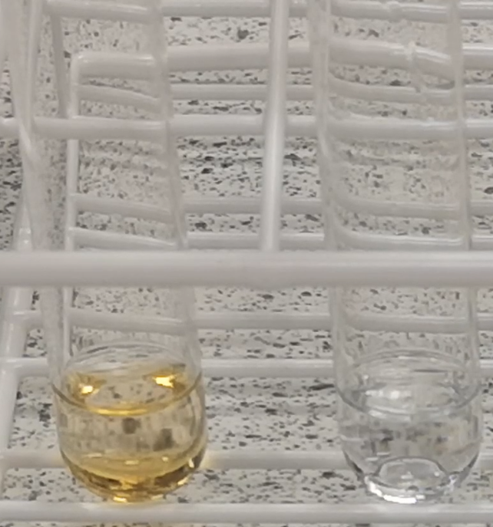

Testing for Unsaturation
UNIT 2 PPA 1
INTRODUCTION
Alkanes and cycloalkanes are described as saturated hydrocarbons because the carbon-carbon bonds they contain are all single covalent bonds. Hydrocarbons which contain at least one carbon = carbon double bond are said to be unsaturated.
The presence of unsaturation in organic compounds can be shown by using bromine solution. It has an orange/red colour as a result of the bromine molecules it contains. When bromine solution is shaken with an unsaturated hydrocarbon the bromine molecules 'add on' across the carbon=carbon double bonds and the reaction mixture rapidly turns colourless. When a saturated hydrocarbon and bromine solution are mixed the orange/red colour remains.
The aim of this experiment is to test for unsaturation in four different hydrocarbons labelled A (C₆H₁₄), B (C₆H₁₂), C (C₆H₁₂) and D (C₆H₁₀) and in the light of the results suggest a possible structure for each one.
You will need

test tubes and rack | hydrocarbons A, B, C and D
bromine solution | Pasteur pipette*

Safety
All the hydrocarbons are highly flammable and irritating to the eyes, skin and lungs. In addition, hydrocarbons A and D are harmful.
Bromine fumes can be given off from bromine water but the quantity will be small and the dilute solution means this is not a significant hazard.
Procedure
For each of the hydrocarbons A, B, C and D follow the procedure outlined below:
- Add the hydrocarbon to a test tube to a depth of about 0.5 cm.
- To the hydrocarbon add about 10 drops of bromine solution.
- Shake the contents of the test tube by 'waggling' it. Do not place your thumb on the mouth of the test tube.
- Record your observations.
- Repeat for the rest of the samples

Results sheet
What was the aim of the experiment?

What is the main difference between saturated and unsaturated hydrocarbons in terms of
structure?

Procedure
Describe briefly how you tested for unsaturation in the hydrocarbons.
Results/Conclusions
Complete the following table

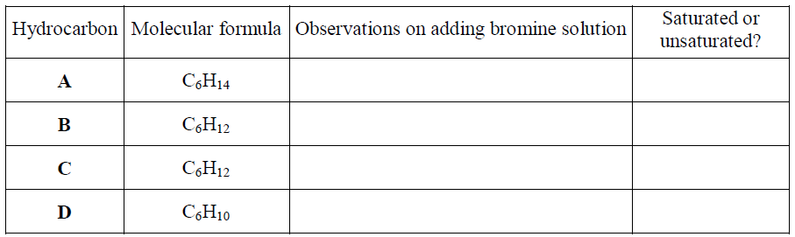

Conclusion

Draw a possible full structural formula for each of the hydrocarbons.
A (C₆H₁₄)

B (C₆H₁₂)

C (C₆H₁₂)

D (C₆H₁₀)

