Chemical Investigations
Electrolysis
Teacher/Technician Guide
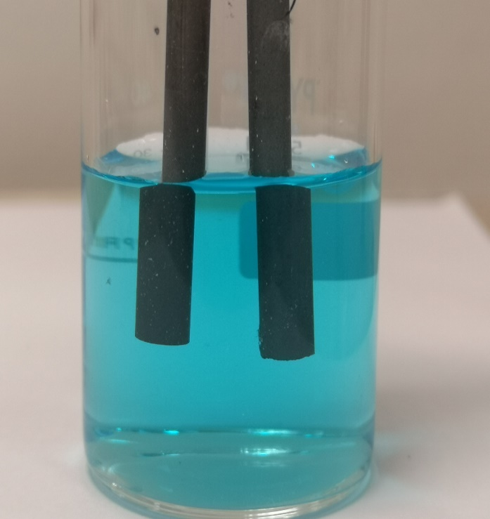

Electrolysis
UNIT 1 PPA 3
INTRODUCTION
When an ionic compound is dissolved in water it conducts electricity. A conducting solution of this kind is an example of an electrolyte. Since opposite charges attract, the positively charged ions in the electrolyte move to the negative electrode while the negatively charged ions move to the positive electrode. The ions undergo chemical changes at the electrodes which result in the decomposition or breakdown of the electrolyte. This process of passing a current of electricity through an electrolyte is known as electrolysis.
The aim of this experiment is to electrolyse copper chloride solution and to identify the products at the positive and negative electrodes.

You will need

electrolytic cell with carbon electrodes | low voltage source of electricity
connecting wires | 0.1 mol l⁻¹ Copper II chloride solution
blue litmus paper*

* pH paper can be used as an alternative to litmus paper.

Safety
Copper chloride is an eye irritant. Wear eye protection.
The chlorine produced in the reaction irritates the lungs and may trigger off wheezing if you are asthmatic.
The electrolysis should be carried out on a small scale and in a well-ventilated room.
Students who are asthmatic should be warned that the chlorine released may provoke an attack.
Various types of electrolytic cells can be used but the current should be kept below 0.3 A to limit the amount of chlorine released.
A safer version is to use a microscale approach. A method is in the Microscale Chemistry section of the SSERC website. The reaction is not only smaller scale but is carried out within a Petri dish which contains the chlorine thus all but eliminating the risk.

Procedure
1. Add copper(II) chloride solution to the electrolytic cell.
2. As directed by your teacher/lecturer set up a circuit containing the electrolytic cell but do not switch on the electrical source until your circuit has been checked by your teacher/lecturer.
3. Switch on the source of electricity. Observe and record what is happening at the positive electrode (the one connected to the red terminal of the electrical source).
4. Hold a piece of moist blue litmus paper over the positive electrode and record what happens to the litmus paper.
5. Switch off the source of electricity.
6. To smell the gas given off at the positive electrode follow the technique outlined below.
- First breathe in deeply to fill the lungs with uncontaminated air.
- With your nose at least 30 cm from the electrolytic cell gently waft your hand over the cell towards your nose and take just a sniff of the gas.
- Record the smell.
7. Empty out the electrolytic cell and look closely at the electrode which had been connected to the negative terminal of the electrical source. Record your observations.

