Chemical Investigations
Effect of Temperature on Reaction Rate
Pupil Guide
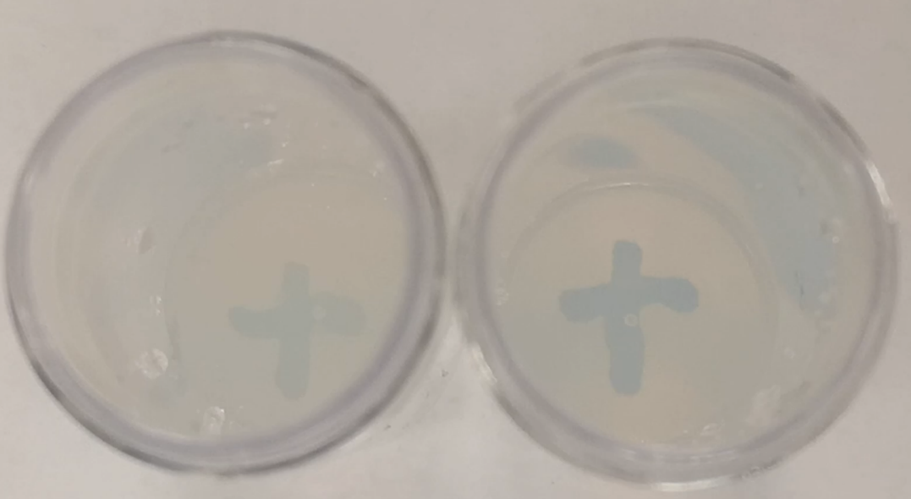

Effect of Temperature on Reaction Rate
UNIT 1 PPA 2
INTRODUCTION
The aim of this experiment is to find the effect of varying temperature on the rate of reaction between sodium thiosulphate solution and hydrochloric acid.
Initially the reaction mixture is clear but gradually becomes cloudy as solid sulphur is formed in the reaction. We can follow the course of the reaction by placing the reaction mixture over a cross drawn on a piece of paper and timing how long it takes for the cross to be obscured by the sulphur:
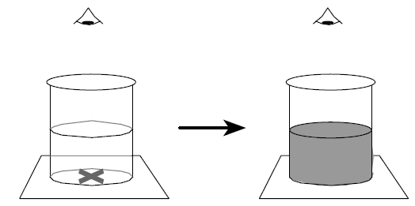
A series of experiments will be carried out in which only the temperature of the reaction mixture will be varied. The concentrations and volumes of the reactants will be kept constant.
The amount of sulphur needed to obscure the cross will be the same in each experiment but the time it takes for this to happen will vary. If the time taken to obscure the cross is t then we can express the rate as:
rate = 1
t
If t is in seconds then the rate will have units, s⁻¹.

You will need

Syringes 20 cm³ & 1 cm³ * | 100 & 250 cm³ glass beakers
timer | Thermometer
tripod | Bunsen burner & heatproof mat
paper with 'cross' mark
0.1 mol l⁻¹ sodium thiosulphate solution | 1.0 mol l⁻¹ hydrochloric acid

* Graduated pipettes or measuring cylinders could be used in place of the syringes. To reduce the risk of contamination a separate syringe for each solution is recommended.
Safety
This experiment should be carried out in a well-ventilated room.
Students who are asthmatic should be warned that the sulphur dioxide released may provoke an attack.
Conical flasks could be used in place of the beakers thus reducing the amount of sulphur dioxide released into the atmosphere.
Immediately a measurement or run has been completed a few cm³ of 2.0 mol l⁻¹ sodium carbonate could be added to the reaction mixture before filling the container with cold water. This would further limit the release of sulphur dioxide.
A much safer alternative is to carry out the experiment on a microscale – see the procedure in the microscale section of the SSERC website.
Safer still would be to use the Rhubarb, Rhubarb activity which looks at potassium manganate VII being decolourised by oxalic acid in rhubarb.
Procedure
Add about 100 cm³ of sodium thiosulphate solution to the large glass beaker.
Using a syringe measure 20 cm³ of sodium thiosulphate solution from the large beaker into a small glass beaker and place the reaction mixture on a piece of paper with a cross marked on it.
3. Fill the small syringe with 1 cm³ of hydrochloric acid. Quickly add this to the sodium thiosulphate solution in the small beaker and at the same time start the timer.
4. Measure and record the time it takes for the cross to be obscured as you look down into the solution. Measure and record the temperature of the reaction mixture.
5. Fill the beaker with cold water before you dispose of the solution down the sink. This reduces the amount of sulphur dioxide released into the atmosphere.
6. Heat the remaining sodium thiosulphate solution in the large beaker until its temperature is about 30 °C but do not record this temperature.
7. Measure out 20 cm³ of the warm sodium thiosulphate solution into a small glass beaker and place it over the cross. Add 1 cm³ of hydrochloric acid and measure and record the time taken for the cross to be obscured. Measure and record the temperature of the reaction mixture. †
8. Repeat the experiment after heating the sodium thiosulphate solution to about 40 °C and then again after heating the sodium thiosulphate solution to about 50 °C. Do not heat the sodium thiosulphate solution beyond this temperature.

† If you are using the same small glass beaker as you used in the first part of the experiment, then make sure it has been thoroughly cleaned.

