Chemical Investigations
Effect of Concentration on Reaction Rate
Teacher/Technician Guide
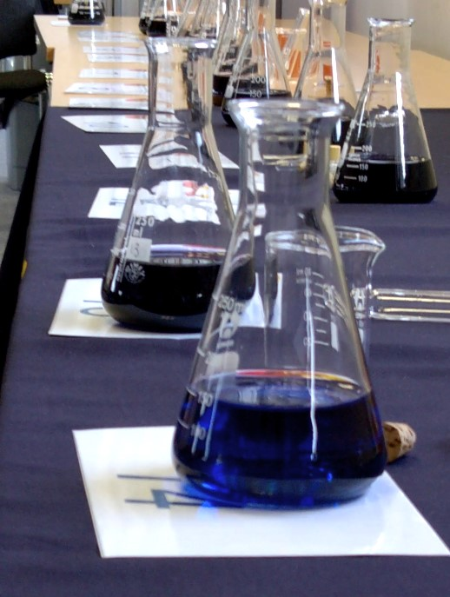

Effect of Concentration on Reaction Rate
UNIT 1 PPA 1
INTRODUCTION
The aim of this experiment is to find the effect of varying the concentration of sodium peroxidisulphate solution on the rate of its reaction with potassium iodide solution.
Small quantities of starch and sodium thiosulphate are included in the reaction mixture in order to provide us with a convenient way of following the course of the reaction. Initially the reaction mixture is colourless but after some time a blue/black colour suddenly appears as the starch reacts with the iodine produced in the reaction. This marks a point when the reaction has gone a set 'distance'.
If t is the time taken for the blue/black colour to appear then the rate of the reaction can be expressed as:
rate = 1
t
If t is in seconds then the rate will have units, s⁻¹.
A series of experiments will be carried out in which only the concentration of the sodium peroxidisulphate solution will be varied. The concentration and volume of the potassium iodide solution will be kept constant as will the temperature at which the experiments are performed.
Each group will need

Syringes eg 1 x 1 cm³ and 3 x 10 cm³ * | 4 x 100 cm³ glass beakers
timer | white tile
28 cm³ 0.1 mol l⁻¹ sodium peroxidisulphate solution** | 40 cm³ potassium iodide / sodium thiosulphate solution***
4 cm³ 1% starch solution | 12 cm³ deionised water

* Graduated pipettes or measuring cylinders could be used in place of the syringes. To reduce the risk of contamination a separate syringe for each solution is recommended.
** Older samples of persulphate may have deteriorated badly and may not work well. A preclass trial is advised for old samples.
*** 0.3 mol l⁻¹ KI / 0.006 mol l⁻¹ Na₂S₂O₃ (50g KI and 1.5g Na₂S₂O₃ in 1 litre of water). The starch could be included in the potassium iodide solution but it rapidly deteriorates on standing.
Safety
Sodium persulphate solution is a skin sensitiser. Avoid splashing it on the skin. If you do, wash off immediately.
Procedure
- Using syringes measure out 10 cm³ of sodium peroxidisulphate solution and 1 cm3 of starch solution into a dry 100 cm³ glass beaker and place the beaker on the white tile.
- Fill another syringe with 10 cm³ of potassium iodide solution. Quickly add this to the sodium peroxidisulphate solution in the glass beaker and at the same time start the timer.
- When the reaction mixture suddenly goes blue/black in colour stop the timer and record the time in seconds.
- Using syringes, measure out 8 cm³ of sodium peroxidisulphate solution, 2 cm³ of deionised water and 1 cm³ of starch solution into a dry 100 cm³ glass beaker. Adding water dilutes the sodium peroxidisulphate solution and so reduces its concentration.
- Place this beaker on the white tile. Quickly add 10 cm³ of potassium iodide solution to the diluted sodium peroxidisulphate solution and at the same time start the timer.
- When the reaction mixture just turns blue/black stop the timer and record the time in seconds.
- Repeat the experiment another two times:
firstly with 6 cm³ of sodium peroxidisulphate solution, 4 cm³ of deionised water and 1 cm³ of starch solution being added to the beaker before adding 10 cm³ of potassium iodide solution and
secondly with 4 cm³ of sodium peroxidisulphate solution, 6 cm3 of deionised water and 1 cm³ of starch solution being added to the beaker before adding 10 cm³ of potassium iodide solution.
In each case measure and record the time it takes for the blue/black colour to appear.

