Chemical Investigations
Effect of Concentration on Reaction Rate
Pupil Guide
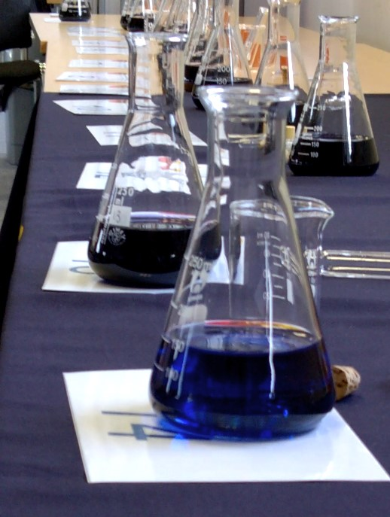

Effect of Concentration on Reaction Rate
UNIT 1 PPA 1
INTRODUCTION
The aim of this experiment is to find the effect of varying the concentration of sodium peroxidisulphate solution on the rate of its reaction with potassium iodide solution.
Small quantities of starch and sodium thiosulphate are included in the reaction mixture in order to provide us with a convenient way of following the course of the reaction. Initially the reaction mixture is colourless but after some time a blue/black colour suddenly appears as the starch reacts with the iodine produced in the reaction. This marks a point when the reaction has gone a set 'distance'.
If t is the time taken for the blue/black colour to appear then the rate of the reaction can be expressed as:
rate = 1
t
If t is in seconds then the rate will have units, s⁻¹.
A series of experiments will be carried out in which only the concentration of the sodium peroxidisulphate solution will be varied. The concentration and volume of the potassium iodide solution will be kept constant as will the temperature at which the experiments are performed.
You will need

Syringes 1 x 1 cm³ and 3 x 10 cm³ | 4 x 100 cm³ glass beakers
timer | white tile
0.1 mol l⁻¹ sodium peroxidisulphate solution | potassium iodide / sodium thiosulphate solution
1% starch solution | deionised water

Safety
Sodium persulphate solution is a skin sensitiser. Avoid splashing it on the skin. If you do, wash off immediately.
Procedure (what you do)
- Using syringes measure out 10 cm³ of sodium peroxidisulphate solution and 1 cm3 of starch solution into a dry 100 cm³ glass beaker and place the beaker on the white tile.
- Fill another syringe with 10 cm³ of potassium iodide solution. Quickly add this to the sodium peroxidisulphate solution in the glass beaker and at the same time start the timer.
- When the reaction mixture suddenly goes blue/black in colour stop the timer and record the time in seconds.
- Using syringes, measure out 8 cm³ of sodium peroxidisulphate solution, 2 cm³ of deionised water and 1 cm³ of starch solution into a dry 100 cm³ glass beaker. Adding water dilutes the sodium peroxidisulphate solution and so reduces its concentration.
- Place this beaker on the white tile. Quickly add 10 cm³ of potassium iodide solution to the diluted sodium peroxidisulphate solution and at the same time start the timer.
- When the reaction mixture just turns blue/black stop the timer and record the time in seconds.
- Repeat the experiment another two times:
firstly with 6 cm³ of sodium peroxidisulphate solution, 4 cm³ of deionised water and 1 cm³ of starch solution being added to the beaker before adding 10 cm³ of potassium iodide solution and
secondly with 4 cm³ of sodium peroxidisulphate solution, 6 cm3 of deionised water and 1 cm³ of starch solution being added to the beaker before adding 10 cm³ of potassium iodide solution.
In each case measure and record the time it takes for the blue/black colour to appear.

Results sheet
What was the aim of the experiment?

Procedure

How was the concentration of the sodium peroxidisulphate solution varied?

How was the rate of the reaction determined?

Results
Complete the following table apart from the bottom row of entries:

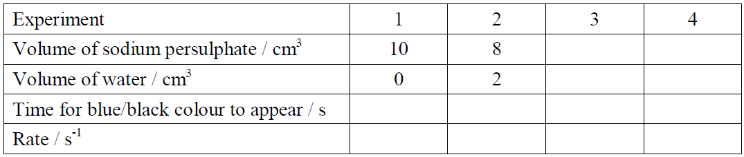

Work out the rate of each reaction and add these to the table above.

On the graph overleaf,
Draw a line graph of reaction rate / s ⁻¹ against volume of sodium peroxidisulphate.
solution / cm³

(Since the total volume of the reaction mixture was the same in each experiment we can assume that the volume of the sodium peroxidisulphate solution is a measure of its concentration)

Conclusion

State the conclusion of the experiment.

