Chemical Investigations
Burning Carbohydrates
Teacher/Technician Guide
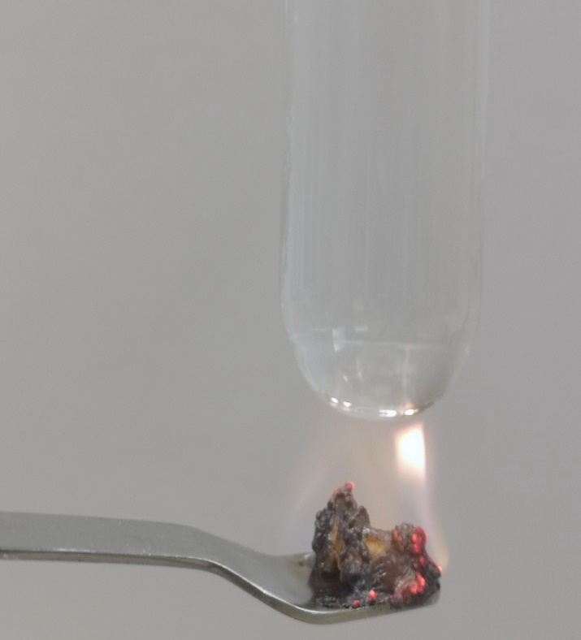

Burning Carbohydrates
UNIT 3 PPA 2
INTRODUCTION
Carbohydrates are compounds of carbon, hydrogen and oxygen. Starch and sugar are carbohydrates and they provide us with the energy our bodies need.
The aim of this experiment is to show that heat energy is produced when starch and sugar are burned and to compare how much heat energy each produces.
We will burn flour as the 'starch' carbohydrate and icing sugar as the 'sugar' carbohydrate. The energy produced when they burn will be used to heat water. The rise in temperature of the water will give us some idea of how much heat energy has been produced.
To make the experiment fair the same amount of flour and icing sugar will be burned and the same volume of water will be heated.

Each group will need
1 x boiling tube | 100 cm³ beaker
spatula | Thermometer 0 – 100°C
50 / 100 cm³ measuring cylinder | Bunsen burner and heating mat
clamp stand and clamp | Flour ~0.2g
icing sugar ~0.2g

Safety
Flour can be a respiratory sensitiser if inhaled. The quantities here are small and significant dust is unlikely to be raised. Avoid inhaling dust.
There is a possible danger of students getting their hands slightly burned when holding the spatula in the Bunsen flame.
This risk could be avoided by clamping the spatula or by using a combustion spoon with a wooden handle.
A better version of this activity involved the burning of puffed wheat type snacks such as Wotsits. These are easier to ignite and burn more rapidly.

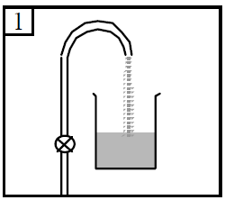
Procedure
- Fill the beaker half full with water

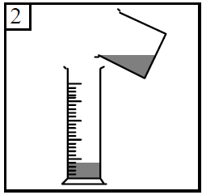

- Add water to the measuring cylinder up to the 10 cm³ mark.

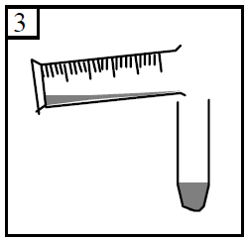
- Pour this water into the boiling tube.

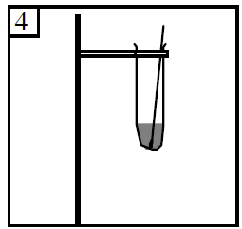

- Clamp the boiling tube in a vertical position. Measure the temperature of the water in the boiling tube. Record this temperature by writing it down in the table.

- Light the Bunsen burner and add flour to the spatula to give a level spatulaful.
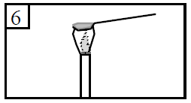
- Heat the flour in the Bunsen flame until it just catches fire.

- Quickly place the burning flour underneath the boiling tube so that the flames are touching the bottom of the boiling tube.
- When the flour has stopped burning, stir the water with thermometer. Measure and record the final temperature of the water.
- Repeat the experiment using icing sugar. Make sure the amount of icing sugar you burn is the same as the amount of flour you burned.
Remember to measure and record the starting temperature of the water and the final temperature of the water.

