Chemical Investigations
Solubility
Pupil Guide
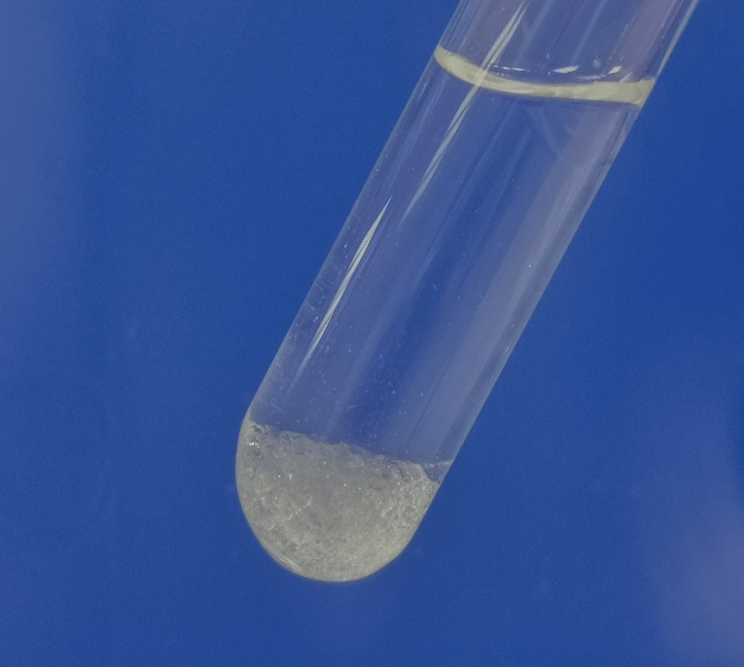

Solubility
UNIT 3 PPA 1
INTRODUCTION
Compounds called fertilisers are added to the soil to help plants to grow well. A compound can be used as a fertiliser if it contains one of the essential elements, nitrogen (N), phosphorus (P) or potassium (K) and if it dissolves in water.
Ammonium compounds (N), potassium compounds (K), nitrate compounds (N) and phosphate compounds (P) are all possible fertilisers because each one contains an essential element.
However, only the ones which are soluble in water will be able to fertilise plants.
The aim of this experiment is to test the solubility in water of some ammonium, potassium, nitrate and phosphate compounds in order to decide if they could be used as fertilisers.
You will need
test tubes & rack | beaker
Samples of solids: | ammonium sulphate, potassium nitrate, sodium nitrate, calcium phosphate, ammonium phosphate

Safety
The ammonium and calcium compounds are of no hazard.
Potassium nitrate is a skin/eye/respiratory irritant
Sodium nitrate is an eye irritant
Eye protection may be prudent but the quantities are very small and the hazard is not great,

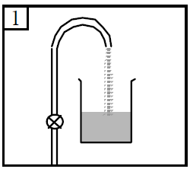
Procedure
- Add dilute hydrochloric acid to the beaker until it is half full.

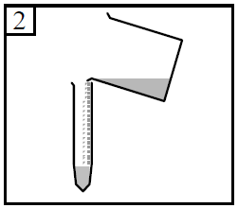
- Pour water into a test tube to a depth of 3 - 4 cm.

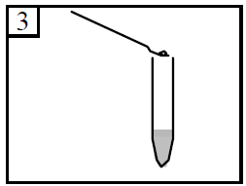
- Using a spatula add a tiny amount (about the size of half a pea) of ammonium sulphate to the water.

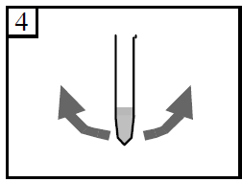
- Hold the test tube at the mouth and 'flick' it back and forth for several minutes.*
* Some students may not be familiar with the 'flicking' technique of shaking. If this is the case then it should be demonstrated to them. Alternatively, provide bungs and allow them to shake the tubes

- Look at the mixture to see if the solid has dissolved.
- Record the result in the table by writing down the name of the compound and whether it was soluble or insoluble.
- Repeat the experiment with each of the remaining compounds recording the result each time.

.

