Chemical Investigations
Factors which affect Lathering of Soap
Teacher/Technician Guide
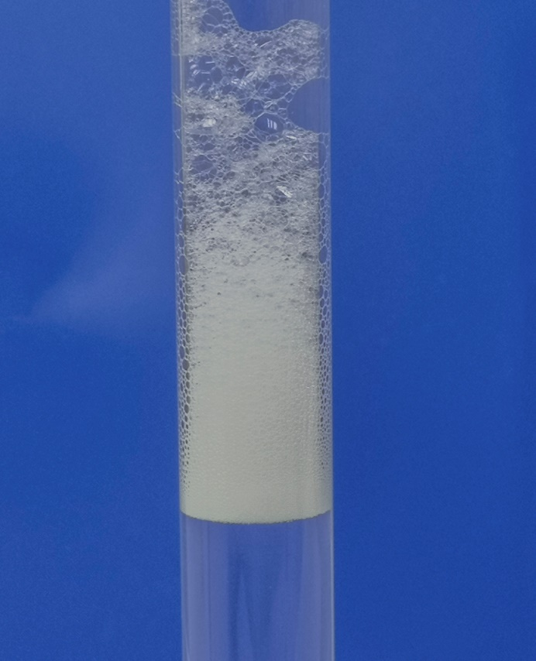

Factors Affecting lathering of Soap
UNIT 2 PPA 3
INTRODUCTION
It is difficult to clean things in water alone because substances like oil and grease do not dissolve in water. This is why we have to add detergents to the water. Detergents break down grease and oil into very tiny drops which then mix with the water and can be washed away.
Most detergents produce a lather or foam when they are shaken with water.
The aim of this experiment is to investigate a factor which might affect the amount of lather produced when detergents are shaken with water.
Some of the factors we could investigate are:
- the type of detergent
- the volume of detergent
- the temperature of the water
- the amount of shaking
- the volume of water
To make the investigation fair we can only change one factor during the experiments. All the other factors must be kept the same.
From the first two factors in the list, choose one you would like to investigate.
Pupils choose from investigating either the type of detergent or the volume of detergent.
You will need
test tubes with stoppers & rack | ruler
5 cm³ syringe | timer
50 cm³ beaker | Solutions of: washing powder/liquid, dishwasher powder, washing-up liquid*

* Some experiment may be required here but as a guide:
Washing powder/liquid – use a 5% solution v/v
Washing up liquid – use a 1% solution (v/v)
Safety
While the concentrated detergents can be irritating, the dilute solutions are of no significant hazard.
Avoid ‘biological’ detergents, or any which may contain bleaching agents.

Procedure
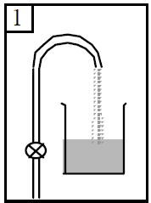
A Type of detergent
- Add dilute hydrochloric acid to the beaker until it is half full.

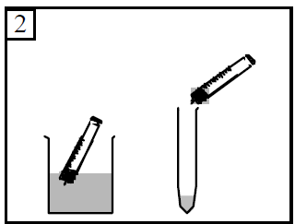
- Using the syringe measure out 3 cm³ of water into a test tube.

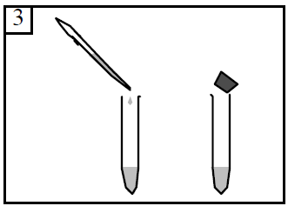

- Add two drops of automatic washing powder solution to the water and stopper the tube.

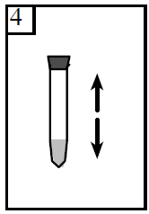
- With your thumb on the stopper shake the test tube hard for 15 seconds.
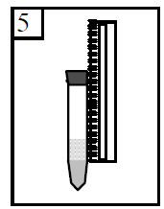

- Let the solution settle for 15 seconds and then use the ruler to measure the height of the foam.

- Record your result by writing it down in the table.
- Repeat the experiment first with the solution of the non-automatic washing powder and then with the solution of the dishwasher powder. Remember to do each one twice to get duplicate results.

B Volume of detergent
- Add dilute hydrochloric acid to the beaker until it is half full.

- Using the syringe measure out 3 cm³ of water into a test tube.

- Add one drop of the solution of washing-up liquid to the water and stopper the tube.

- With your thumb on the stopper shake the test tube hard for 15 seconds.

- Let the solution settle for 15 seconds and then use the ruler to measure the height of the foam.
Record your result by writing it down in the table.
- To obtain a duplicate result repeat steps 2 to 5 with one drop of the solution of washing-up liquid.
Remember to measure and record the height of the foam.
- Repeat the experiment first with two drops of the solution of washing-up liquid and then with three drops of the same solution. Remember to do each one twice to get duplicate results.

