Chemical Investigations
Reaction of Metals with Acid
Pupil Guide
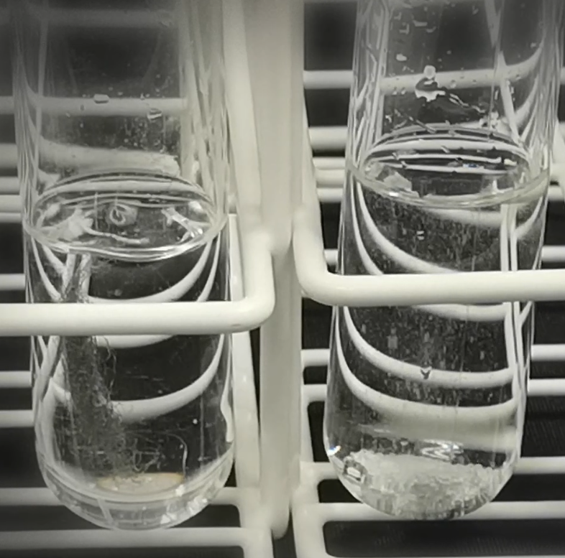

Reactions of Metals with Acid
UNIT 2 PPA 2
INTRODUCTION
Different metals react at different speeds with acid. A metal which reacts quickly with acid is called a reactive metal. An unreactive metal reacts only slowly or does not react at all. By finding out how quickly different metals react with acid we can put them in order of reactivity.
When a metal does react with an acid, bubbles of gas are produced. The speed at which the bubbles are given off tells us how reactive the metal is.
The aim of this experiment is to place the metals, zinc, magnesium and copper in order of reactivity by watching how quickly they react with hydrochloric acid.
You will need
test tubes & rack | beaker
2 mol l⁻¹ hydrochloric acid | samples of zinc, magnesium and copper

Safety
Wear goggles.
Do not sniff at the reaction mixture – an irritating acid mist is formed.
Keep away from flames.

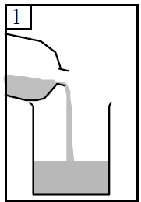
Procedure (what you do)
- Add dilute hydrochloric acid to the beaker until it is half full.

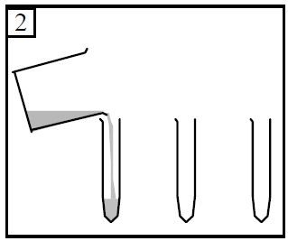

- Pour some of the hydrochloric acid into the first test tube to a depth of about 4 cm.
Pour the same volume of acid into the other two test tubes.

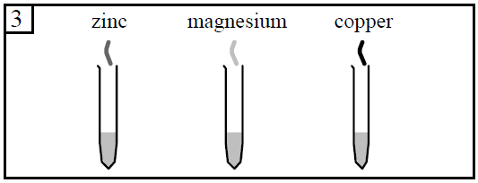
- Add a piece of zinc to the first test tube.
Add a piece of magnesium to the second test tube.
Add a piece of copper to the third test tube.
- Watch carefully what happens in each test tube.
In the table on your 'assessment' sheet record your results by writing down
- the name of each metal
- whether bubbles of gas were given off or not
- the speed at which the bubbles were given off.
Results sheet
What was the aim of the experiment?

Procedure

What allowed you to get some idea of the reactivity of the metals?

Complete the following table:

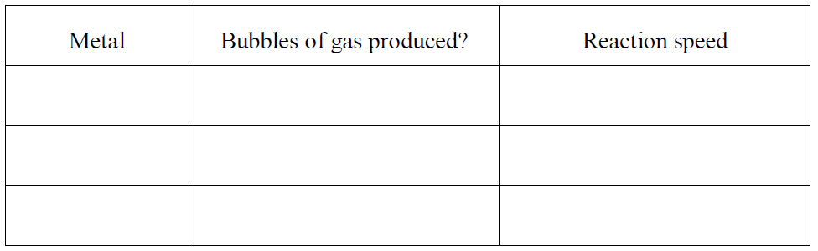

Conclusion

Put the metals in order of reactivity starting with the most reactive.

