Chemical Investigations
Electrical Conductivity
Teacher/Technician Guide
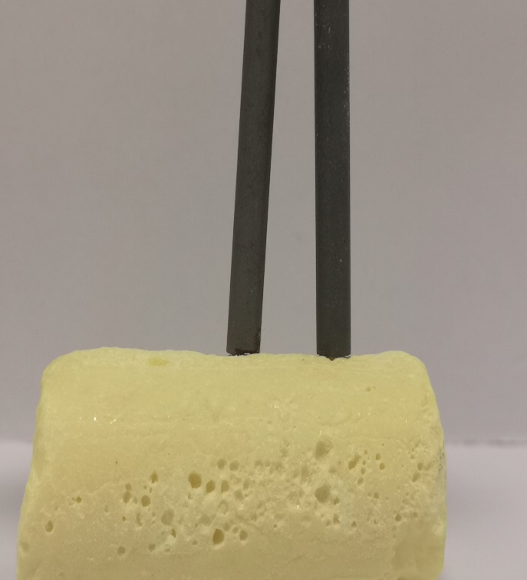

Electrical Conductivity
UNIT 2 PPA 1
INTRODUCTION
A current of electricity is a flow of charged particles.
Some substances are conductors of electricity. This means they allow a current to pass through them. Other substances do not let a current pass through them and they are called non-conductors.
In this experiment we will look at elements - metal elements and non-metal elements.
The aim of this experiment is to test the electrical conductivity of some metals and nonmetals and from the results work out a general rule about the electrical conductivity of elements.
Each group will need
low voltage source of electricity | Bulb/LED or buzzer or ammeter
connecting wires | (alternatively, a multimeter)
Samples of  (The exact selection can be slightly different) | Aluminium, carbon (graphite), copper, iron, nickel, sulphur, zinc*

* aluminium (foil)
carbon (graphite) (lump charcoal or carbon rod)
copper (foil or wire)
iron (wire)
nickel (foil)
sulphur (lump or roll)
nickel (foil) - may be best avoided.
Other possibilities
Lead (foil) could also be used – again, care is needed.
Magnesium ribbon
Sodium/potassium – as a demonstration

Safety
Sulphur is flammable but not highly so as long as it is not put in a flame, there is no issue.
Pieces of metal may have sharp edges so beware of cuts
Do not use powdered versions of the elements. As well as being less likely to conduct well, they are more likely to be inhalable or have a flammability risk.

Procedure
- Set up the circuit you will need to test the electrical conductivity of the elements. Pupils should not switch on the electrical source until your circuit has been checked by the teacher/lecturer.
Alternatively, you could use a multimeter set to read resistance.
- Take one of the elements and test its electrical conductivity.
- In the table on your 'assessment' sheet record the result by writing down
- the name of the element
- whether it is a metal or a non-metal (you can find this out by looking at your data booklet)
- whether it is a conductor or a non-conductor.
- Repeat the experiment with each of the remaining elements recording the result each time.
In the table on your 'assessment' sheet you will find the names of some more elements.
For safety reasons you have not been asked to test these.
You are told their electrical conductivities and all you have to do is find out whether each one is a metal or a non-metal.

