Chemical Investigations
Electrical Conductivity
Pupil Guide
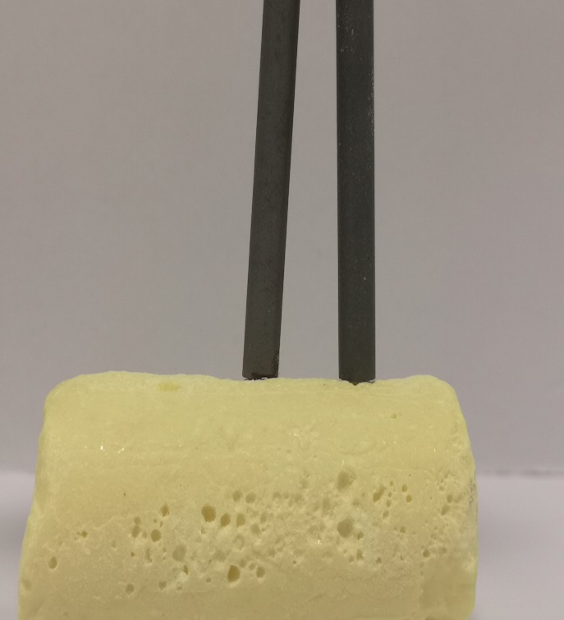

Electrical Conductivity
UNIT 2 PPA 1
INTRODUCTION
A current of electricity is a flow of charged particles.
Some substances are conductors of electricity. This means they allow a current to pass through them. Other substances do not let a current pass through them and they are called non-conductors.
In this experiment we will look at elements - metal elements and non-metal elements.
The aim of this experiment is to test the electrical conductivity of some metals and nonmetals and from the results work out a general rule about the electrical conductivity of elements.
You will need
low voltage source of electricity | Bulb/LED or buzzer or ammeter
connecting wires | (alternatively, a multimeter)
Samples of  (The exact selection can be slightly different) | Aluminium, carbon (graphite), copper, iron, nickel, sulphur, zinc

Procedure (what you do)
- Set up the circuit you will need to test the electrical conductivity of the elements. Do not switch on the electrical source until your circuit has been checked by your teacher/lecturer.
The details will vary depending on exactly what equipment you are using but you just need a simple series circuit connected so that when the circuit is complete (if your sample conducts) the buzzer sounds, the bulb/LED lights or the meter gives a reading.
Alternatively, you could use a multimeter set to read resistance.
- Take one of the elements and test its electrical conductivity.
- In the table on your 'assessment' sheet record the result by writing down
- the name of the element
- whether it is a metal or a non-metal (you can find this out by looking at your data booklet)
- whether it is a conductor or a non-conductor.
- Repeat the experiment with each of the remaining elements recording the result each time.
In the table on your 'assessment' sheet you will find the names of some more elements.
For safety reasons you have not been asked to test these.
You are told their electrical conductivities and all you have to do is find out whether each one is a metal or a non-metal.
Results sheet
What was the aim of the experiment?

Procedure

Draw a labelled diagram of the electrical circuit you used.

How were you able to tell if the element conducted electricity?

Complete the following table:
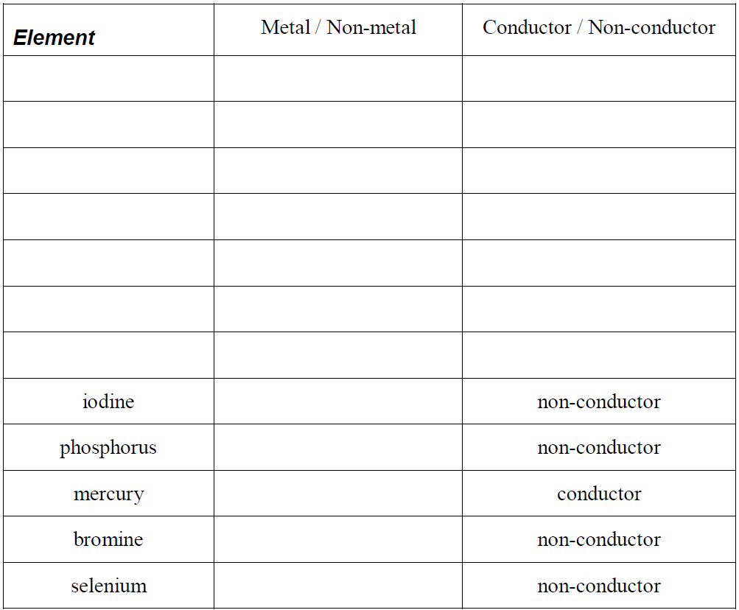
Conclusion

Write a general rule about the electrical conductivity of elements by completing
the following sentences:

………………………. conduct electricity but ………………………. do not conduct
electricity.
The element which does not fit this rule is ………………………. .

