Chemical Investigations
Testing the pH of Solutions
Teacher/Technician Guide
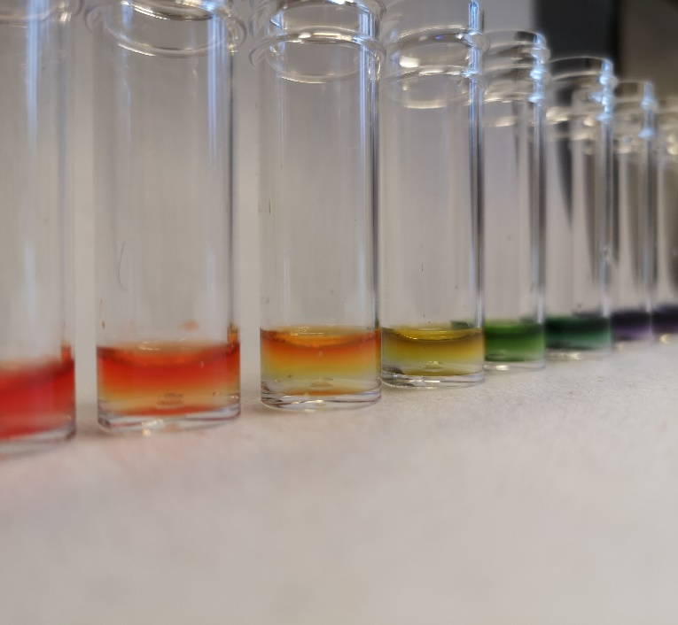

Testing the pH of Solutions
UNIT 1 PPA 3
INTRODUCTION
The pH scale measures how acidic (or how alkaline) a solution is. The pH scale runs from just below 0 to just above 14.
Solutions with a pH below 7 are acidic. Solutions with a pH above 7 are alkaline. Neutral solutions have a pH of 7.
The pH of a solution can be found by using pH indicator solution or pH paper. When either of these is added to the solution it changes colour. Matching up this colour with one of those on a pH colour chart gives us the pH of the solution.
The aim of this experiment is to find the pH values of some household substances and to classify them as acidic, alkaline or neutral.
Decide whether to use pH indicator solution or pH paper to test the substances.

Each group will need
For indicators
8 x test tubes and rack | Universal indicator solution
pH colour chart | 25 cm³ Distilled water
2 cm³ Soda water | 2 cm³ vinegar
2 cm³ Lemon juice | 0.2g salt
0.2g Sodium bicarbonate | 0.2g washing powder
2 cm³ diluted household ammonia* | Pasteur pipettes

For pH paper
dimple tray | pH indicator paper
pH colour chart | A few drops of vinegar
A few drops of Soda water | A few drops of Distilled water
A few drops of Lemon juice | A few grains of salt
A few grains of Sodium bicarbonate | A few grains of washing powder
A few drops of diluted household ammonia* | Pasteur pipettes
Tweezers

* 2% (2 cm³ per 100 cm³ water)
Household ammonia has a concentration of just under 6 mol l⁻¹ and as suggested a diluted solution should be provided for student use.
If household ammonia is not available use a 0.1 mol l⁻¹ solution for the pupils
A 'biological' washing powder should be avoided.
Safety
Wear eye protection – some of the solutions can irritate the eyes.
Check the washing powder for hazards.
Universal indicator is usually flammable – keep away from sources of ignition.

Procedure (what you do)
Using Indicator solution
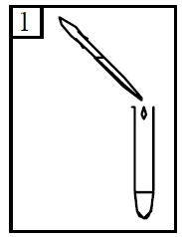
- Add some vinegar to a test tube to a depth of about 2 cm.

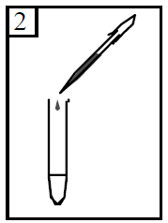
- Add 2 or 3 drops (no more) of the pH indicator solution to the vinegar and shake the mixture.

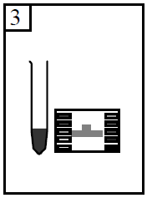

- To find the pH, match the colour of the solution to one of those on the colour chart.
- Record this pH by writing it down in the table.

- Repeat steps 1 to 4 with lemon juice, soda water and diluted household ammonia. Remember to record the pH each time.
- Add some water to a test tube to a depth of about 2 cm. Using a spatula add a tiny amount of common salt (about the size of half a pea) to the water and shake the mixture.
- Add 2 or 3 drops (no more) of the pH indicator solution to the salt solution and shake the mixture.
- Measure and record the pH, by matching the colour of the solution to one of those on the colour chart.
- Repeat steps 6 to 8 with bicarbonate of soda, sugar and automatic washing powder. Remember to record the pH each time.

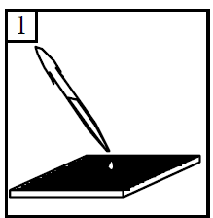
Procedure (what you do)
Using Indicator paper
- Add a few drops of vinegar to a dimple in the tray.

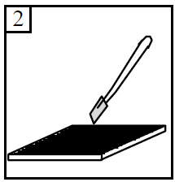
- Using the tweezers dip a piece of pH paper into the vinegar.

- To find the pH, match the colour of the pH paper to one of those on the colour chart.
- Record this pH by writing it down in the table.

- Repeat steps 1 to 4 with lemon juice, soda water and diluted household ammonia. Remember to record the pH each time.
- Add a few drops of water to a dimple in the tray. Using a spatula add a tiny amount of common salt (about the size of a lentil) to the water.
- Using the tweezers dip a piece of pH paper into the salt solution..
- Measure and record the pH, by matching the colour of the pH paper to one of those on the colour chart.
- Repeat steps 6 to 8 with bicarbonate of soda, sugar and automatic washing powder. Remember to record the pH each time.

