Chemical Investigations
Testing the pH of Solutions
Pupil Guide
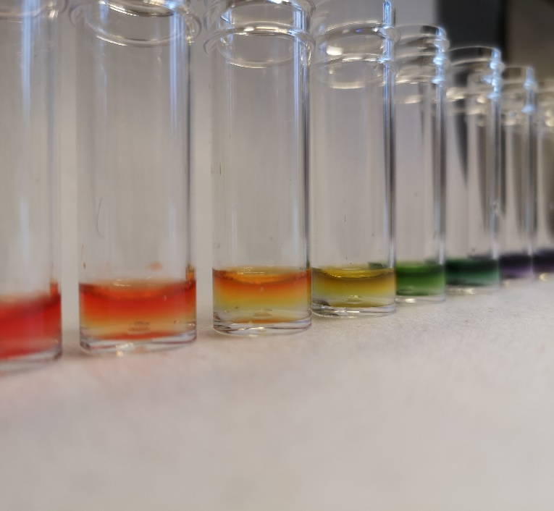

Testing the pH of Solutions
UNIT 1 PPA 3
INTRODUCTION
The pH scale measures how acidic (or how alkaline) a solution is. The pH scale runs from just below 0 to just above 14.
Solutions with a pH below 7 are acidic. Solutions with a pH above 7 are alkaline. Neutral solutions have a pH of 7.
The pH of a solution can be found by using pH indicator solution or pH paper. When either of these is added to the solution it changes colour. Matching up this colour with one of those on a pH colour chart gives us the pH of the solution.
The aim of this experiment is to find the pH values of some household substances and to classify them as acidic, alkaline or neutral.
Decide whether you will use pH indicator solution or pH paper to test the substances. If you choose the indicator solution, go to the section with the heading 'pH indicator solution'. If you choose the paper go to the section with the heading 'pH paper'.
Using Indicator Solution
You will need

test tubes and rack or dimple tray | pH indicator solution/paper
pH colour chart | vinegar
Soda water | Distilled water
Lemon juice | salt
Sodium bicarbonate | washing powder
diluted household ammonia | Pasteur pipettes
Tweezers 9for paper only)

Safety
Wear eye protection – some of the solutions can irritate the eyes.

Procedure (what you do)
Using Indicator solution
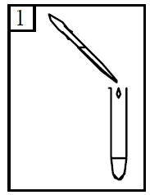
- Add some vinegar to a test tube to a depth of about 2 cm.

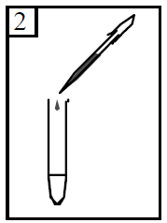
- Add 2 or 3 drops (no more) of the pH indicator solution to the vinegar and shake the mixture.

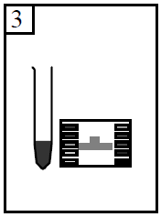

- To find the pH, match the colour of the solution to one of those on the colour chart.
- Record this pH by writing it down in the table.

- Repeat steps 1 to 4 with lemon juice, soda water and diluted household ammonia. Remember to record the pH each time.
- Add some water to a test tube to a depth of about 2 cm. Using a spatula add a tiny amount of common salt (about the size of half a pea) to the water and shake the mixture.
- Add 2 or 3 drops (no more) of the pH indicator solution to the salt solution and shake the mixture.
- Measure and record the pH, by matching the colour of the solution to one of those on the colour chart.
- Repeat steps 6 to 8 with bicarbonate of soda, sugar and automatic washing powder. Remember to record the pH each time.

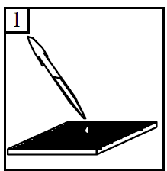
Procedure (what you do)
Using Indicator paper
- Add a few drops of vinegar to a dimple in the tray.

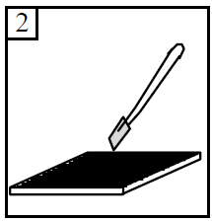
- Using the tweezers dip a piece of pH paper into the vinegar.

- To find the pH, match the colour of the pH paper to one of those on the colour chart.
- Record this pH by writing it down in the table.

- Repeat steps 1 to 4 with lemon juice, soda water and diluted household ammonia. Remember to record the pH each time.
- Add a few drops of water to a dimple in the tray. Using a spatula add a tiny amount of common salt (about the size of a lentil) to the water.
- Using the tweezers dip a piece of pH paper into the salt solution..
- Measure and record the pH, by matching the colour of the pH paper to one of those on the colour chart.
- Repeat steps 6 to 8 with bicarbonate of soda, sugar and automatic washing powder. Remember to record the pH each time.

Results sheet
What was the aim of the experiment?

Procedure

How did you use the colour chart to get the pH value?

How did you get some idea of how quickly the magnesium reacted with the dilute sulphuric
acid?

Complete the following table:
